Quality Improvement Plan

Department for Education
Site Number: 5363
CaFE Enfield Children’s Centre

Updated 13/11/2025

Acknowledgment of Country

We acknowledge the Kaurna people as the traditional custodians of the lands and waters where our centre is located and recognise their continuing connection to country. We pay our respects to Elders past and present and extend that respect to all Aboriginal peoples.

The National Quality Standard and Quality Improvement
The National Quality Standard is the standard against which providers self-assess the performance of their service/s in delivering quality education and care, and plan future improvements to their service/s. One result of this process is a Quality Improvement Plan (QIP).
The Education and Care Services National Regulations 2017 (the National Regulations) require approved providers to prepare a Quality Improvement Plan (regulation 55) for each service that:

- includes an assessment by the provider of the quality of the practices of the service against the National Quality Standard
- and the National Regulations; and
- identifies any areas that the provider considers may require improvement; and
- contains a statement of philosophy of the service.

The National Regulations do not prescribe a format for a Quality Improvement Plan. The purpose of this template is to offer a format that supports approved providers to meet their obligations under the National Regulations.
Approved providers also have an obligation (r56) to review and revise the Quality Improvement Plan at least annually, having regard to the National Quality Standard.

A Quality Improvement Plan must be reviewed and/or submitted to the regulatory authority on request. The National Regulations do not prescribe a format for a Quality Improvement Plan.
Approved providers also have an obligation (r56) to review and revise the Quality Improvement Plan at least annually, having regard to the National Quality Standard. A Quality Improvement Plan must be reviewed and/or submitted to the regulatory authority on request.
About the ACECQA Quality Improvement Plan template
The purpose of this template is to offer a planning format that supports approved providers to meet their obligations under the National Regulations.
This template provides quick links to helpful resources for each quality area in the Guide to the National Framework and the ACECQA website.
Exceeding NQS themes guidance
The Exceeding NQS sections provided for each standard should be completed when there is evidence of one or more Exceeding NQS themes demonstrated in the practice at the service.
When the QIP is submitted to the regulatory authority for assessment and rating, an authorised officer will consider the evidence documented and gathered at the assessment visit to determine if the Exceeding NQS themes are being met.

For further information on the three Exceeding themes, including what
authorised officers consider when reviewing whether evidence demonstrates a theme, see ACECQA’s Exceeding the NQS webpage.

Service details

Service name |  |  | Service approval number
C.a.F.E Enfield Children’s Centre |  |  | Kindergarten: SE 00010208  Childare: SE 00010207
Physical location of service |  |  | Physical location contact details
Street | 17a Wilkins Street |  | Telephone | (08) 8262 3329
Suburb | Enfield |  | Mobile | N/A
State/territory | South Australia
Postcode | 5085 |  | Email | dl.5363.leaders@schools.sa.edu.au
Nominated Supervisor
Primary contact | Name | Rowena McAvaney
Telephone | Telephone | 08 8262 3329
Mobile | Mobile | N/A
Email | Email | Rowena.Mcavaney51@schools.sa.edu.au
Government Preschool Operating hours during school terms.
 | Monday | Tuesday | Wednesday | Thursday | Friday
Opening time | 8:00 | 8:00 | No Session | 8:00 | 8:00
Closing time | 15:30 | 15:30 | No Session | 15:30 | 15:30

 | Monday | Tuesday | Wednesday | Thursday | Friday
Childcare Opening time | 7:00 | 7:00 | 7:00 | 7:00 | 7:00
Childcare Closing time | 18:00 | 18:00 | 18:00 | 18:00 | 18:00

Childcare Operating Hours (50 weeks of the calendar year)
Additional information about your service (context)

Welcome to C.a.F.E. Enfield Children's Centre for Early Childhood Development and Parenting. C.a.F.E. is an acronym for Children and Families Everywhere, a name that was devised and agreed upon by the founding members of community in 2002. We offer State Funded Preschool Program integrated with community based childcare centre with a capacity of 84 children. C.a.F.E. Enfield is an Integrated Early Years’ service in which multi-disciplinary professionals work together to provide a wraparound service for children and their families. We work in conjunction and collaboratively with
- Child and Family Health Service
- Learning Together Central Adelaide
- Enfield Primary School
- Department for Child Protection

Contextual influences
Our centre is in an area where 2.1% of people are indigenous; 38% of people are born overseas; 32% of families speak a language other than English at home; 41% of families rent, 29% owner with mortgage and 10.6% unemployed.

Our key focus during 2025 is to continue to develop integrated, flexible, high-quality programs and services to meet the needs of families. Our purpose is to engage every child to support achievement at the highest possible level of their learning and wellbeing, through quality education and care programs

In 2025 our government preschool program of 15 hours runs twice a week during the school terms. We have a set capacity of 55 enrolments so there can be up to 27 children in both Group A (sessions on Monday and Tuesday 8:00am – 3:30pm) and Group B (sessions on Thursday and Friday 8:00am – 3:30pm). During the Preschool session times, the centre integrates the 4 to 5 childcare alongside the preschool program with a maximum of ten children enrolled and educated by two Diploma qualified early childhood educators.

Our large staff team in the Preschool consists of Director Rowena McAvaney, Teacher Elli Kratounis, Part-time Teacher Nicole Al Halah and Leah Ramandanis. Our core ECW’s include Natja Hahn, Anh Nguyen and Zahra Yaghoubi. For the 4 to 5 year old childcare, the site has Diploma qualified educators, Kate Martin and Anila Kiri to collaborate with the Preschool staff. Anh Nguyen runs small groups for the bilingual children recognised for receiving additional support with their communication. Our permanent Teacher, Leah Ramandanis is currently on leave for term 1 and aims to return to work part time in Term 2. Majority of the staff are trained in Marte Meo practices which enables staff to build strong working relationships with the children and families, many of whom are returning families with younger sibling’s wanting to re-engage in the high-quality education and care program.

Children that attend our site come from many cultural and religious backgrounds, varying socio-economic standings and present with an array of speech, language, and developmental differences. We are inclusive of all and do what we can to support children and families as best we can. Typically, we have over 18 different first home languages that our children derive from. These children have access to 10-weeks of bilingual support and all families are invited to attend parent teacher chats which are offered twice a year. The team also work closely with on-site Child and Youth Health Services to ensure all children engage in their health checks. Through DfE process, when possible, we support families by accommodating their child’s external providers to attend appointments on site. We collaborate with University of South Australia to have students complete their practicum experiences on site and the educators work cohesively with the Education Department Support Services to support children. Being a children’s centre we also have support from the sites allocated Community Development Co-ordinator, Jill Meldrum who facilitates many groups on site including the Multi-cultural women’s Group on a Wednesday and Dad’s playgroup (First Saturday of the month).

We hold many family events and added learning experiences, such as the Harmony Day, significant persons day, kindy campfire and mid year/end of year kindy celebration. Children are given opportunities to attend incursions and local walks. This year, all staff received professional development by Leisl Von Der Borch, First Nations Educator, informing the whole site staff cohort about Aboriginal and Torres Strait Islander people and in particular focus on Pedagogy of Place. This was to build educators capacity so that they can be confident to engage all children in deepening their understanding and respect for First Nations people, how they connect and respectfully use the land and waters to ensure sustainability of nature. The preschool also connects with the Primary school on site, visiting the Beyond Space situated on the Enfield Primary Oval for children to engage in authentic nature play, visit the schools library and gym to connect with the school community and the Kindergarten educators arrange other incursions such as Fire Brigade, SAPOL, Ambulance and other theatre performances.

Analysing our 2024 Parent Kindergarten Survey, we continue to make improvements to our program, addressing some of these reflections and outcomes in our 2025 QIP. For example, via the Kindy newsletter, educators are proactively inviting families to contribute toward the children’s inquiries by sharing the children’s wonderings, theories and ideas and then adding a provocation to encourage their feedback/perspectives around what they are noticing their child now knowing, doing and being as an integral part of the community. These meaningful conversations have led to family members engaging in the curriculum and this is an aspect of the planning cycle that we have been striving to uplift.

The following information will assist the regulatory authority to plan the assessment visit.
Provide additional information about your service—parking, school holiday dates, pupil-free days, etc.
School Holiday Dates (No sessions):
Term 1 – 12th April – 27th April
Term 2 – 5th July – 20th July
Term 3 – 27th September – 12th October
Term 4 – 13th December – 26th January
Pupil Free Day Dates:
Term 1, Week 6 Friday the 7th March (Music Strategy, interoception training and reflecting on our Sites Inclusion Plan (SIP)
Term 2, Week 4 Friday the 23rd May (Pedagogical Documentation - Portfolio)
Term 3, Week 8 Friday the 12th September (Self-Regulation - Portfolio)
Term 4, Week 6 Monday the 17th November (Ped Doc analysis and QIP evaluation)

Parking:
Located at the end of Patella street is an entry into a car park that is shared by families attending CaFHS appointments, Learning Together playgroups or dropping off or picking up at the children’s centre.
How are the children grouped at your service?
C.a.F.E Enfield Children’s Centre has a capacity of 84 children per day. The Preschool currently accomadates 27 of those places. The Preschool alone operates during school terms for eligible children on Monday, Tuesday, Thursday and Fridays from 8:00am-3:30pm. All children attending the Preschool program are entitled to 15 hours of funding per week. The families receive this entitlement through either attending our Group A session - Monday and Tuesday OR Group B session - Thursday and Friday. Parents indicate on enrolment which they prefer and why. We aim to support all families in allocating the Group based best on their needs. In the term prior to children commencing their year of preschool, on a Wednesday we offer a couple of short transition sessions to support and when they’re new to our site, start to build a trusting connection.
The childcare is currently made up of three age groups, The 0-2’s room called Yipti Tarnanthi (word form Kaurna Nation means seed sprouting), the 2-4’s room called Karra (word from Kaurna Nation means Red Gum) and 4-5/ Kindergarten’s room called Kangkulya (word from Kaurna nation Red Gum seed pod). We acknowledge that the Kaurna language is the cultural property of the Kaurna people and we thank Kaurna Warra Pintyanthi (KWP) for allowing us permission in 2016 to use these Kaurna words in naming the children’s learning spaces after the life cycle of a Karra tree (River Red Gum).
Write the name and position of person(s) responsible for submitting this Quality Improvement Plan
Rowena McAvaney, Nominated Supervisor/Director
Service statement of philosophy
C.a.F.E. Enfield Children’s Centre is an integrated site including Community managed Child Care, Department for Education Preschool, playgroups, Child and Family Health Services, Learning Together Communities and parenting support programs. These services work together to support health, social, emotional and learning outcomes for children and their families.

We are committed to developing the cultural responsiveness of our educators with respect to Aboriginal and Torres Strait Islander cultures as we work towards development of our Reconciliation Action Plan. We acknowledge the Kaurna people as the traditional custodians of the Adelaide region and that their cultural and heritage beliefs are still as important to the living Kaurna people today.

We believe that inclusion is a right and that every child is entitled to high quality early education and care. Our practices reflect the belief that children are capable and competent learners from birth and unique in their own individual way. Educators encourage children to try things for themselves, and support them to build a sense of optimism and positive well-being.

We believe families have a critical role in early development of their children’s learning. We believe young children are happier and achieve more when early year’s educators work together with families to share insights, aspirations and documentation to support and extend children’s learning and development. We provide a safe, welcoming place for all children and their families to foster a strong sense of belonging and community.

We believe children have a right to play. Play is fundamental to young children’s learning as they engage in exploration, imagination and investigation, while socialising and communicating with children and adults around them. Our environments both indoors and outdoors are valued equally as important learning spaces. We believe the role of the learning environment is to provide flexible, ever-evolving materials and spaces to enable children to participate uninterrupted, to work alone, in small intimate groups or as a member of a large group.

We believe children should experience wonder in their world. Children are citizens from birth, and as such have a right to be listened to and a voice in decisions that affect them. Educators work with children to develop skills, knowledge and dispositions to connect them to their environment and their community. We model sustainable practices and promote active engagement by learning from, with and in the natural environment.

We believe children need healthy food, quality sleep and lots of exercise to assist with brain and body development. Meal times are social learning times that provide opportunity to develop connections between people. Our daily routines and programs encourage children to eat a wide variety of nutritious foods every day.

The quality of Educators is the key to the provision of high quality care and education of young children. This notion is supported through an environment of trust and respect with the community and in a culture of continual reflection and renewal of ideas and understandings. Educators are actively encouraged to access and continue training and professional development to continually improve practice and pedagogy.

Last Reviewed July 2025

Quality Area 1: Educational program and practice
This quality area of the National Quality Standard focuses on ensuring that the educational program and practice is stimulating and engaging and enhances children’s learning and development. In school age care services, the program nurtures the development of life skills and complements children’s experiences, opportunities and relationships at school, at home and in the community.
Additional information and resources about Quality Area 1 are available in the Guide to the National Quality Framework and the ACECQA website.
Quality Area 1: Standards and elements
Standard 1.1 | The educational program enhances each child’s learning and development.
Approved learning framework | Element 1.1.1 | Curriculum decision-making contributes to each child’s learning and development outcomes in relation to their identity, connection with community, wellbeing, confidence as learners and effectiveness as communicators.
Child-centred | Element 1.1.2 | Each child’s current knowledge, strengths, ideas, culture, abilities and interests are the foundation of the program.
Program learning opportunities | Element 1.1.3 | All aspects of the program, including routines, are organised in ways that maximise opportunities for each child’s learning.
Standard 1.2 | Educators facilitate and extend each child’s learning and development.
Intentional teaching | Element 1.2.1 | Educators are deliberate, purposeful, and thoughtful in their decisions and actions.
Responsive teaching and scaffolding | Element 1.2.2 | Educators respond to children’s ideas and play and extend children’s learning through open-ended questions, interactions and feedback.
Child directed learning | Element 1.2.3 | Each child’s agency  is promoted, enabling them to make choices and decisions that influence events and their world.
Standard 1.3 | Educators and co-ordinators take a planned and reflective approach to implementing the program for each child.
Assessment and planning cycle | Element 1.3.1 | Each child’s learning and development is assessed or evaluated as part of an ongoing cycle of observation, analysing learning, documentation, planning, implementation and reflection.
Critical reflection | Element 1.3.2 | Critical reflection on children’s learning and development, both as individuals and in groups, drives program planning and implementation.
Information for families | Element 1.3.3 | Families are informed about the program and their child’s progress.
National Law and National Regulations underpinning Quality Area 1
The table below shows the sections of the National Law and National Regulations underpinning Quality Area 1 and lists the most relevant element of the NQS associated with each section and regulation. Please note that this table serves as a guide only and regulatory authorities have flexibility in how they assign non-compliance with the National Law and National Regulations against the quality areas, standards and elements of the NQS.
National Law and National Regulations |  | Associated element
Section 51(1)(b) | Conditions on service approval (educational and developmental needs of children) | 1.1.1
Section 168 | Offence relating to required programs | 1.1.1, 1.1.2
Regulation 73 | Educational program | 1.1.1
Regulation 74 | Documenting of child assessments or evaluations for delivery of educational program | 1.3.1
Regulation 75 | Information about educational program to be kept available | 1.3.3
Regulation 76 | Information about educational program to be given to parents | 1.3.3
Regulation 325B  SA | Programs for children over preschool age | 1.3.1
Quality Improvement Plan for Quality Area 1
Summary of strengths for Quality Area 1
Strengths | Programming for individual children, rooms and whole of site utilizes and reflects current research and support documents such as Belonging, Being and Becoming: The Early Years Learning Framework for Australia; Reflect, Respect, Relate; DfE Literacy & Numeracy Indicators and guide books, Child Protection documents, Early Childhood Australia's Code of Ethics and the UN Convention on the Rights of the Child.  -Children's individual learning dispositions are embraced and acted upon  - Information is sought from families on a regular basis, both formally and informally via conversations & questionnaires, and through interactions in parenting groups and playgroups.  - Information is also gathered from other professionals on site who may have contact with the child & family during playgroups, parenting groups etc  - Conversations are facilitated throughout the day between children and Educators, and children and their peers, during play and routine times such as at mealtimes. Differing points of view are shared, explored and discussed.  - Children's experiences are a balance of child initiated and intentional teaching. The curriculum is play-based with lots of time for children to explore and extend on ideas deeply.  - A range of documents such as Learning Portfolios, Daily routine books, Workbooks and/or Curriculum recordings (Eg Floorbooks) are in such a way that parents are able to continuously access them  - Surveys & information from families provide opportunities for formally sharing home experiences and are used to shape and guide planning  - Play areas are established to build upon individual children's knowledge and ideas gathered from previous experiences  - Play situations have multiple entry points to allow and encourage participation by all children as it considers individual identity and learning styles  - Inquiry based projects are conducted with children to extend their thinking and learning processes. Through projects children can share & try out many ideas, draw on ideas from their previous experience & knowledge, challenge one another & work collaboratively as they share and create knowledge together. Educators work alongside children as co-researchers throughout this process, posing provocations, documenting processes and learning, and adding to their own knowledge about how children learn. -  - Teams work together to create large documentation panels of projects, these are displayed in public areas to share the learning processes of the children, making learning visible to families and the community.  -Educators are given time to engage in professional conversations and dialogue, and to make critically reflective judgements about children's learning, curriculum and documentation  During self-assessment at the end of 2024, we as a staff team, identified that we were still being challenged to effectively embed sustained, shared thinking strategies and documentation for all children into our program/curriculum. Engaging in numerous reflective meetings, we analysed what factors might be inhibiting this? The key pattern that emerged from this discussion was that due to the uniqueness of our context (children’s varying backgrounds and needs), we as educators were not implementing sufficient inclusive practices and communication strategies which was inhibiting ESL children from accessing rich learning opportunities. The other main protagonist being wellbeing. We had noticed a high rate of dysregulation patterns across the site, but particularly in the kindergarten setting where the new cohorts of children are enrolled either mid-year or the new year. This led the Kindergarten team to intentionally carry out an inquiry around Regulation. By focusing on the zones of regulation, children were able to recognise what zone they were in according to their feelings, and then through sustained shared thinking, they were able to self-select from a variety of strategies what actions to take to support themselves in getting back into the green zone which then supported their engagement/agency for learning. This process brought us to the question, should our ‘Area of Impact’ focus for all children be wellbeing. For all children to be agent in their learning, they have to be regulated and once regulated their experiences during play will uplift them socially and emotionally. As research tells us, children’s learning is optimised when a child is socially and emotionally sound. This led the team to wonder… what could our program offer to support and uplift all children, shifting their wellbeing to effectively engage and be agentic in the learning program and then successfully articulate their thinking. Hence our QIP Goal for 2025 evolved, By developing a strong and culturally responsive and inclusive environment whereby all children’s 100 languages are acknowledged uplifting their agency to confidently engage in the learning. To carry out this work, as a whole site we are collaboratively piecing together our Strategic Inclusive Plan (Lady Gowrie Document) and have already in Term 1 dedicated two whole site professional development days to this work. Refer to Appendix 1 (Agenda and Minutes dated 24th January and 7th March). To share progress and more dialogue across the site all rooms since the start of 2024 have access to an I-Pads in their rooms so they can communicate via Teams. (Norms for using I-Pads were established and collaboratively agreed upon on 24th Jan). This resource has supported all educators being aware of each room’s inquiries and supported building educator’s pedagogy capacity. Through a variety of Professional development, staff are banking more strategies to support all children’s regulation. For example, Music is a universal language and through coaches from the DfE Music Strategy delivering the benefits of engaging children in music experiences, educators are learning enjoyable strategies to support co-regulate all children. Another professional from DfE, Nicolle Stephanos, sites Inclusive educator delivered a power point presentation regarding the Alert Program (8 sensory senses) and how by analysing what is happening for a child’s regulation, you can support them by implementing specific strategies. For example, educators support children by asking them if it is alright to squeeze a child’s limbs to help them to calm their bodies down. This co-regulation strategy is combined with staff’s training to intentionally implement Marte Meo practices. This is when educator’s name the child’s verbal and/or physical expression, uplifting their feelings in that moment which support them to get back into the green zone and support agentic play. Marte Meo training is embedded across the site and majority of the staff have completed this training. Italia Parletta is booked to carry out further staff training starting mid May to build capacity in the new educators employed hence offering continuity of learning for all children.
Summary of strengths in practice where there is evidence of Exceeding NQS themes
Notes:
- This Exceeding NQS section is to be completed when there is evidence of one or more of the Exceeding NQS themes demonstrated in the practice at your service.
- Additional information about the Exceeding NQS themes is available on ACECQA’s Exceeding the NQS webpage.
Standard 1.1 – Program: The educational program enhances each child’s learning and development.
Exceeding themes
1. Practice is embedded in service operations | [If you have identified strengths in this area, describe how your practices are embedded in service operations for this Standard]  Remy Dickerson Statement of Learning Parent Comment:  “We have witnessed Remy’s development and growth with such pride this past 12 months. Many thanks for the guidance and support from Nicole, Elli, Natja, Ahn, Candy and all the educators at Cafe Enfield. Remy felt the belief you had in him and for his capacity to learn and that has made him believe in himself. Thank you to you all for going above and beyond with your help to brainstorm Remy to school next year, he’ll take with him so many valuable lessons and memories from his time as a little explorer, adventurer and learner at Café Enfield.”  Nyla Khanal Statement of Learning Parent Comment:  I personally felt Nyla actively engaging in group/within social circle. Before kindy she was not really engaged in groups, wanting to play alone. Now when I see her, I can see a big difference. She is very happy girl now who wants to explore everything and socialise. Thanks to all Kindy teachers.”  ***Kate/Elli any Ped Doc capturing children’s feedback on their learning and development?
2. Practice is informed by critical reflection | [If you have identified strengths in this area, describe how your services practices in this Standard, have been informed by critical reflection.]  ****Elli to write up environment change regarding Regulation Hub. We moved it from back room to play space and Finley said it was no good. We put it back in its original spot the same day. This was A-ha moment in that educators recognised, how this space (arch) was valued particularly by the dysregulated children. Teachers informed families in Newsletter about the effectiveness of regulation space and then you had Ester’s mother send email of the space Ester and her mother had created at home. (Appendix 2: Add Ester’s Email)  Site wide music project 2025. KK room terms 2-3 evaluation 23/9/25 staff meeting:  Actions Taken:  - PD related to music.  - Staff meeting (having discussions about our notices and wonderings related to music learning).  - Connecting this learning to families (sharing songs from home).  What progress have we made?  - Educators are learning themselves and expanding their knowledge.  - Children outcomes (what they knew before about music and what they know after exploring music) expanding their language, knowledge and ideas.  - Special moments with Reyarsh, Harrison and Ruben.  - More engagement with music outside and made-up music.  - The connection between kindy learning and home (linking them together).  - Promoting problem-solving skills and reflective thinking.  What factors have been critical for success?  - Being open-ended and having a provocation (rather than teacher-led), supported with children being intrigued and engaged in the music project  - Made it a priority which helped educators to prioritise that goal, with ensuring every child is included and differentiate based on children’s needs.  Inhibitors:  - Complex needs of children and not having the time for small group or extensions of ideas.  - Mid-year intake (possible cause for dysregulation amongst everybody).  Next Steps: Given the inhibitors, be more intentional and plan accordingly, in order to attend and extend other children (e.g., children with complex needs can use the woodwork space from 10-10:30am). Using the studio space more to cater to different needs and be inclusive of all. Connect it to our routine to further experiment and explore music.
3. Practice is shaped by meaningful engagement with families, and/or community | [If you have identified strengths in this area, describe how your services practices in this Standard, have been shaped by meaningful engagement with families, and/or community]  *** Grandparent who was a retired librarian was invited to come read Alexander’s Outing by Pamella Allen to the 4 to 5 year old cohort of children. She made props and engaged children in helping to tell the story. (please add photos to this text box with some child voice if possible.)  Preschool MYI parent/teacher chat survey wk 8 2025 re: how is your child agent at home?:  Preschool MYI parent/teacher chat survey re:
  A participates in a range of activities at home including preparation ingridients for baking, making springroll, cleaning, putting things away. She makes choice for her clothing & shoes, and lots of the time on the food and drink she wants.
  Giving more choices wherever possible eg do you want the blue shirt or green shirt, toast or weetbix, walk the dog or go to the playground etc.
  Letting him know what needs to be done and the time frame but not dictating when or how he does it. We need to brush our teeth and put on our shoes before the end of this show or when the visual timer goes off. He and Fox often plan together how they are going to do it.
  Resolving minor conflicts with his brother Fox. I leave them time to see if they can resolve it together while I supervise.
  My child is more willing to get himself ready for going out. He shows a stronger interest in brushing his teeth and washing face when we say big kids can do it themselves, babies need help.
  Picking his clothes, getting himself dressed, making his own breakfast / pouring ceral and milk / spreading on toast. Letting him listen to his body (if he's had 3 bites of dinner but feels that his body doesn't need more) deciding if he wants anything. Being given choices, and having body autonomy (deciding he wants to keep his long hair, but knowing with long hair he needs to look after it brushing/tying it up etc)
  We encourage K to participate in all activities, we play indoor outdoor games with her, we do painting, singing and dancing with her.
  We offer choices to R around his food preparation, he is involved in cooking meals at home. He choses what he wants to wear in the morning and gets himself dressed. He choses activities at home or outdoors e.g., do you want to go to the park or read a book.
  We encourage him to try to do things for himself while providing support and assistance if needed.
  I try to provide a variety of different activities at home and out and encourage him to try new things. When Z shows an interest in something I tend to go with it and we will borrow lots of books about those things and include it in our play. I try to let my kids decide what to play and also encourage independent play and reading too.
  Good
  We are play indoor n outdoor games with Kiara and help her in painting and creativity.and Happely increase my daughter's confidence.
  We are play indoor and outdoor games with Kiara and help her in painting and creativity.and we are always to increase her confidence.
  M is naturally very independent, we always give her the opportunity to do things by herself with little help unless she needs it. We try to give her lots of options, whether it's what activity she wants to do or what food she wants to eat etc, so that she never feels forced.
  I encourage Z to help around the house, kitchen and outdoors when the weather calm
  We encourage A to make choices about her clothes etc. and to have independence by trying and solve problems around the house.
  At home, C is very independent. He regularly gets himself dressed, makes his own bed, brushes his own teeth, gets his own snacks and drink bottle.
  We would love to know what you have noticed has positively developed in your child since starting Kindy (this could be social skills, language skills, self-help skills, etc).
  B is more independent. He is more confident on drop off. He has started to get himself dressed and choosing to do some tasks himself now. His drawings are continuing to become more imaginative and detailed. He is recognising more numbers and letter and also asking more questions.
  My child has been able to rebuild relationships with a couple of friends he used to play with.
  Building his social confidence (he loves coming to kindy, and learning/playing new things)
  Language skills
  R has talked positively about his experience at preschool. He has made some friends and I feel his social skills and ability to understand concepts and language has improved e.g. he has been telling me what letters rhyme with each other.
  I love hearing about Z’s day and all of his new friends. He’s always been quite social but it’s nice to see him socialising in an unfamiliar environment. I think he is building upon his independence in a positive way and improving his communication skills with things such as telling me about his day - what he ate, who he played with etc.
  I also think that Z’s self help skills such as the desire to dress himself independently have improved at home.
  Self help skills
  Language skills
  Language skills.
  Language skills, confidence
  Absolutely have noticed a difference, especially in his social skills and self help
  A is more interested in practicing writing letters.
  I have noticed that since starting Kinder, C has become more confident in his drop-off with Elli and Leah. He also talks about his "best-friend C", which is a lovely development as friendships can be challenging for him. He loves socialising and wants to play with other children but can sometimes find it tricky.

Summary of strengths in practice where there is evidence of Exceeding NQS themes
Notes:
- This Exceeding NQS section is to be completed when there is evidence of one or more of the Exceeding NQS themes demonstrated in the practice at your service.
- Additional information about the Exceeding NQS themes is available on ACECQA’s Exceeding the NQS webpage.
Standard 1.2 – Practice: Educators facilitate and extend each child’s learning and development.
Exceeding themes
1.Practice is embedded in service operations | [If you have identified strengths in this area, describe how your practices are embedded in service operations for this Standard]  *** Do we have a Letter/email of appreciation from a parent addressing their child’s engagement in the program has uplifted their child’ learning and development.  Anjali (Prathit’s Mum) reached out during his transition to preschool with regards to discussing his performance and seeking out support due to their background context (i.e., new to Australia, Prathit’s first time in a care setting, mum unaware of Australian educational system etc). During this meeting we discussed goals and strategies to support him with being an active preschool participant. Few weeks have gone by, and mum emailed her appreciation with regards to Prathit’s engagement in the program and uplifting his development.  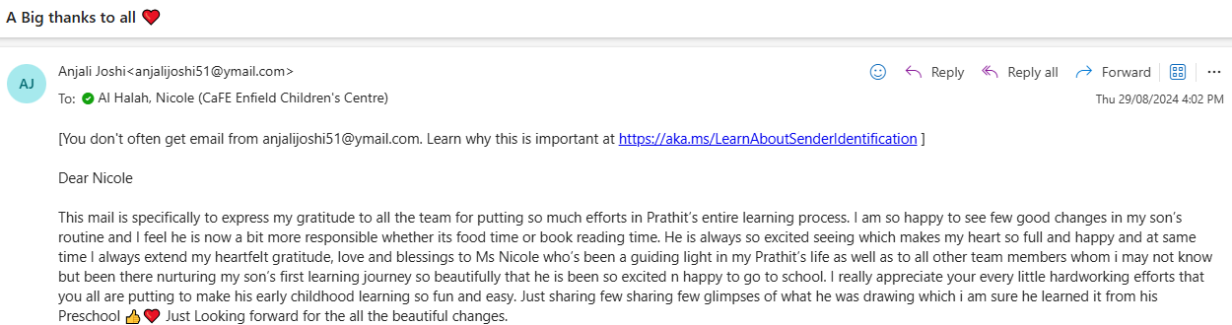  She also included images he drew at home with regards to learning around ‘The Zones of Regulation’.  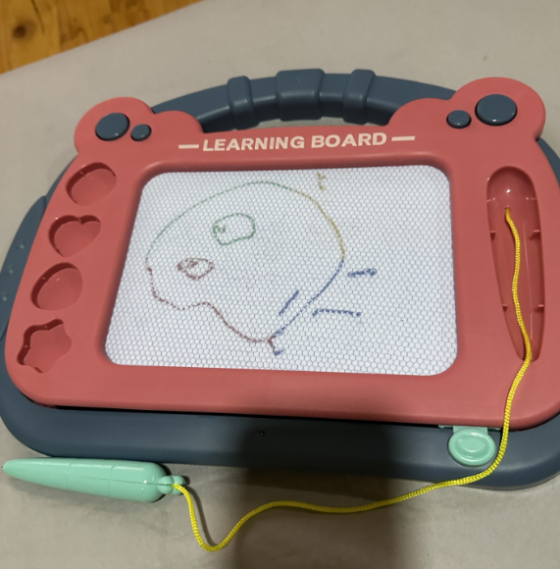  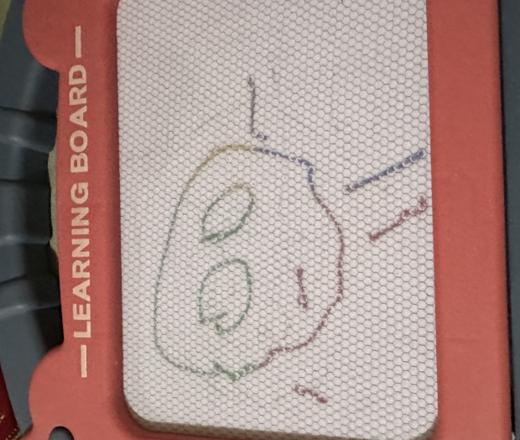
2. Practice is informed by critical reflection | [If you have identified strengths in this area, describe how your services practices in this Standard, have been informed by critical reflection.]  Since mid-year intake 2025, we have three new children who are constantly placing non-edible items in their mouth. Due to this, the team critically reflected at a KK staff meeting how limited access to the woodwork station was a negative result of this behaviour. Through much brainstorming, the educators strategically decided to intentionally place the woodwork bench and equipment in the Yipti studio yard space whereby small groups of children could access the equipment, stretching their learning outcomes.
3. Practice is shaped by meaningful engagement with families, and/or community | [If you have identified strengths in this area, describe how your services practices in this Standard, have been shaped by meaningful engagement with families, and/or community]  *** Karra room child care. Child was sucking on her clothing to the point of saturation. Educator provided a chew tool. Parent was disappointed about this offering. This led to educators working alongside sites O.T Jo O’Callaghan to co-design a permission form for families to sign off on before a chew tool can be provided to a child. ???

Summary of strengths in practice where there is evidence of Exceeding NQS themes
Notes:
- This Exceeding NQS section is to be completed when there is evidence of one or more of the Exceeding NQS themes demonstrated in the practice at your service.
- Additional information about the Exceeding NQS themes is available on ACECQA’s Exceeding the NQS webpage.
Standard 1.3 – Assessment and planning: Educators and co-ordinators take a planned and reflective approach to implementing the program for each child.
Exceeding themes
1. Practice is embedded in service operations | [If you have identified strengths in this area, describe how your practices are embedded in service operations for this Standard]  Preschool team worked alongside family to support child with special rights (ASD, Level 3) and DCP to transition into the Preschool room.  Preschool team met with all service providers involved and family (Uncle, Speech Pathologist, Occupational Therapist, DCP) to collaborate as a team to plan how to best support the child’s transition into preschool and discuss common goals all providers are working towards. Each month all providers engaged in reflective meetings to discuss progress notes (what is working well, what needs to change), and where to next. Preschool team shared progress notes from preschool and make recommendations or take on recommendations from service providers.  Below is evidence of meeting notes from one meeting held and an email from the family at the end of their child’s preschool year thankful for support from preschool team 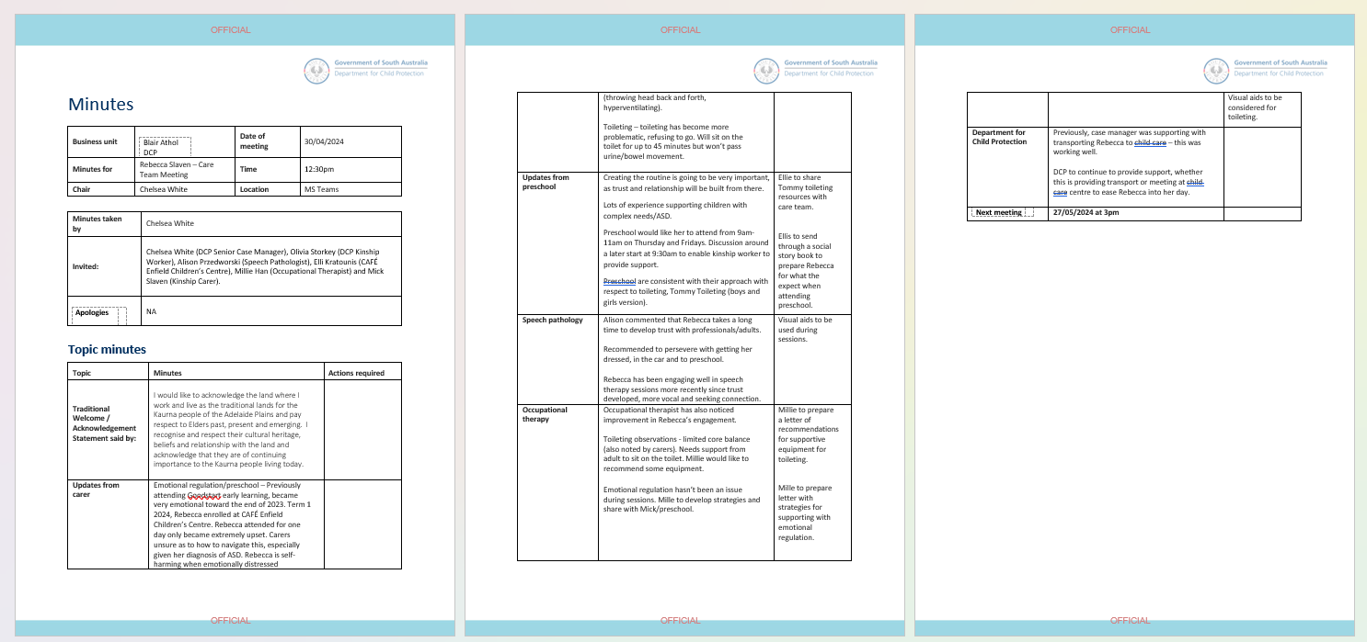  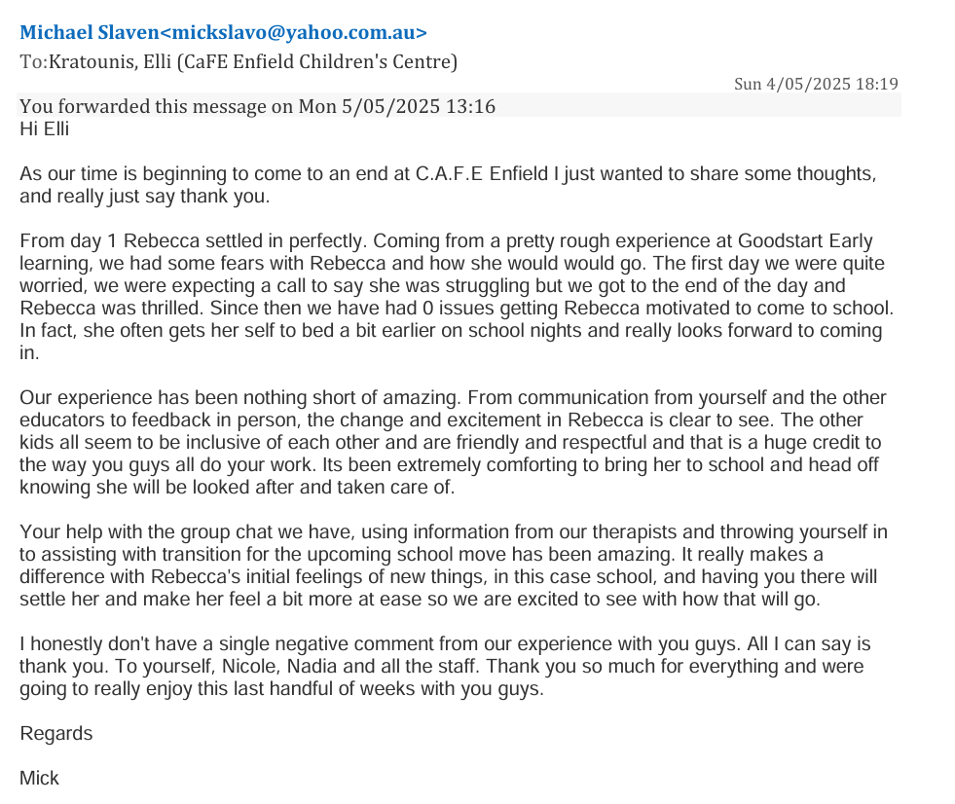
2. Practice is informed by critical reflection | [If you have identified strengths in this area, describe how your services practices in this Standard, have been informed by critical reflection.]  *** Elli/Nicole After parent teacher chats (Referencing the parent s/feedback slips) what did you intentionally implement to support the children’s learning.  In the Preschool, at the beginning of each Preschool year/Mid Year, we conduct ‘Parent Teacher Conversations’ with families to get to know each other, develop a trusting relationship and co-construct common goals for their child whilst attending Preschool.  **Elli – H.R example
3. Practice is shaped by meaningful engagement with families, and/or community | [If you have identified strengths in this area, describe how your services practices in this Standard, have been shaped by meaningful engagement with families, and/or community]  *** Nicole/Leah/Elli…Meeting with the family to discuss one plan goals. Capturing parent voice on the one plan around aspirations for their own child’s learning. How this may have determined the goals for the child.  See survey results from Parent/Teacher Chats wk 8 2025:  Wk 8 2025:  As a follow up for example with child: R- Leah met with the family regarding their concern for his fine motor. We discussed the things we could do here at Kindy and the things they could do at home. Leah offered to provide some readings and resources and gave these to the family which they appreciated and dad shared they would start that night; information around ‘w sitting’ and a name tracing laminated sheet with whiteboard marker.  Leah shared the data we have been collecting re: fine motor and handwriting and we discussed how we would keep sharing this back and forth during his Kindy year. Zahra is focusing on fine motor intervention groups as per our data collection. Family shared they are really keen for all feedback and to not feel uncomfortable sharing anything regarding to R’s learning. This has helped strengthen our professional relationship with the family, with the child’s best interests at heart.  Child: G’s mum chatted to Leah re: noticing he does not cross the midline as observed by his retired teacher grandmother. Leah linked with our OT Jo who shared some resource ideas and readings around this to both share with the family and for us to do in Kindy. Jo shared a teacher’s companion book around crossing the midline and regulation with Anila.  Child: B’s parents shared their concerns with her speech. Leah linked with site SP Tricia to see if she may be a child who’s eligible for our DfE SP program. Tricia shared her speech needs were minor based on her observations and that DfE SP Ann Marriott would not be the necessary avenue and that the family could be supported to attend private speech therapy for some short term practice of sounds before school. Tricia also shared some parent information regarding how to support language development at home. The family were grateful and are looking into private speech therapy.
  For A to continue to thrive, be confident in socialising with others.
  I just want B to be happy and feel good. The rest will come when he is ready.
  We’d like E to develop more active listening skills and thinking before answering. He tends to say “I don’t know” when we raise questions, sometimes he knows answers, it’s just his habit to say I don’t know.
  We would also like E to participate more in learning experiences that will enhance his fine motor skills.
  To continue to build his confidence, and would love to see him be more comfortable with building relationships with his peers, building resilience
  Our goal is that he participates in all activities.
  I would like R to be able to improve his written comprehension. He cannot write his name yet and im hoping he will continue to improve his writing of letters even with the tracing.
  I would like him to feel more comfortable communicating with educators especially with things such as needing the toilet or needing water, and also to gain a bit more self awareness with himself too.
  Be more involved in activities
  In the next term. I wish that she learn more things and her language skills improve.
  In the next term ,we that she's learn more things and improve language skill.
  Improve her numeracy and literacy
  To be hopefully writing his name on his own
  A little bit more independent
  More social
  To play more happily with other children at kindy - she seems quite overwhelmed by how busy (“hectic”) kindy is and seems uncomfortable playing with large groups of other children.
  We would love for C to work on having a positive drop-off and continuing to build his play and social skills with other children. We would also love C to work on his communication skills with peer and teacher. I think having his OT and Speech Therapist in the classroom occasionally would help with these goals

Quality Area 2: Children’s health and safety
This quality area of the National Quality Standard focuses on safeguarding and promoting children’s health and safety.
Additional information and resources about Quality Area 2 are available in the Guide to the National Quality Framework and on the ACECQA website.
Quality Area 2: Standards and elements
Standard 2.1 | Each child’s health and physical activity is supported and promoted.
Wellbeing and comfort | Element 2.1.1 | Each child’s wellbeing and comfort is provided for, including appropriate opportunities to meet each child’s need for sleep, rest and relaxation.
Health practices and procedures | Element 2.1.2 | Effective illness and injury management and hygiene practices are promoted and implemented.
Healthy lifestyle | Element 2.1.3 | Healthy eating and physical activity is promoted and is appropriate for each child.
Standard 2.2 | Each child is protected.
Supervision | Element 2.2.1 | At all times, reasonable precautions and adequate supervision ensure children are protected from harm and hazard.
Incident and emergency management | Element 2.2.2 | Plans to effectively manage incidents and emergencies are developed in consultation with relevant authorities, practised and implemented.
Child protection | Element 2.2.3 | Management, educators and staff are aware of their roles and responsibilities to identify and respond to every child at risk of abuse or neglect.

National Law and National Regulations underpinning Quality Area 2
The table below shows the sections of the National Law and National Regulations underpinning Quality Area 2 and lists the most relevant element of the NQS associated with each section and regulation. Please note that this table serves as a guide only and regulatory authorities have flexibility in how they assign non-compliance with the National Law and National Regulations against the quality areas, standards and elements of the NQS.
National Law and National Regulations |  | Associated element
Section 51(1)(a) | Conditions on service approval (safety, health and wellbeing of children) | 2.1.1, 2.1.2, 2.1.3, 2.2.1,  2.2.2, 2.2.3
Section 162A | Persons in day-to-day charge, nominated supervisors and family day care co-ordinators to have child protection training | 2.2.3
Section 165 | Offence to inadequately supervise children | 2.2.1
Section 166 | Offence to use inappropriate discipline | 2.1.1, 2.2.1
Section 167 | Offence relating to protection of children from harm and hazards | 2.2.1
Section 170 | Offence relating to unauthorised persons on education and care service premises | 2.2.1
Section 171 | Offence relating to direction to exclude inappropriate persons from education and care premises | 2.2.1
Regulation 77 | Health, hygiene and safe food practices | 2.1.2
Regulation 78 | Food and beverages | 2.1.3
Regulation 79 | Service providing food and beverages | 2.1.3

National Law and National Regulations |  | Associated element
Regulation 82 | Tobacco, drug and alcohol free environment | 2.2.1
Regulation 83 | Staff members and family day care educators not to be affected by alcohol or drugs | 2.2.1
Regulation 84 | Awareness of child protection law | 2.2.3
Regulation 84A | Sleep and rest | 2.1.1
Regulation 84B | Sleep and rest policies and procedures | 2.1.1
Regulation 84C | Risk assessment for purposes of sleep and rest policies and procedures | 2.1.1
Regulation 84D | Prohibition of bassinets | 2.1.1
Regulation 85 | Incident, injury, trauma and illness policies and procedures | 2.1.2
Regulation 86 | Notification to parents of incident, injury, trauma and illness | 2.1.2
Regulation 87 | Incident, injury, trauma and illness record | 2.1.2
Regulation 88 | Infectious diseases | 2.1.2
Regulation 89 | First aid kits | 2.1.2
Regulation 90 | Medical conditions policy | 2.1.2
Regulation 91 | Medical conditions policy to be provided to parents | 2.1.2
Regulation 92 | Medication record | 2.1.2
Regulation 93 | Administration of medication | 2.1.2
Regulation 94 | Exception to authorisation requirement—anaphylaxis or asthma emergency | 2.1.2
Regulation 95 | Procedure for administration of medication | 2.1.2
Regulation 96 | Self-administration of medication | 2.1.2
Regulation 97 | Emergency and evacuation procedures | 2.2.2

National Law and National Regulations |  | Associated element
Regulation 98 | Telephone or other communication equipment | 2.2.2
Regulation 99 | Children leaving the education and care premises | 2.2.1
Regulation 100 | Risk assessment must be conducted before excursion | 2.2.1
Regulation 101 | Conduct of risk assessment for excursion | 2.2.1
Regulation 102 | Authorisation for excursions | 2.2.1
Regulation 102AAB | Safe arrival of children policies and procedures | 2.2.1
Regulation 102AAC | Risk assessment for the purposes of safe arrival of children policies and procedures | 2.2.1
Regulation 102B | Transport risk assessment must be conducted before service transports child | 2.2.1
Regulation 102C | Conduct of risk assessment for transporting of children by the education and care service | 2.2.1
Regulation 102D | Authorisation for service to transport children | 2.2.1
Regulation 102E | Children embarking a means of transport—centre-based service | 2.2.1
Regulation 102F | Children disembarking a means of transport—centre-based service | 2.2.1

Quality Improvement Plan for Quality Area 2
Summary of strengths for Quality Area 2
Strengths | Health and safety are apart of our daily routine  Educators provide explicit teaching and role modelling of handwashing and embed daily hygiene routines to support children’s  … prevent the spread of infectious disease  We operate from a rights based approach to education and care . The right to play. The right to have a voice and be listened to. The right to make decisions. The right to experience safe, secure relationships. The right to be participate and be included. The right to healthy food & sleep. The right to be kept safe. Our educators draw on their knowledge of Attachment Theory & Marte Meo Principles in order to be attuned to children and to cue into their needs. Emotional regulation  Children are given daily opportunities to be adventurous, face challenges and take risks in their play which support physical development and the ability to self-assess risks. Children work alongside Educators to develop formal risk assessments.  - Our Active Ed sessions are based on the evidence that movement is critical for early brain development. Sessions incorporate Fundamental Movement Skills that utilise the large muscles of the body (gross motor skills) which, in turn, help strengthen and refine the small muscles of the body (fine motor skills), promoting strength, coordination and control.  - Educators work with our on-site Occupational Therapist to incorporate OT principles & knowledge, to embed physical activity in everyday life. This includes the design and set up of learning environments, planned learning experiences and opportunities to engage in heavy work & daily tasks that contribute to physical development as well as to the life of the Centre.  Healthy eating is promoted with children on a daily basis through relaxed, intimate meal times where children are involved in setting tables, serving their own food and having time for lengthy conversations with peers and educators.  - Children talk with our cook throughout the day and are able to observe her preparing food. The implementation of the "Eat a Rainbow" healthy program enables children to learn more about specific foods in their raw state, and to be actively involved in food preparation.  - Menus are planned using the online Feed Australia Program. This allows for detailed analysis of ingredients and quantities to meet daily nutritional requirements for children, and to be able to communicate this to families via displayed weekly menus.  - Messages about healthy eating are shared with families regularly through newsletters, parent sessions, documentation of learning and visual displays. Families contribute to this program through two way conversations, sharing of menu ideas, and home routines.  Children's individual needs for sleep, rest and relaxation are discussed with families, and there is flexibility around sleep and rest times to accommodate these.  - Educators create calm environments for children to rest & sleep, and spaces to retreat to for relaxation throughout the day (such as hammocks, cosy spaces, dens and cubbies).  - Messages about safe sleeping environments, & the importance of quality sleep for supporting children's brain development & wellbeing are promoted to families in a range of ways including through our Philosophy.  “Keeping Safe” Child Protection curriculum documents inform practice and supports planning for and with children. Educators have been engaging in professional learning and critical reflection about supporting children's wellbeing, and Trauma Informed practice.  March 2024, made contact with Chubb Fire & Security to initiate getting professional Emergency Evacuation Plans for the site. Mark Cooke the state training manager sent me an email with a list of procedures to carry out before a consultant could come on site and ensure all the plans had everything located correctly and where the plot see where the plans would be installed on the Exit walls. On completion of the plans being installed, I ensured every educator was aware of their location and their information. This led to reassessing and re-doing all the Evacuation Procedures on the walls and ensuring each team was inducted with the new process. Since this upgrade, Evacuation feedback data has been collected from each room including from the CaFHS and any necessary concerns have been actioned. For example,all staff now are to sign on the bottom of the daily attendance sheet so that all staff are accounted for by their colleagues as well as the Lee completing a Roster check. CaFHS, Admin and director mobile phones all contain each other’s phone contacts so that communication can occur across opposite sides of the building.  July 2024, recognised needed to support staff with more information around children’s eating habits and arranged for Anna Ritten (clinical nutritionist) from Nourishing Little Lives to present professional development to the whole team with a focus on managing mealtimes and the division of responsibility between adults and children. The key takeaways included:  - Division of Responsibility:  - Adults are responsible for what, when, and where a child eats.  - Children are responsible for how much they eat, what they eat from what is offered, and whether they eat.  - Children's Natural Eating Ability:  - Children have an innate ability to eat as much as they need, grow appropriately, and learn to eat the foods their parents eat.  - It's crucial for adults to trust children to decide how much and whether to eat from what is provided.  - Neutral Approach to Food:  - Avoid labelling foods as good/bad or healthy/unhealthy. Focus on discussing colours and textures instead.  - Parents/Carers' Feeding Responsibilities:  - Choose and prepare food.  - Provide regular meals and snacks.  - Make eating times pleasant.  - Model appropriate eating behaviours.  - Avoid pressuring children to eat.  - Benefits of Eating Together:  - Repeated exposure to foods leads to increased familiarity, acceptance, and liking.  - Involve children in meal preparation to support their learning.  - Learning to Eat:  - Feeding is a complex task for children, starting from around six months of age, involving all eight senses: visual, tactile, auditory, olfactory, gustatory, proprioception.  - When to Seek Help:  - If a child refuses whole food groups, has poor growth, eats less than 20 foods, or if mealtimes cause stress.  - Concerns about eating habits should be addressed with a dietitian or GP.  This content was designed to guide adults in supporting children's healthy eating habits and addressing any concerns that may arise and supporting parents and care givers on how to approach matters of concern.

Summary of strengths in practice where there is evidence of Exceeding NQS themes
Notes:
- This Exceeding NQS section is to be completed when there is evidence of one or more of the Exceeding NQS themes demonstrated in the practice at your service.
- Additional information about the Exceeding NQS themes is available on ACECQA’s Exceeding the NQS webpage.
Standard 2.1 – Health: Each child’s health and physical activity is supported and promoted.
Exceeding themes
1. Practice is embedded in service operations | [If you have identified strengths in this area, describe how your practices are embedded in service operations for this Standard]  ***Lisa have you ever received cards emails or letters of thanks for the menu?? Have you had a parent ask for a recipe??  *** Kate when implementing the phys ed program , did you receive feedback from families within the ped doc??  *** Ro letter from OT External provider stating their appreciation for support to carry out their work with their client on site.
2. Practice is informed by critical reflection | [If you have identified strengths in this area, describe how your services practices in this Standard, have been informed by critical reflection.]  *** Elli/Nicole copy of a one plan whereby parent or external providers recommendation is weaved into the child’s one plan that you’ve designed for developing a child’s oral eating plan or gross motor development.  Elli – Monroe One Plan?/ Rebecca One Plan?
3. Practice is shaped by meaningful engagement with families, and/or community | [If you have identified strengths in this area, describe how your services practices in this Standard, have been shaped by meaningful engagement with families, and/or community]  ***Jill, Jo, Tricia please share any parent feedback (email?) after you’ve operated a health related workshops and it has supported their child’s wellbeing.  ***Director, Ayan’s OT (external provider) and Ayan’s mother met term 2, 2025 to collaborate and write application for Ayan to attend The Briar’s for his Kindergarten experience term 3, 2025. Director communicated with Tash at The Briar’s to negotiate an appointment time for Ayan’s mother to see the site. Ayan’s family accepted an offer from The Briar’s and he still attends 4 to 5 childcare with C.a.F.E one day a week to support the family.

Summary of strengths in practice where there is evidence of Exceeding NQS themes
Notes:
- This Exceeding NQS section is to be completed when there is evidence of one or more of the Exceeding NQS themes demonstrated in the practice at your service.
- Additional information about the Exceeding NQS themes is available on ACECQA’s Exceeding the NQS webpage.
Standard 2.2 – Safety: Each child is protected.
Exceeding themes
1. Practice is embedded in service operations | [If you have identified strengths in this area, describe how your practices are embedded in service operations for this Standard]  ***Elli/Nicole provide any parent feedback regarding all the risk assessments that were created for the Local Walk Consent Forms. Any feedback around appreciation for the work that has been completed for this to happen. Perhaps ask Lisa (Harry and Charlie’s mum) as she is on Management and probably appreciates the work that went into making the local walks.
2. Practice is informed by critical reflection | [If you have identified strengths in this area, describe how your services practices in this Standard, have been informed by critical reflection.]  ***Elli/Nicole: thoughtful social stories are created for individual children to support them with their safety…(feedback from a parent).  ***Elli share the risk assessment with Ruben’s mother and get feedback
3. Practice is shaped by meaningful engagement with families, and/or community | [If you have identified strengths in this area, describe how your services practices in this Standard, have been shaped by meaningful engagement with families, and/or community]  Parent meeting 22/9/25 with J.N (child) to discuss behaviour, regulation and meaningful participation both at home and Kindy. Family shared their struggles and their openness to wanting to find avenues to support J. Parents shared as a result of the meeting they are now reflecting on the language they use to label the child/ giving J choices as child empowerment is important. Eg. they said “I need to work on the words I say” &“We can give her a choice right now as to who drives her home after this meeting”.  We talked about how we as educators are also practising Marte Meo and ‘striving for 5’ so that our interactions with J are primarily positive and relationship building so when it is time to discuss safe/unsafe or fair/unfair, they are more receptive to it. We talked about child empowerment and how like adults, children deserve choice and agency within adult parameters eg. “it’s time to sit for lunch, would you like the blue or green cup?” Parents agreed J is much more receptive when it’s her idea.  Family keenly sought out our feedback around potential referrals for external providers re: OT and Speech. Family wondered if a sport would be a good channel for J to develop discipline, mindfulness and focus and we all agreed this would be wonderful. Family to look into gymnastics.  At the conclusion of the meeting dad shared how wonderful our care of J has been in comparison to other sites they have had experience with and that he can tell we care and love children. He shared how appreciative he was of our time and dedication to support her behaviours.

Quality Area 3: Physical environment

This quality area of the National Quality Standard focuses on the physical environment and ensuring that it is safe, suitable and provides a rich and diverse range of experiences that promote children’s learning and development.
Additional information and resources about Quality Area 3 are available in the Guide to the National Quality Framework and on the ACECQA website.
Quality Area 3: Standards and elements
Standard 3.1 | The design of the facilities is appropriate for the operation of a service.
Fit for purpose | Element 3.1.1 | Outdoor and indoor spaces, buildings, fixtures and fittings are suitable for their purpose, including supporting the access of every child.
Upkeep | Element 3.1.2 | Premises, furniture and equipment are safe, clean and well maintained.
Standard 3.2 | The service environment is inclusive, promotes competence and supports exploration and play-based learning.
Inclusive environment | Element 3.2.1 | Outdoor and indoor spaces are organised and adapted to support every child’s participation and to engage every child in quality experiences in both built and natural environments.
Resources support play-based learning | Element 3.2.2 | Resources, materials and equipment allow for multiple uses, are sufficient in number, and enable every child to engage in play-based learning.
Environmentally responsible | Element 3.2.3 | The service cares for the environment and supports children to become environmentally responsible.

National Law and National Regulations underpinning Quality Area 3
The table below shows the sections of the National Law and National Regulations underpinning Quality Area 3 and lists the most relevant element of the NQS associated with each section and regulation. Please note that this table serves as a guide only and regulatory authorities have flexibility in how they assign non-compliance with the National Law and National Regulations against the quality areas, standards and elements of the NQS.
National Law and National Regulations |  | Associated element
Regulation 84D | Prohibition of bassinets | 3.1.2
Regulation 103 | Premises, furniture and equipment to be safe, clean and in good repair | 3.1.2
Regulation 104 | Fencing | 3.1.1
Regulation 105 | Furniture, materials and equipment | 3.2.2
Regulation 106 | Laundry and hygiene facilities | 3.1.1
Regulation 107 | Space requirements—indoor | 3.1.1
Regulation 108 | Space requirements—outdoor | 3.1.1
Regulation 109 | Toilet and hygiene facilities | 3.1.1
Regulation 110 | Ventilation and natural light | 3.1.1
Regulation 111 | Administrative space | 3.1.1
Regulation 112 | Nappy change facilities | 3.1.1
Regulation 113 | Outdoor space—natural environment | 3.2.1
Regulation 114 | Outdoor space—shade | 3.1.1
National Law and National Regulations |  | Associated element
Regulation 115 | Premises designed to facilitate supervision | 3.1.1
Regulation 116 | Assessments of family day care residences and approved family day care venues | 3.1.1
Regulation 116A | Inspection of swimming pools, water features and other potential water hazards at family day care residences and approved family day care venues | 3.1.1
Regulation 116B | Inspection report (additional requirement for family day care) | 3.1.1
Regulation 116C | Compliance with fencing requirements for swimming pools at family day care residences and approved family day care venues | 3.1.1
Regulation 117 | Glass (additional requirement for family day care) | 3.1.1
Regulation 274  NSW | Swimming pools | 3.1.2
Regulation 345  Tasmania | Swimming pool prohibition | 3.1.2

Quality Improvement Plan for Quality Area 3
Summary of strengths for Quality Area 3
Strengths | Our learning environments are provisioned with open-ended materials that support the participation of all children by enabling multiple entry points for children to work with the materials. The ways that are environments, both inside and outside, are set up allow children to to self- initiate play, to be creative thinkers and problem solvers.  - Indoor and outdoor spaces are used flexibly to allow shared use (such as using our community space as a 'pop-up dining space) & for indoor/outdoor play to happen simultaneously.  - We have 1 large outdoor environment that is shared by children from babies to preschool age. This supports connections between children and educators, fosters collaboration and maintains relationships.  -Natural play spaces foster a connection to the natural world, inspire curiosity and exploration. Educators support children to take a shared responsibility for caring for the world around us and this i embedded in daily practices. This is done in several ways such as caring for our Centre plants and animals. Children and families are actively involved in increasing the biodiversity of our local community. As a community we have created a frog pond and native garden at the entrance to the Centre, and a new butterfly garden outside of our back fence. We host workshops for families on propagation so that we can use our existing plants to expand habitats. All these initiatives foster a sense of community and develop understandings about lifecycles and ecosystems.  -our outdoor environments offer risk & challenge and are designed to ensure active participation by every child. Children are encouraged to be explorers and risk takers in order to develop their skills in safely assessing risks.  -The children are involved in other daily sustainable practices that offer important opportunities for learning. They assist in sorting and categorising our mixed recycling and collect the bins from around the centre to take to the larger bins; Food scraps are fed to our animals, composted, or used in our worm farms. The worm wee & castings are then harvested by children and distributed to families to be used in their gardens at home.  - Educators participate in Cultural Competence professional development- particularly in relation to Aboriginal and Torres Strait Islander cultures and perspectives. The children acknowledge that we are on Kaurna country daily; we sing songs, read books and use words in Kaurna language daily also. The centre is actively working on a Reconciliation Action Plan  -We support the inclusion of all children in a range of ways. For example, the embedded use of keyword signing, visual communication boards and electronic communication programmes on devices supports the communication of all children. IELP's are developed for individual children. We work alongside our Inclusion Support provider, and Allied Health professionals including on-site Speech Pathologist, Occupational Therapist, CAFHS nurses and NDIS providers who may deliver services onsite.  - Bilingual educators support children and families in their home language and a bilingual transition playgroup supports new families to transition into preschool & helps build a sense of belonging.  - Daily outdoor inspections are conducted and documented, and we have an educator trained in Playground Safety Inspections who conducts detailed quarterly inspections.  Starting 2024 as Acting Director, my office was in the community space which was too far away from the children, families and staff. I also shared an office with the sites CDC, O.T and Speech Pathologist and this made it difficult to have private conversations personally or over the phone. So I began to think about the possibilities and reflected on the size of the existing staff room that accommodates up to 35 staff. It made sense to swope the spaces but then I needed to provide the CDC, O.T and Speech Pathologist with a space of their own. This is when I began negotiations with the Property Manager to gain one of the CaFHS practitioner rooms back. The outcome was that the CaFHS room would be vacated in September which allowed time for planning. Phase 1 of the plan was to clean the new CDC, OT, and Speech Pathologist office, by removing the sink, cleaning the carpets, painting the walls, installing a new lock on the door and moving in the furniture. Phase two was moving the staffroom furniture to the original director’s office and then the director’s furnishing to the old staff room. To benefit the staff’s wellbeing they have a new fridge, kettle, microwave, dinning table and some singular couches to furnish the new spacious staffroom. Staff have commented their appreciation for the new staff room being located away from the rooms and that they are no longer having to manoeuvre in a confined space.  KINDY ROOM CHANGES 2024. After visiting Woodville Gardens preschool/childcare, the Kindy team reflected on the C.a.F.E Kindergarten room, recognising the space was too congested and the experiences that supported the children to regulate such as blocks and wood work weren’t available for them to experiment with. The team recognised that all the children’s trays (in cupboard units) took up too much floor space in the room. So through discussions about what the children actually store in their trays, they decided to provides alternative storage for their work books, shoes, jackets and hats. Within a short time the educators recognised that the children’s agency had diminished and this wasn’t a preferable outcome. So to rectify the matter the teachers came in on a Saturday and returned the cupboards containing trays, only this time they set them up on the veranda allowing the indoor play space to remain spacious.

Summary of strengths in practice where there is evidence of Exceeding NQS themes
Notes:
- This Exceeding NQS section is to be completed when there is evidence of one or more of the Exceeding NQS themes demonstrated in the practice at your service.
- Additional information about the Exceeding NQS themes is available on ACECQA’s Exceeding the NQS webpage.
Standard 3.1 – Design: The design of the facilities is appropriate for the operation of a service.
Exceeding themes
1. Practice is embedded in service operations | [If you have identified strengths in this area, describe how your practices are embedded in service operations for this Standard]  ***Bijal when rearranging the Karra room in 2024 to uplift children’s agency, did you have any parents feedback or comments written in the floor book??
2. Practice is informed by critical reflection | [If you have identified strengths in this area, describe how your services practices in this Standard, have been informed by critical reflection.]  ***Lee do we have parent voice that was considered and instigated when designing the outdoor environment???
3. Practice is shaped by meaningful engagement with families, and/or community | [If you have identified strengths in this area, describe how your services practices in this Standard, have been shaped by meaningful engagement with families, and/or community]  ***Elli/Bijal/Kate Via Ped Doc Parents supported the children’s inquiries by purchasing fruit trees and lemon Myrtle for the garden. These were planted during a community working bee. ( Attach the cards from the families.)

Summary of strengths in practice where there is evidence of Exceeding NQS themes
Notes:
- This Exceeding NQS section is to be completed when there is evidence of one or more of the Exceeding NQS themes demonstrated in the practice at your service.
- Additional information about the Exceeding NQS themes is available on ACECQA’s Exceeding the NQS webpage.
Standard 3.2 – Use: The service environment is inclusive, promotes competence and supports exploration and play-based learning.
Exceeding themes
1. Practice is embedded in service operations | [If you have identified strengths in this area, describe how your practices are embedded in service operations for this Standard]  ***Kate in 2025 each staff member is responsible for setting up a cultural provocation or an acknowledgement of a celebration. On 21st February, it was the celebration of International Mother Language. Auyuktha’s family shared Surya Ashtakam (sun set of eight stanzas).  ***Yilu Child singing ‘head shoulders knees and toes’ in Kaurna and the parent was wanting to know what was this song her child was singing. Yilu shared they’d been learning the song in Kaurna language.
2. Practice is informed by critical reflection | [If you have identified strengths in this area, describe how your services practices in this Standard, have been informed by critical reflection.]  *** Jill n Mel Conversations were had around concerns of how we could encourage families to engage with their children in the community space whilst waiting for their CaFHS appointments as we were noticing lots of parents engaging with their mobile phones rather than their babies and children. Created a poster and set up a Kaurna language provocation.
3. Practice is shaped by meaningful engagement with families, and/or community | [If you have identified strengths in this area, describe how your services practices in this Standard, have been shaped by meaningful engagement with families, and/or community]  ***Elli/Jill written/verbal feedback from one of the families that currently attend the Multi-Cultural Women’s Group on how the sites service has supported their child in many ways including CaFHS visit, Bilingual workshops, OT and/or Speech. (perhaps you received a thank you card or a letter??)

Quality Area 4: Staffing arrangements

This quality area of the National Quality Standard focuses on the provision of qualified and experienced educators, co-ordinators and nominated and experienced supervisors who are able to develop warm, respectful relationships with children, create safe and predictable environments and encourage children’s active engagement in the learning program. Please note that a number of transitional and jurisdiction-specific regulations apply to staffing arrangements. Refer to Chapter 7 of the Education and Care Services National Regulations for more information.

Additional information and resources about Quality Area 4 are available in the Guide to the National Quality Framework and on the ACECQA website.
Quality Area 4: Standards and elements
Standard 4.1 | Staffing arrangements enhance children's learning and development
Organisation of educators | Element 4.1.1 | The organisation of educators across the service supports children’s learning and development.
Continuity of staff | Element 4.1.2 | Every effort is made for children to experience continuity of educators at the service.
Standard 4.2 | Management, educators and staff are collaborative, respectful and ethical.
Professional collaboration | Element 4.2.1 | Management, educators and staff work with mutual respect and collaboratively, and challenge and learn from each other, recognising each other’s strengths and skills.
Professional standards | Element 4.2.2 | Professional standards guide practice, interactions and relationships.

National Law and National Regulations underpinning Quality Area 4
The table below shows the sections of the National Law and National Regulations underpinning Quality Area 4 and lists the most relevant element of the NQS associated with each section and regulation. Please note that this table serves as a guide only and regulatory authorities have flexibility in how they assign non-compliance with the National Law and National Regulations against the quality areas, standards and elements of the NQS.
National Law and National Regulations |  | Associated element
Section 51(2) | Conditions on service approval (FDC Coordinators) | 4.1.1
Section 161 | Offence to operate education and care service without nominated supervisor | 4.1.1
Section 161A | Offence for nominated supervisor not to meet prescribed minimum requirements | 4.1.1
Section 162 | Offence to operate education and care service unless responsible person is present | 4.1.1
Section 163 | Offence relating to appointment or engagement of family day care co-ordinators | 4.1.1
Section 164 | Offence relating to assistance to family day care educators | 4.1.1
Section 164A | Offence relating to the education and care of children by family day care service | 4.1.1
Section 169 | Offence relating to staffing arrangements | 4.1.1
Section 269 | Register of family day care educators, co-ordinators and assistants | 4.1.1
Regulation 117A | Placing a person in day-to-day charge | 4.1.1
Regulation 117B | Minimum requirements for a person in day-to-day charge | 4.1.1
Regulation 117C | Minimum requirements for a nominated supervisor | 4.1.1
Regulation 118 | Educational leader | 4.1.1
National Law and National Regulations |  | Associated element
Regulation 119 | Family day care educator and family day care educator assistant to be at least 18 years old | 4.1.1
Regulation 120 | Educators who are under 18 to be supervised | 4.1.1
Regulation 123 | Educator to child ratios – centre based services | 4.1.1
Regulation 123A | Family day care co-ordinator to educator ratios—family day care service | 4.1.1
Regulation 124 | Number of children who can be educated and cared for – family day care educator | 4.1.1
Regulation 126 | Centre-based services – general educator qualifications | 4.1.1
Regulation 126A | Illness or absence of a qualified educator who is required to meet the relevant educator to child ratio | 4.1.1
Regulation 127 | Family day care educator qualifications | 4.1.1
Regulation 128 | Family day care co-ordinator qualifications | 4.1.1
Regulation 130 | Requirement for early childhood teacher – centre-based services – fewer than 25 approved places | 4.1.1
Regulation 131 | Requirement for early childhood teacher – centre-based services – 25 or more approved places but fewer than 25 children | 4.1.1
Regulation 132 | Requirement for early childhood teacher – centre-based services – 25-59 children | 4.1.1
Regulation 133 | Requirement for early childhood teacher – centre-based services – 60 to 80 children | 4.1.1
Regulation 134 | Requirement for early childhood teacher – centre-based services – more than 80 children | 4.1.1
Regulation 135 | Illness or absence of early childhood teacher or suitably qualified person | 4.1.1
National Law and National Regulations |  | Associated element
Regulation 136 | First aid qualifications | 4.1.1
Regulation 143A | Minimum requirements for a family day care educator | 4.1.1
Regulation 143B | Ongoing management of family day care educators | 4.1.1
Regulation 144 | Family day care educator assistant | 4.1.1
Regulation 145 | Staff record | 4.1.1
Regulation 146 | Nominated Supervisor | 4.1.1
Regulation 147 | Staff members | 4.1.1
Regulation 148 | Educational leader | 4.1.1
Regulation 149 | Volunteers and students | 4.1.1
Regulation 150 | Responsible person | 4.1.1
Regulation 151 | Record of educators working directly with children | 4.1.1
Regulation 152 | Record of access to early childhood teachers | 4.1.1
Regulation 152A | Record of replacement of educator | 4.1.1
Regulation 152B | Record of replacement of early childhood teacher or suitably qualified person | 4.1.1
Regulation 153 | Register of family day care educators, co-ordinators and assistants | 4.1.1
Regulation 154 | Record of staff other than family day care educators, family day care co-ordinators and family day care educator assistants | 4.1.1

Quality Improvement Plan for Quality Area 4
Summary of strengths for Quality Area 4
Strengths | Our Centre has a low turn-over of Educators with the average length of service being nearly seven years, providing stability and continuity for children and families. Our Educators are highly qualified as the Centre has a commitment to employ Diploma of Children's Services or above- this currently represents 85% of our educators. This is consistent with research which consistently links quality interactions & positive learning experiences for children to the levels of qualification & experience held by educators. This understanding is also directly addressed in our Philosophy ensuring a match with practices.  High staff –child ratios ensure that educators are always physically and emotionally available to support children's learning and development and can adapt their pedagogy to meet where children are at each day. High ratios also allow for sustained conversations with families at drop off and pick up times. This is further supported by having extra educators rostered at the beginning of the day and in the afternoon to assist with washing, kitchen duties, yard checks etc so that core educators can focus on engaging with children and families.  One shared outdoor learning environment means that educators from across rooms (including relief educators) work together on daily basis and form collegial relationships. This also makes it possible for children to see, hear and interact with educators from across the Centre on a daily basis, allowing relationships with educators to develop gradually over a long period of time- supporting both future and past transitions between rooms, and relationships with our regular relief educators.  Daily arrival and departure times of children are used as a data source to inform future rostering to ensure that not only are ratios maintained across the day, but that sufficient educators are available at peak drop-off & pick-up times to be available to families and children to assist with separation and settling.  Our Educators work across programs on site, giving opportunity to work alongside and with families for an extended length of time. Children also benefit from the continuity of educators across programs such as playgroup, childcare & preschool.  Professionalism  Educators are provided with a range of opportunities to meet with their team or with educators from other rooms through involvement in Team Programming, Leadership meetings, Reconciliation Action Plan working group, small group Professional Development & whole team staff development. This fosters a culture of collaboration, develops leadership across the team and a shared sense of direction and purpose.  The Management Committee encourages and supports educators to engage in regular professional development, formal study and opportunities to attend professional conferences both virtually & in-person.  Educators use documents such as the Early Childhood Australia Code of Ethics, United Nations Convention on The Rights of the Child, Respect Reflect Relate & the Guide to the NQS to guide practices and reflections. In 2022, 17 educators undertook 3 x sessions of Professional Development exploring the fundamental elements & practical applications of the ECA Code of Ethics.  Programming is organised to maximise opportunities for sharing ideas. Individuals and teams are allocated programming and meeting times for critical reflection, planning discussions and documentation of children's learning, to explore issues in greater depth through bigger picture thinking around children’s learning, ethical considerations and children's rights.

Summary of strengths in practice where there is evidence of Exceeding NQS themes
Notes:
- This Exceeding NQS section is to be completed when there is evidence of one or more of the Exceeding NQS themes demonstrated in the practice at your service.
- Additional information about the Exceeding NQS themes is available on ACECQA’s Exceeding the NQS webpage.
Standard 4.1 – Staffing arrangements: Staffing arrangements enhance children’s learning and development.
Exceeding themes
1. Practice is embedded in service operations | [If you have identified strengths in this area, describe how your practices are embedded in service operations for this Standard]  Six new staff engaged in Marte Meo training this year. Including Yilu, Ivy, Yifan, Nicole, Zahra and Masuma. Majority of on-site staff now have qualification to practice Marte-Meo. Feedback from training within their PDP’s.  The Director and Masuma attended alongside some of the parents the sites’ Circle of Security’ training in Term 3 over 7 weeks.
2. Practice is informed by critical reflection | [If you have identified strengths in this area, describe how your services practices in this Standard, have been informed by critical reflection.]  Site operates 3 to 4 whole site closure days per year to ensure all staff are receiving the same message and be engaged in the same critical reflection conversations. Opportunity to reflect on our Philosophy, Code of Conduct and policies and Procedures ensuring that our practices are withheld at a high quality standard.
3. Practice is shaped by meaningful engagement with families, and/or community | [If you have identified strengths in this area, describe how your services practices in this Standard, have been shaped by meaningful engagement with families, and/or community]  Natja finished her seven year employment at the site and before leaving completed on a thorough handover of the Speech and Language programs to Nicole. This change in the delivery of the program was communicated with the KK families.  May Newsletter 2025. Updating families about Staffing. See below.
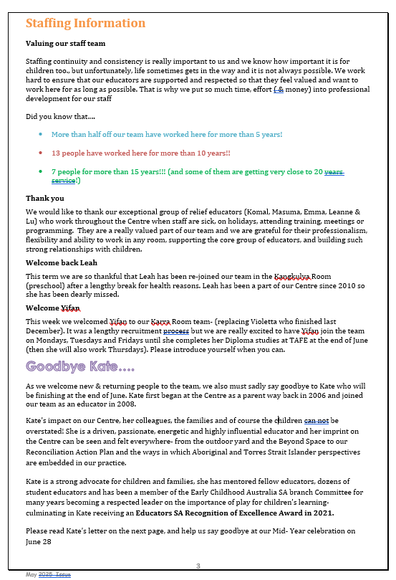

Summary of strengths in practice where there is evidence of Exceeding NQS themes
Notes:
- This Exceeding NQS section is to be completed when there is evidence of one or more of the Exceeding NQS themes demonstrated in the practice at your service.
- Additional information about the Exceeding NQS themes is available on ACECQA’s Exceeding the NQS webpage.
Standard 4.2 – Professionalism: Management, educators and staff are collaborative, respectful and ethical.
Exceeding themes
1. Practice is embedded in service operations | [If you have identified strengths in this area, describe how your practices are embedded in service operations for this Standard]
2. Practice is informed by critical reflection | 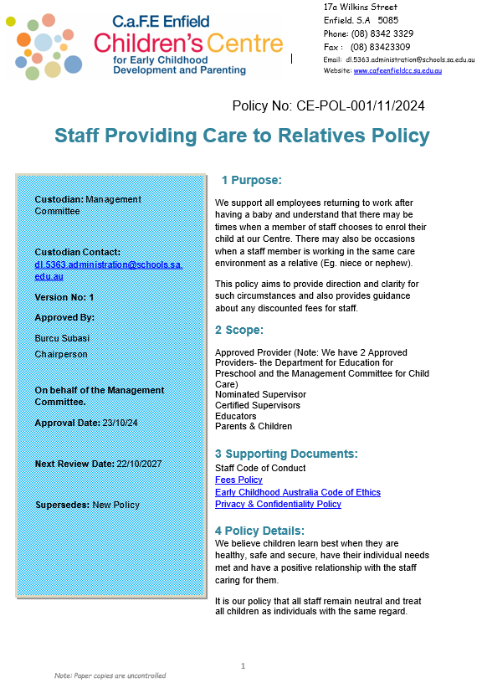  [If you have identified strengths in this area, describe how your services practices in this Standard, have been informed by critical reflection.]  Leadership listened to staff feedback regarding staff members who had young relations attending the site and a Policy was co-created and then presented to the Management committee. Leadership also recognised that there was likely to be staff having babies soon and the timing of such a policy would be beneficial for all to reference.
3. Practice is shaped by meaningful engagement with families, and/or community | [If you have identified strengths in this area, describe how your services practices in this Standard, have been shaped by meaningful engagement with families, and/or community]

Quality Area 5: Relationships with children

This quality area of the National Quality Standard focuses on relationships with children being responsive, respectful and promoting children’s sense of security and belonging. Relationships of this kind free children to explore the environment and engage in play and learning.

Additional information and resources about Quality Area 5 are available in the Guide to the National Quality Framework and on the ACECQA website.
Quality Area 5: Standards and elements
Standard 5.1 | Respectful and equitable relationships are maintained with each child.
Positive educator to child interactions | Element 5.1.1 | Responsive and meaningful interactions build trusting relationships which engage and support each child to feel secure, confident and included
Dignity and rights of the child | Element 5.1.2 | The dignity and the rights of every child are maintained.
Standard 5.2 | Each child is supported to build and maintain sensitive and responsive relationships.
Collaborative learning | Element 5.2.1 | Children are supported to collaborate, learn from and help each other.
Self-regulation | Element 5.2.2 | Each child is supported to regulate their own behaviour, respond appropriately to the behaviour of others and communicate effectively to resolve conflicts.

National Law and National Regulations underpinning Quality Area 5
The table below shows the sections of the National Law and National Regulations underpinning Quality Area 5 and lists the most relevant element of the NQS associated with each section and regulation. Please note that this table serves as a guide only and regulatory authorities have flexibility in how they assign non-compliance with the National Law and National Regulations against the quality areas, standards and elements of the NQS.
National Law and National Regulations |  | Associated element
Section 166 | Offence to use inappropriate discipline | 5.1.1, 5.1.2, 5.2.2
Regulation 155 | Interactions with children | 5.1.1, 5.1.2, 5.2.2
Regulation 156 | Relationships in groups | 5.2.2

Quality Improvement Plan for Quality Area 5
Summary of strengths for Quality Area 5
Strengths
  Our Staff team includes an on-site Occupational Therapist (OT) who works with all Educators to review programs to ensure that all children are supported in their sensory and emotional regulation. The OT works with individual Educators as well as teams to facilitate deeper learning and understanding. Programs such as 'Traffic Jam in the brain' has been presented to all Educators with opportunity to work as a study group to unpack the information and explore how this could be used in day-to-day practice. Ongoing sessions with the OT leading are programmed for Educators to revisit and refresh. Programs such as Marte Meo and Circle of Security give common language, pedagogical framework and consistency for every child and family across the service.
  The Circle of Security training is delivered on-site to parents, and to educators. The Circle of Security promotes the establishment of a secure attachment relationships between the caregiver and the child. This training is available for all Educators and high priority is given to providing training for new staff when they join our team.
  The Marte Meo method focuses on the importance of communication in building relationships and emotional connections between educators and children. It also provides educators with a reflective pedagogy for supporting children to develop cooperative behaviour and relationships with their peers through everyday interactions.
  Respect-Reflect-Relate (RRR)- Educators use the RRR relationship scale to support quality relationships with children. The scale supports educators to understand theories and research that underpin relationships and reflect on the educator’s role in building quality supportive relationships.
  Click or tap here to enter text.

Summary of strengths in practice where there is evidence of Exceeding NQS themes
Notes:
- This Exceeding NQS section is to be completed when there is evidence of one or more of the Exceeding NQS themes demonstrated in the practice at your service.
- Additional information about the Exceeding NQS themes is available on ACECQA’s Exceeding the NQS webpage.

Standard 5.1 – Relationships between educators and children: Respectful and equitable relationships are maintained with each child.
Exceeding themes
1. Practice is embedded in service operations | [If you have identified strengths in this area, describe how your practices are embedded in service operations for this Standard]
2. Practice is informed by critical reflection | [If you have identified strengths in this area, describe how your services practices in this Standard, have been informed by critical reflection.]
3. Practice is shaped by meaningful engagement with families, and/or community | [If you have identified strengths in this area, describe how your services practices in this Standard, have been shaped by meaningful engagement with families, and/or community]

Summary of strengths in practice where there is evidence of Exceeding NQS themes
Notes:
- This Exceeding NQS section is to be completed when there is evidence of one or more of the Exceeding NQS themes demonstrated in the practice at your service.
- Additional information about the Exceeding NQS themes is available on ACECQA’s Exceeding the NQS webpage.

Standard 5.2 – Relationships between children: Each child is supported to build and maintain sensitive and responsive relationships.
Exceeding themes
1. Practice is embedded in service operations | [If you have identified strengths in this area, describe how your practices are embedded in service operations for this Standard]
2. Practice is informed by critical reflection | [If you have identified strengths in this area, describe how your services practices in this Standard, have been informed by critical reflection.]
3. Practice is shaped by meaningful engagement with families, and/or community | [If you have identified strengths in this area, describe how your services practices in this Standard, have been shaped by meaningful engagement with families, and/or community]

Quality Area 6: Collaborative partnerships with families and communities

This quality area of the National Quality Standard focuses on collaborative relationships with families that are fundamental to achieving quality outcomes for children and community partnerships that are based on active communication, consultation and collaboration.

Additional information and resources about Quality Area 6 are available in the Guide to the National Quality Framework and on the ACECQA website.
Quality Area 6: Standards and elements
Standard 6.1 | Respectful relationships with families are developed and maintained and families are supported in their parenting role.
Engagement with the service | Element 6.1.1 | Families are supported from enrolment to be involved in the service and contribute to service decisions.
Parent views are respected | Element 6.1.2 | The expertise, culture, values, beliefs of families are respected and families share in decision-making about their child’s learning and wellbeing.
Families are supported | Element 6.1.3 | Current information is available to families about the service and relevant community services and resources to support parenting and family wellbeing.
Standard 6.2 | Collaborative partnerships enhance children’s inclusion, learning and wellbeing.
Transitions | Element 6.2.1 | Continuity of learning and transitions for each child are supported by sharing relevant information and clarifying responsibilities.
Access and participation | Element 6.2.2 | Effective partnerships support children’s access, inclusion and participation in the program.
Community engagement | Element 6.2.3 | The service builds relationships and engages with its community.

National Law and National Regulations underpinning Quality Area 6
The table below shows the sections of the National Law and National Regulations underpinning Quality Area 6 and lists the most relevant element of the NQS associated with each section and regulation. Please note that this table serves as a guide only and regulatory authorities have flexibility in how they assign non-compliance with the National Law and National Regulations against the quality areas, standards and elements of the NQS.
National Law and National Regulations |  | Associated element
Section 175 | Offence relating to requirement to keep enrolment and other documents | 6.1.3, 6.2.1
Regulation 157 | Access for parents | 6.1.1

Quality Improvement Plan for Quality Area 6
Summary of strengths for Quality Area 6
Strengths | Supportive relationships with Families  Many avenues are taken to encourage the participation of families at the centre.  - Families contribute to site decisions and their ideas are actively sought through representation on the Centre Management Committee and conversation during parenting groups.  - parents have an active and critical role in all aspects of the Centre including policy development & review, Philosophy review, setting the budget & fees, recruitment of childcare staff.  - We host a range of site Community Events for example, Movie night on the school oval, obstacle-a-thon, play events in the Beyond Space - where parents and staff come together to facilitate and organise the event.  Some of the groups and parenting sessions we offer include.  - Saturday morning playgroups for Dads, Community playgroups, baby playgroups  - First Aid for parents,  - Toilet Learning,  - How do I support my child's language in a Bilingual home  · Centre information is available via Leaflets, Newsletters, Displays, Parent Meetings, and one to one conversations with families and on centre the website - www.cafeenfieldcc.sa.edu.au  · Transitions are tailored to each child and their family. This applies to both initial transition to the centre, transitions between rooms, and when starting school. Transition playgroups (including a bilingual transition playgroup) help to build connections between families as well as with educators prior to the child starting.  - Questionnaires are distributed to families to gather information for improvement  - Families and Community Members are encouraged to share aspects of their home cultures through cooking, dance, stories, music and language.  Collaborative partnerships  · Professionals across the service work with agencies such as Inclusion Support Agency, Uniting Care Wesley Bowden, Relationships Australia Occupational Therapy, Speech Therapist, .  · We work closely with Child and Family Health Services, Learning Together who are co-located on site.  · Centre has a Strategic Inclusion Plan in place a to support the inclusion of all children within environment  · We utilize AEDC and Community Profile data to build understanding of our local community and inform planning.  - Educators undertake Cultural Competence PD with a particular focus on Aboriginal and Torres Strait Islander Cultures and perspectives. The Centre is actively working on a Reconciliation Action Plan.

Summary of strengths in practice where there is evidence of Exceeding NQS themes
Notes:
- This Exceeding NQS section is to be completed when there is evidence of one or more of the Exceeding NQS themes demonstrated in the practice at your service.
- Additional information about the Exceeding NQS themes is available on ACECQA’s Exceeding the NQS webpage.
Standard 6.1 – Supportive relationships with families: Respectful relationships with families are developed and maintained and families are supported in their parenting role.
Exceeding themes
1. Practice is embedded in service operations | [If you have identified strengths in this area, describe how your practices are embedded in service operations for this Standard]
2. Practice is informed by critical reflection | [If you have identified strengths in this area, describe how your services practices in this Standard, have been informed by critical reflection.]  ***In the 2024 Preschool Parent survey. Parents wanted more opportunities to engage in their child’s Kindy program. Since Term 4, 2024. Kindergarten have been implementing termly Family Day’s. (Appendix : Invite to families and photos of attendance)  Parent sign in sheet is in the office- add how many families attended as it was a wonderful turn out.  Add comment A’s dad shared:  23/9/25  Summarised: Everytime I drop A off I wonder what he does and wish I could see it. And then we got this invitation and I was so happy. He doesn’t talk a lot at home due to speech delays but is starting to talk a lot more and now I get to see what he is talking about.  The Kangkulya Team invites you to:  ‘Family Day’ at Preschool!  Last year the Preschool children came up with the idea to host a ‘Family Day’ at Preschool. Through their group time discussions, they came up with the idea of asking a special family member to join them for a morning at kindy. It was such a great success, we have decided to implement it again this year!  Come and play for an hour and see your child engage in our everyday learning experiences!  When: 10am – 11am  Group A – Tuesday 23rd September  Group B – Friday 26th September  Where – C.a.F.E. Enfield Children’s Centre – Kangkulya Room (Preschool Room)  Please RSVP via email or tell us in person by Friday 19th September, if you are attending.  We look forward to seeing you!
3. Practice is shaped by meaningful engagement with families, and/or community | [If you have identified strengths in this area, describe how your services practices in this Standard, have been shaped by meaningful engagement with families, and/or community]
Summary of strengths in practice where there is evidence of Exceeding NQS themes
Notes:
- This Exceeding NQS section is to be completed when there is evidence of one or more of the Exceeding NQS themes demonstrated in the practice at your service.
- Additional information about the Exceeding NQS themes is available on ACECQA’s Exceeding the NQS webpage.

Standard 6.2 – Collaborative partnerships: Collaborative partnerships enhance children’s inclusion, learning and wellbeing.
Exceeding themes
1. Practice is embedded in service operations | [If you have identified strengths in this area, describe how your practices are embedded in service operations for this Standard]  Term 4 week 2 2025 pyjama day site wide, led by KK with support of Jill. PJ Day is run through the Pyjama Day foundation which raises money for children in foster care. This is a charity close to us as a centre and we hold it bi-annually. This term we are furthering the learning for the children around empathy and giving to those in need and working with a community organisation recommended by Jill:Treasure Boxes. Families and staff are encouraged to donate second hand pyjamas (still in good quality) as part of our PJ Day. This organisation works with families needing support during complex housing crises.
2. Practice is informed by critical reflection | [If you have identified strengths in this area, describe how your services practices in this Standard, have been informed by critical reflection.]
3. Practice is shaped by meaningful engagement with families, and/or community | Multi-cultural Women's group was implemented as a response to the number of Multi-cultural families in our community and lack of support networks often resulting in social isolation. The focus of the group has changed over time to meet the changing needs of the group. In co-planning with the Women there is a particular focus on the voice of the child and making sure they have timely access to formalised early education and care. Various levels of support to facilitate the enrolments into either childcare or preschool is provided. This might also include referrals to non-government agencies supporting families with more extensive support should they require it.  Allied Health is often provided in the form of Speech Pathology to ensure families have recent evidence-based information in supporting the acquisition of Multiple languages and the maintenance of home language.  A current example of this is:- A child enrolled in pre-school by their family who commenced at the centre.  - No prior history was known as the parent.  - Three transition visits were offered in the term preceding full-time preschool were offered.  - Child did not attend these transition visits.  - First day at preschool for the child was challenging, with the child being distressed by the separation.  - Educators were informed by parent that the child required nappies and bottles to meet their needs.  - The Educator engaged the CDC to assess whether we could offer more support for the family.  - The CDC organised a face to face meeting with the parent to offer some extra support, including the opportunity to join the Multi-cultural Women's group.  - In discussion with the parent we also identified that the parent had other children including a school age child and a toddler.  - CDC plans to continue to build on the relationship with the family including exploring the needs of the toddler.  - In the process of identifying the needs of this parent and child both the Educator and CDC felt that Circle of Security Parenting program, maybe of assistance in supporting this child.  - In discussion with the Kindy Educators other families could benefit from the Circle of Security program.  - Following this discussion the CDC contacted Relationships Australia to engage them in the delivery of Circle of Security in term 2.

Quality Area 7: Governance and Leadership

This quality area of the National Quality Standard focuses on effective leadership and governance of the service to establish and maintain quality
environments for children’s learning and development. Effective leaders establish shared values for the service that reflect the service context and
professionalism and set clear direction for the service’s continuous improvement. Governance refers to the systems in place to support effective
management and operation of the service, consistent with the service’s statement of philosophy.

Additional information and resources about Quality Area 7 are available in the Guide to the National Quality Framework and on the ACECQA website.
Quality Area 7: Standards and elements
Standard 7.1 | Governance supports the operation of a quality service.
Service philosophy and purpose | Element 7.1.1 | A statement of philosophy is developed and guides all aspects of the service’s operations.
Management systems | Element 7.1.2 | Systems are in place to manage risk and enable the effective management and operation of a quality service.
Roles and responsibilities | Element 7.1.3 | Roles and responsibilities are clearly defined, and understood, and support effective decision-making and operation of the service.
Standard 7.2 | Effective leadership build and promotes a positive organisational culture and professional learning community.
Continuous improvement | Element 7.2.1 | There is an effective self-assessment and quality improvement process in place.
Educational leadership | Element 7.2.2 | The educational leader is supported and leads the development and implementation of the educational program and assessment and planning cycle.
Development of professionals | Element 7.2.3 | Educators, co-ordinators and staff members’ performance is regularly evaluated and individual plans are in place to support learning and development.

National Law and National Regulations underpinning Quality Area 7
The table below shows the sections of the National Law and National Regulations underpinning Quality Area 7 and lists the most relevant element of the NQS associated with each section and regulation. Please note that this table serves as a guide only and regulatory authorities have flexibility in how they assign non-compliance with the National Law and National Regulations against the quality areas, standards and elements of the NQS.
National Law and National Regulations |  | Associated element
Section 21 | Reassessment of fitness and propriety (provider approvals) | 7.1.2
Section 56 | Notice of addition of nominated supervisor | 7.1.2
Section 56A | Notice of change of a nominated supervisor's name or contact details | 7.1.2
Section 161 | Offence to operate education and care service without nominated supervisor | 7.1.2
Section 161A | Offence for nominated supervisor not to meet prescribed minimum requirements | 7.1.2
Section 162 | Offence to operate education and care service unless responsible person is present | 7.1.2
Section 162A | Persons in day-to-day charge, nominated supervisors and family day care co-ordinators to have child protection training | 7.1.2
Section 163 | Offence relating to appointment or engagement of family day care co-ordinators | 7.1.2, 7.1.3
Section 164 | Offence relating to assistance to family day care educators | 7.1.2
Section 164A | Offence relating to the education and care of children by family day care service | 7.1.2, 7.1.3
Section 165 | Offence to inadequately supervise children | 7.1.2
Section 166 | Offence to use inappropriate discipline | 7.1.2
National Law and National Regulations |  | Associated element
Section 167 | Offence relating to protection of children from harm and hazards | 7.1.2
Section 168 | Offence relating to required programs | 7.1.2
Section 169 | Offence relating to staffing arrangements | 7.1.2
Section 170 | Offence relating to unauthorised persons on education and care service premises | 7.1.2
Section 171 | Offence relating to direction to exclude inappropriate persons from education and care service premises | 7.1.2
Section 172 | Offence to fail to display prescribed information | 7.1.2
Section 173 | Offence to fail to notify certain circumstances to regulatory authority | 7.1.2
Section 174 | Offence to fail to notify certain information to regulatory authority | 7.1.2
Section 174A | Family day care educator to notify certain information to approved provider | 7.1.2, 7.1.3
Section 175 | Offence relating to requirement to keep enrolment and other documents | 7.1.2
Section 188 | Offence to engage person to whom prohibition notice applies | 7.1.2
Section 269 | Register of family day care educators, co-ordinators and assistants | 7.1.2
Regulation 31 | Condition on service approval-quality improvement plan | 7.2.1
Regulation 55 | Quality improvement plans | 7.2.1
Regulation 56 | Review and revision of quality improvement plans | 7.2.1
Regulation 158 | Children’s attendance record to be kept by approved provider | 7.1.2
Regulation 159 | Children’s attendance record to be kept by family day care educator | 7.1.2
National Law and National Regulations |  | Associated element
Regulation 160 | Child enrolment records to be kept by approved provider and family day care educator | 7.1.2
Regulation 161 | Authorisations to be kept in enrolment record | 7.1.2
Regulation 162 | Health information to be kept in enrolment record | 7.1.2
Regulation 163 | Residents at family day care residence and family day care educator assistants to be fit and proper persons | 7.1.2
Regulation 164 | Requirement for notice in relation to persons at residence | 7.1.2
Regulation 165 | Record of visitors | 7.1.2
Regulation 166 | Children not to be alone with visitors | 7.1.2
Regulation 167 | Record of service’s compliance | 7.1.2
Regulation 168 | Education and care service must have policies and procedures | 7.1.2
Regulation 169 | Additional policies and procedures—family day care service | 7.1.2
Regulation 170 | Policies and procedures to be followed | 7.1.2
Regulation 171 | Policies and procedures to be kept available | 7.1.2
Regulation 172 | Notification of change to policies or procedures | 7.1.2
Regulation 173 | Prescribed information to be displayed—education and care service other than a family day care service | 7.1.2
Regulation 173A | Prescribed information to be displayed—family day care service | 7.1.2
Regulation 174 | Time to notify certain circumstances to regulatory authority | 7.1.2
Regulation 174A | Prescribed information to be notified to accompany notice | 7.1.2
Regulation 175 | Prescribed information to be notified to regulatory authority | 7.1.2
National Law and National Regulations |  | Associated element
Regulation 176 | Time to notify certain information to regulatory authority | 7.1.2
Regulation 176A | Prescribed information to be notified to approved provider by family day care educator | 7.1.2
Regulation 177 | Prescribed enrolment and other documents to be kept by approved provider | 7.1.2
Regulation 178 | Prescribed enrolment and other documents to be kept by family day care educator | 7.1.2
Regulation 179 | Family day care educator to provide documents on leaving service | 7.1.2
Regulation 180 | Evidence of prescribed insurance | 7.1.2
Regulation 181 | Confidentiality of records kept by approved provider | 7.1.2
Regulation 182 | Confidentiality of records kept by family day care educator | 7.1.2
Regulation 183 | Storage of records and other documents | 7.1.2
Regulation 184 | Storage of records after service approval transferred | 7.1.2
Regulation 185 | Law and regulations to be available | 7.1.2
Regulation 344  Tasmania | Working with vulnerable people registration – staff members | 7.1.2
Regulation 358  Victoria | Working with children check to be read | 7.1.2
Regulation 359  Victoria | Criminal history record check to be read and considered | 7.1.2
Quality Improvement Plan for Quality Area 7
Summary of strengths for Quality Area 7
Strengths | Management Committee and Leaders work together to explore ways to maximise retention ad continuity of staff in order to support and maintain secure relationships with children- currently the average length of service is 7 years. During COVID the Management Committee recognised the strain and expectation that was being placed on educators as essential workers, so they granted all contracted educators 2 weeks (equivalent to employment) additional COVID sick leave to assist educators needing to isolate.  - Each year the Management Committee approves centre closure days for whole of staff Professional Development. The main benefit of these days is that the entire staff team come together to jointly engage in critical reflection & review of our Philosophy & purpose, our pedagogy & practice, our QIP and the NQS. These days form a significant part of our self-assessment process and continuous improvement as they allow us to clarify our understanding and thinking and to plan for the future.  Each staff member receives a comprehensive induction which includes an initial induction meeting with the Assistant Director; a staff induction pack; a short, paid familiarisation shift (where they are an extra educator); ongoing induction over several weeks into room practices and routines supported by Team leaders and experienced educators; regular informal conversations with the Director/Assistant Director to support the transition into the team.  - Educators are supported to take an active role in the wider ECEC sector in order to further their own professionalism and leadership as they advocate for children and for ECEC more broadly. Through this work our educators are not only informed about what is happening in the broader ECEC context but are actively contributing and shaping that context. The learning and experience gained by educators in these forums supports the development of leadership and enables educators to be stronger advocates for children and families within our service also. An example of the Committees that our educators are active on include Early Childhood Australia (ECA) SA branch, Australian Community Children's Services SA Branch (ACCS), Play Australia. As a service we also actively participate at or contribute submissions to a range of Government inquiries such as the SA Royal Commission into 3-year-old preschool; State discussion into the purpose of Public education; Dept for Education Industry Stakeholders group.  - Regular surveys are conducted to gather information and feedback to inform the soul of the program. Many voices are valued as a collective to truly represent our community. These include orientation evaluations from families, client opinion surveys, staff psychosocial risk surveys.  - Grievances and complaints are actively addressed, investigated fairly, resolved and documented in a timely manner. They are reviewed to look for further areas of improvement.  -The Centre leadership team meets regularly as a Reflective Practice Group to reflect on community engagement, discuss research and data, raise issues & question aspects of practice as part of a commitment to continuous improvement and better engagement with our local community. The leadership team is also meets with other services on our site (Enfield Primary School, CaFHS, Learning Together Communities) as a Local Governance group to share aspects and insights from our individual services, and work collaboratively towards improving outcomes for all children and families across our site.  - Comprehensive administrative systems are in place to enable effective management of the service. There is a schedule for review of policies and procedures, and parents are informed of policies under review and invited to contribute via notifications and links in newsletters. Policies, Information books, Annual Reports and QIP are available on our website. Educators and Management Committee members actively contribute to the review process.

Summary of strengths in practice where there is evidence of Exceeding NQS themes
Notes:
- This Exceeding NQS section is to be completed when there is evidence of one or more of the Exceeding NQS themes demonstrated in the practice at your service.
- Additional information about the Exceeding NQS themes is available on ACECQA’s Exceeding the NQS webpage.
Standard 7.1 – Governance: Governance supports the operation of a quality service.
Exceeding themes
1. Practice is embedded in service operations | [If you have identified strengths in this area, describe how your practices are embedded in service operations for this Standard]
2. Practice is informed by critical reflection | [If you have identified strengths in this area, describe how your services practices in this Standard, have been informed by critical reflection.]
3. Practice is shaped by meaningful engagement with families, and/or community | [If you have identified strengths in this area, describe how your services practices in this Standard, have been shaped by meaningful engagement with families, and/or community]

Summary of strengths in practice where there is evidence of Exceeding NQS themes
Notes:
- This Exceeding NQS section is to be completed when there is evidence of one or more of the Exceeding NQS themes demonstrated in the practice at your service.
- Additional information about the Exceeding NQS themes is available on ACECQA’s Exceeding the NQS webpage.
Standard 7.2 – Leadership: Effective leadership builds and promotes a positive organisational culture and professional learning community.
Exceeding themes
1. Practice is embedded in service operations | [If you have identified strengths in this area, describe how your practices are embedded in service operations for this Standard]
2. Practice is informed by critical reflection | [If you have identified strengths in this area, describe how your services practices in this Standard, have been informed by critical reflection.]
3. Practice is shaped by meaningful engagement with families, and/or community | [If you have identified strengths in this area, describe how your services practices in this Standard, have been shaped by meaningful engagement with families, and/or community]

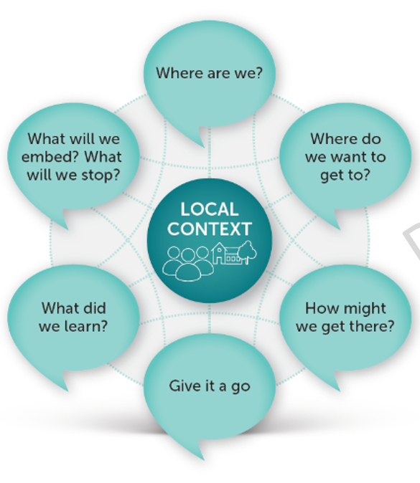
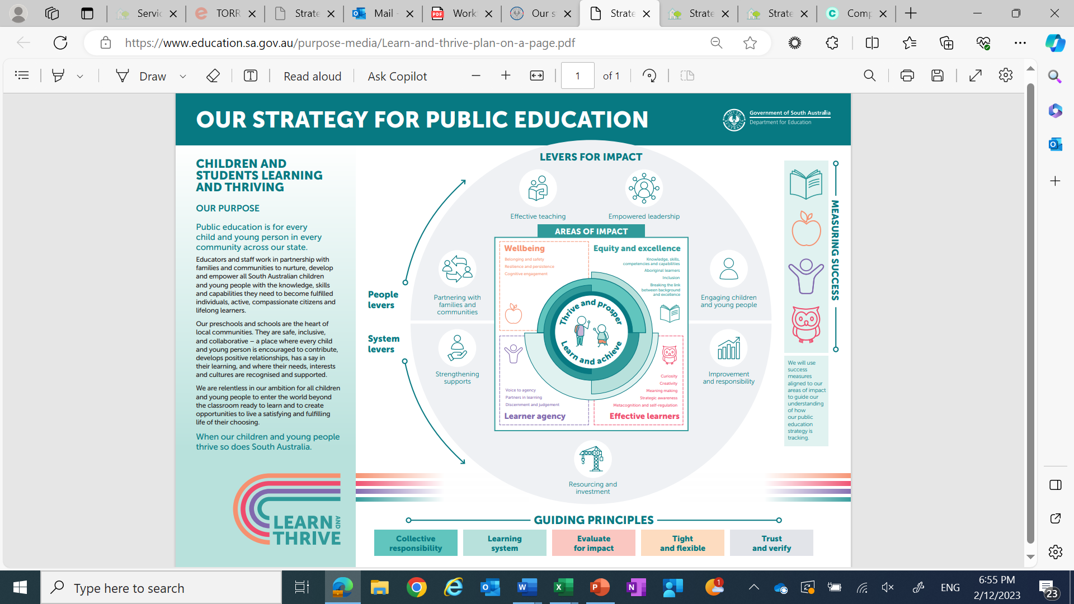

Where are we?
The Area of Impact that will boost current practices and outcomes at
C.a.F.E Enfield Children’s Centre– Wellbeing
Source: Improvement as Learning Guide

During self-assessment at the end of 2024, we as a staff team, identified that we were still being challenged to effectively embed sustained, shared thinking strategies and documentation for all children into our program/curriculum. Engaging in numerous reflective meetings, we analysed what factors might be inhibiting this? The key pattern that emerged from this discussion was that due to the uniqueness of our context (children’s varying backgrounds and needs), we as educators were not implementing sufficient inclusive practices and communication strategies which was inhibiting ESL children from accessing rich learning opportunities. The main protagonist being wellbeing. We had noticed a high rate of dysregulation patterns in the kindergarten setting, through our group times and within play. The team intentionally carried out an inquiry around Regulation to support children being able to recognise what zone they were in and then provided them with strategies to get back into the green zone for engaging their agency for learning. Which brought us to the question, should our Area of Impact focus be wellbeing. For all children to be agent they have to be regulated and once regulated they will be agent in their play. We wondered… what could our program offer to support and uplift all children, shifting their wellbeing to effectively engage and be agentic in the learning program and then successfully articulate their thinking.
OUR 2025 QIP GOAL: Develop a strong culturally responsive and inclusive environment whereby all children’s 100 languages are acknowledged uplifting their agency to confidently engage in the learning.
Challenge of Practice: Educators intentionally implementing inclusive practices, sustained shared thinking and thought provoking provocations, educators will stretch and challenge children’s engagement in the learning.
Success Criteria: Within the analysis of the Ped Doc we will see all children being agent using their 100 languages, to communicate their wonderings, theories or ideas.
Where do we want to get to?
What we want to continue to build on:
- Developing educator capacity around Sustained shared thinking.
- PD for new staff: Marte Meo, Responsive Relationships Training
- Videoing and reflecting on our Practice (alongside Jo O’Callaghan)
- Developing knowledge of consistent scaffolds and strategies to support children's social and emotional regulation
- Whole site Professional Development on Interoception. Understanding and proactively Responding to A child’s Sensory Engine.DfE Inc Ed: Nicolle Stephanos
- Sensory and regulation profiling training through Partnership a Professional Learning Day on 12 September (Pupil Free day)
Collectively what we would like to achieve:
- Engaging families as partners in supporting children’s developing wellbeing and ability to regulate. Element 6.1 & 6.1.2
- Families have access to workshops (eg supporting your Bilingual child),are surveyed for input regarding decision making processes and invited for informal and formal conversations with educators.
- Music Education Strategy 2019 to 2029 ‘Music exists in every culture and is a fundamental form of human expression. It is a vehicle to connect and celebrate the diversity within our site, recognising and embracing children and young people of all cultures, experiences and abilities. Collaborate with Christine Narroway to build capacity in educators knowledge and understanding of the benefits of music in children’s lives.
- Staff attend other Music Strategy PD. Decoding the Dots (Yilu and Elli) and twilight workshops.
- Continue to work alongside community to create inclusive & meaningful Reconciliation Action Plan
- Continue to work on Strategic Inclusion Plan with the whole site team. Whole site closure days 24th Jan and 7th March. Including PD by Leisl Von Der Birch from ‘Walking together with Kaurna’.

Outcomes:
We aim to provide an opportunity to deeply understand the starting points and learning needs of all learners and how we can design learning experiences that respond to this – where practice is most effective when it is embedded, informed, and shaped by NQS and the EYLF practices and principles (by utilising Collective Responsibility).
- Learners can trust at least one adult
- Learners are safe, included and welcomed
- Learners are listened to
- Learner’s culture and identity is recognised positively
- Learners can navigate day-to-day-challenges
- Learners feel and know how to be successful
- Learners are adaptable because they have access to tools, resources and support
- Learners are supported to have a go and persevere with new and complex learning
- Learners feel safe so they can open their minds to learning
- Learners can manage distractions to focus on learning
- Learners can focus on learning because they don’t feel overwhelmed

Outcome 1: pg. 30 children have a strong sense of identity
Outcome 3: pg. 44 children have a strong sense of wellbeing
- Outcome 4: pg.50 children are confident and involved learners.
Element: 2.1.1: Wellbeing and Comfort Element and 6.1 Supportive
- Element: 2.1.1: Wellbeing and Comfort Element and 6.1 Supportive relationships with families and 6.1.2 The expertise, culture, values and beliefs of families are respected and families share in decision making about their child’s learning and wellbeing.

National Quality Standards – Key Improvements as Learning to Develop a strong culturally responsive and inclusive environment whereby all children’s 100 languages are acknowledged uplifting their agency to confidently engage in the learning.

Goals – Where do we want to get to? | NQS links | How might we get there?  Leavers for Impact | Timeline  (by when)  Roles & Responsibilities | Resources to give it a go
Continue to collaborate on Strategic Inclusive Plan. (Gowrie SIP) |  | Week O: Set up Lucky dip Provocation. Staff celebrate events and holidays from various cultures represented through their practice. (set up provocation in environment or intentionally play a cultural game alongside children.  Co -create a CaFE Context resource tool. Tool to acknowledge all staff background, languages and strengths.  Community events with families to involve acknowledging their diversity. Harmony day.
Genuine commitment to embed, respect and be culturally responsive in and of multiple ways of knowing, doing and being, celebrating Aboriginal and Torres Strait Islander perspectives into our Reconciliation Action Plan |  | Seek family input for what they would like to see in the Reconciliation Garden.  - Liaise with community and council organisations where possible.  - Involve the families and communities in the form of working bees.  - Research and seek advise on plants that are perennial, attract native bees and butterflies  – seek elder support to have official opening of the space.  Week O: Build educator Capacity re Kaurna Culture.  Invite Liesl Von Der Birch from Walking Together with Kaurna to deliver PD on Pedagogy of Place.
Educators are able to support all children to regulate and therefore implement their 100 languages to engage in thinking and communicate their learning. |  | PD training Alert Program. Providing staff with understanding of 8 Sensory systems. Strategies for educators to implement to support all children to run their engine in the just right zone so they can engage in the learning.  All Staff to engage their Marte Meo Practices. (Yilu, Ivy, Zahra, Yifan, Masuma Nicole to complete 6 day practitioner course).
Music Education Strategy 2019 to 2029 ‘Music exists in every culture and is a fundamental form of human expression. It is a vehicle to connect and celebrate the diversity within our site, recognising and embracing children and young people of all cultures, experiences and abilities |  | Collaborate with Christine Narroway to build capacity in educators knowledge and understanding of the benefits of music in children’s lives. Connect to supports the wellbeing of children- supports with regulation.  Teachers to attend termly twilight sessions (1hr 15mins) Build capacity.  Staff attend other Music Strategy PD. Decoding the Dots (Yilu and Elli) and twilight workshops.

Progress notes ‘Giving it a go’
Monitoring impact - Are we doing what we said we would do?
Are we improving practice? How effective have our actions been?
Priority | Implementation  (are we doing what we said we would do?)  Enter your overall assessment of progress towards implementing actions for improvement using appropriate font colour |  | Impact for children and families  (Are we improving practice and learning outcomes?)  Enter the evidence of impact of your actions for children and families | Next steps
Priority |  | Kangkulya Kuu
Priority |  | Karra Kuu
Priority |  | Yitpi Tarnanthi Kuu
Priority | Date your notes to ensure you track and monitor adjustments and progress of your plan from 24th Jan onwards.
Continue to collaborate on Strategic Inclusive Plan. (Gowrie SIP) | On a professional development day, the Karra team gathered to brainstorm about the Site Improvement Plan (SIP). We identified the main barriers in the Karra room and planned actions to reduce those barriers. We developed strategies to address limited social skills, including the use of small group activities.  -The YT team identified the main barrier as supporting parents and families views and expectations especially around language development, behaviours and toilet training. To address the barrier, our strategies are meet with families one on one or have regular conversations, setting individual goals for the children, work with advice from other professionals (Tricia, Jill and Jo), asking families for the Ages and Stages Questionnaire and gather family aspirations for their child.  Kangkulya Kuu – (25/2/25)  After attending ‘Pedagogical Documentation Connect Session’ what stood out was sites connecting and networking as a team. Upon reflection the Kangkulya team recognised how that’s been a challenge for us to have these moments and share our ideas and have intentional conversations about ‘What’s happening in the Kangkulya Room’, what are we noticing, what could we explore further, what’s lacking, why and how… |  | Develop a plan for staff members to work collaboratively in small groups.  Create a mind map collaborating these family aspirations to support staff in achieving, meeting the aspirations and planning where to next for our children. This mind map will be an on-going document through the year.  Being vulnerable and highlighting the need for this action, having conversations as to why this is important and how beneficial it would be as a team and the effective outcome it would have to having a shared understanding and communication platform, for us a team and for children’s/families. | In Term 1, we will continue working in small groups daily with all children. Bijal will focus on feelings and the Zones of Regulation. Hetty will explore the book "Handa's Surprise," concentrating on colours, fruits, and vegetables. Yilu will work on the "Alexandria Outing," focusing on numbers, problem-solving skills, and developing language with Karuna language numbers. Deb will focus on sustainability, teaching children about composting and gardening to promote environmental responsibility  In Term 1, we will continue collaborating with the families to meet their expectation through frequent face-to-face meetings, developing the family aspiration mindmap and plans to meet the individual goals, recommending families to do the Age and Stage Questionaire as Jill suggested.  Having a conversation with Rowena and arranging meeting times that accommodates to everyone’s schedule.
Genuine commitment to embed, respect and be culturally responsive in and of multiple ways of knowing, doing and being, celebrating Aboriginal and Torres Strait Islander perspectives into our Reconciliation Action Plan  On 24th February, whole site PD we invited Leisl Von Der Borch from ‘Walking Together with Kaurna’. Leisl discussed Pedagogyof Place and taught us some traditional Aboriginal games.  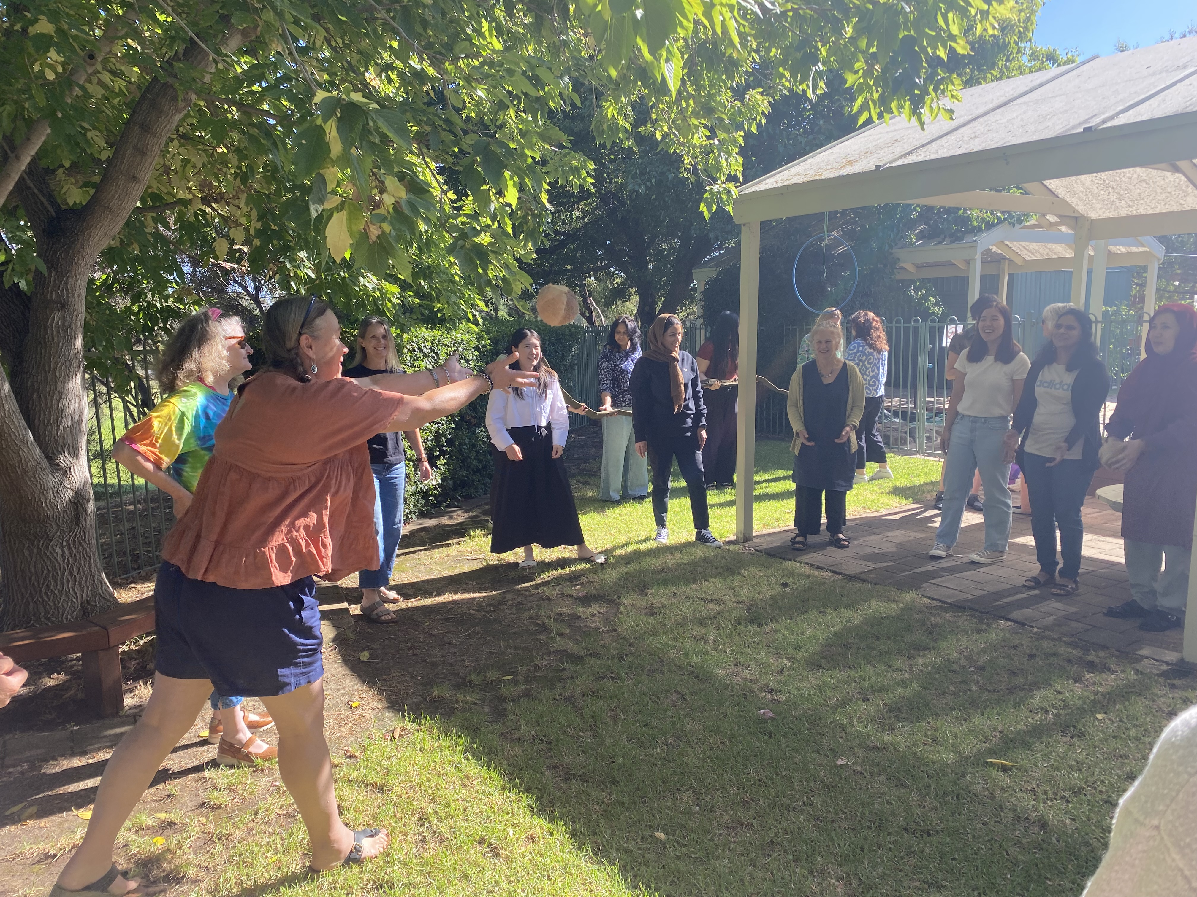  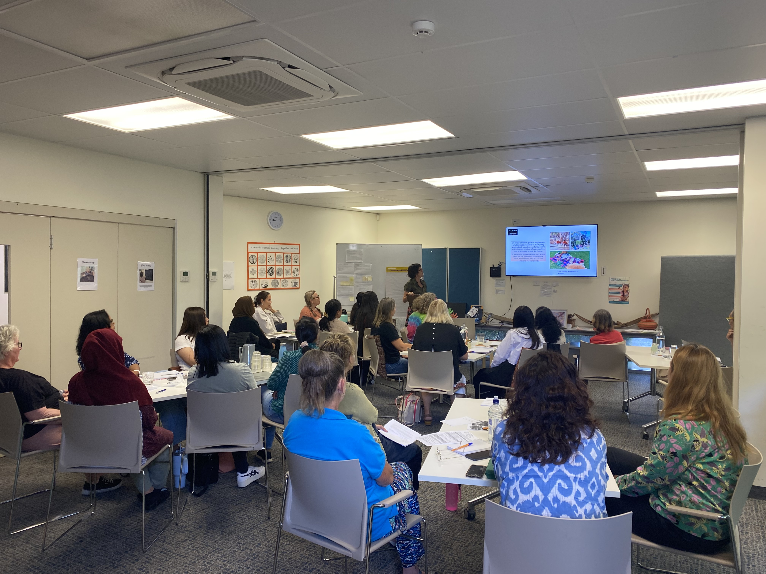  On 7th March, (whole site PD) Staff shared their Acknowledgement of Country in the Beyond Space. Collaboratively they reflected and shared their practice within their rooms and what impact that was having on the children’s learning outcomes.  Ro took recordings on her phone.  Jill our Community Development co-ordinator  Acknowledged in Community space that Feb 13th was the anniversary of National Apology to Stollen Generation and “The Sorry Day” book and a copy of the apology written by Kevin Rudd.  Also in community space February 21 celebrated ‘International Day of mother Languages’. Variety of books in different dialects and provocation in community space in Kaurna language.  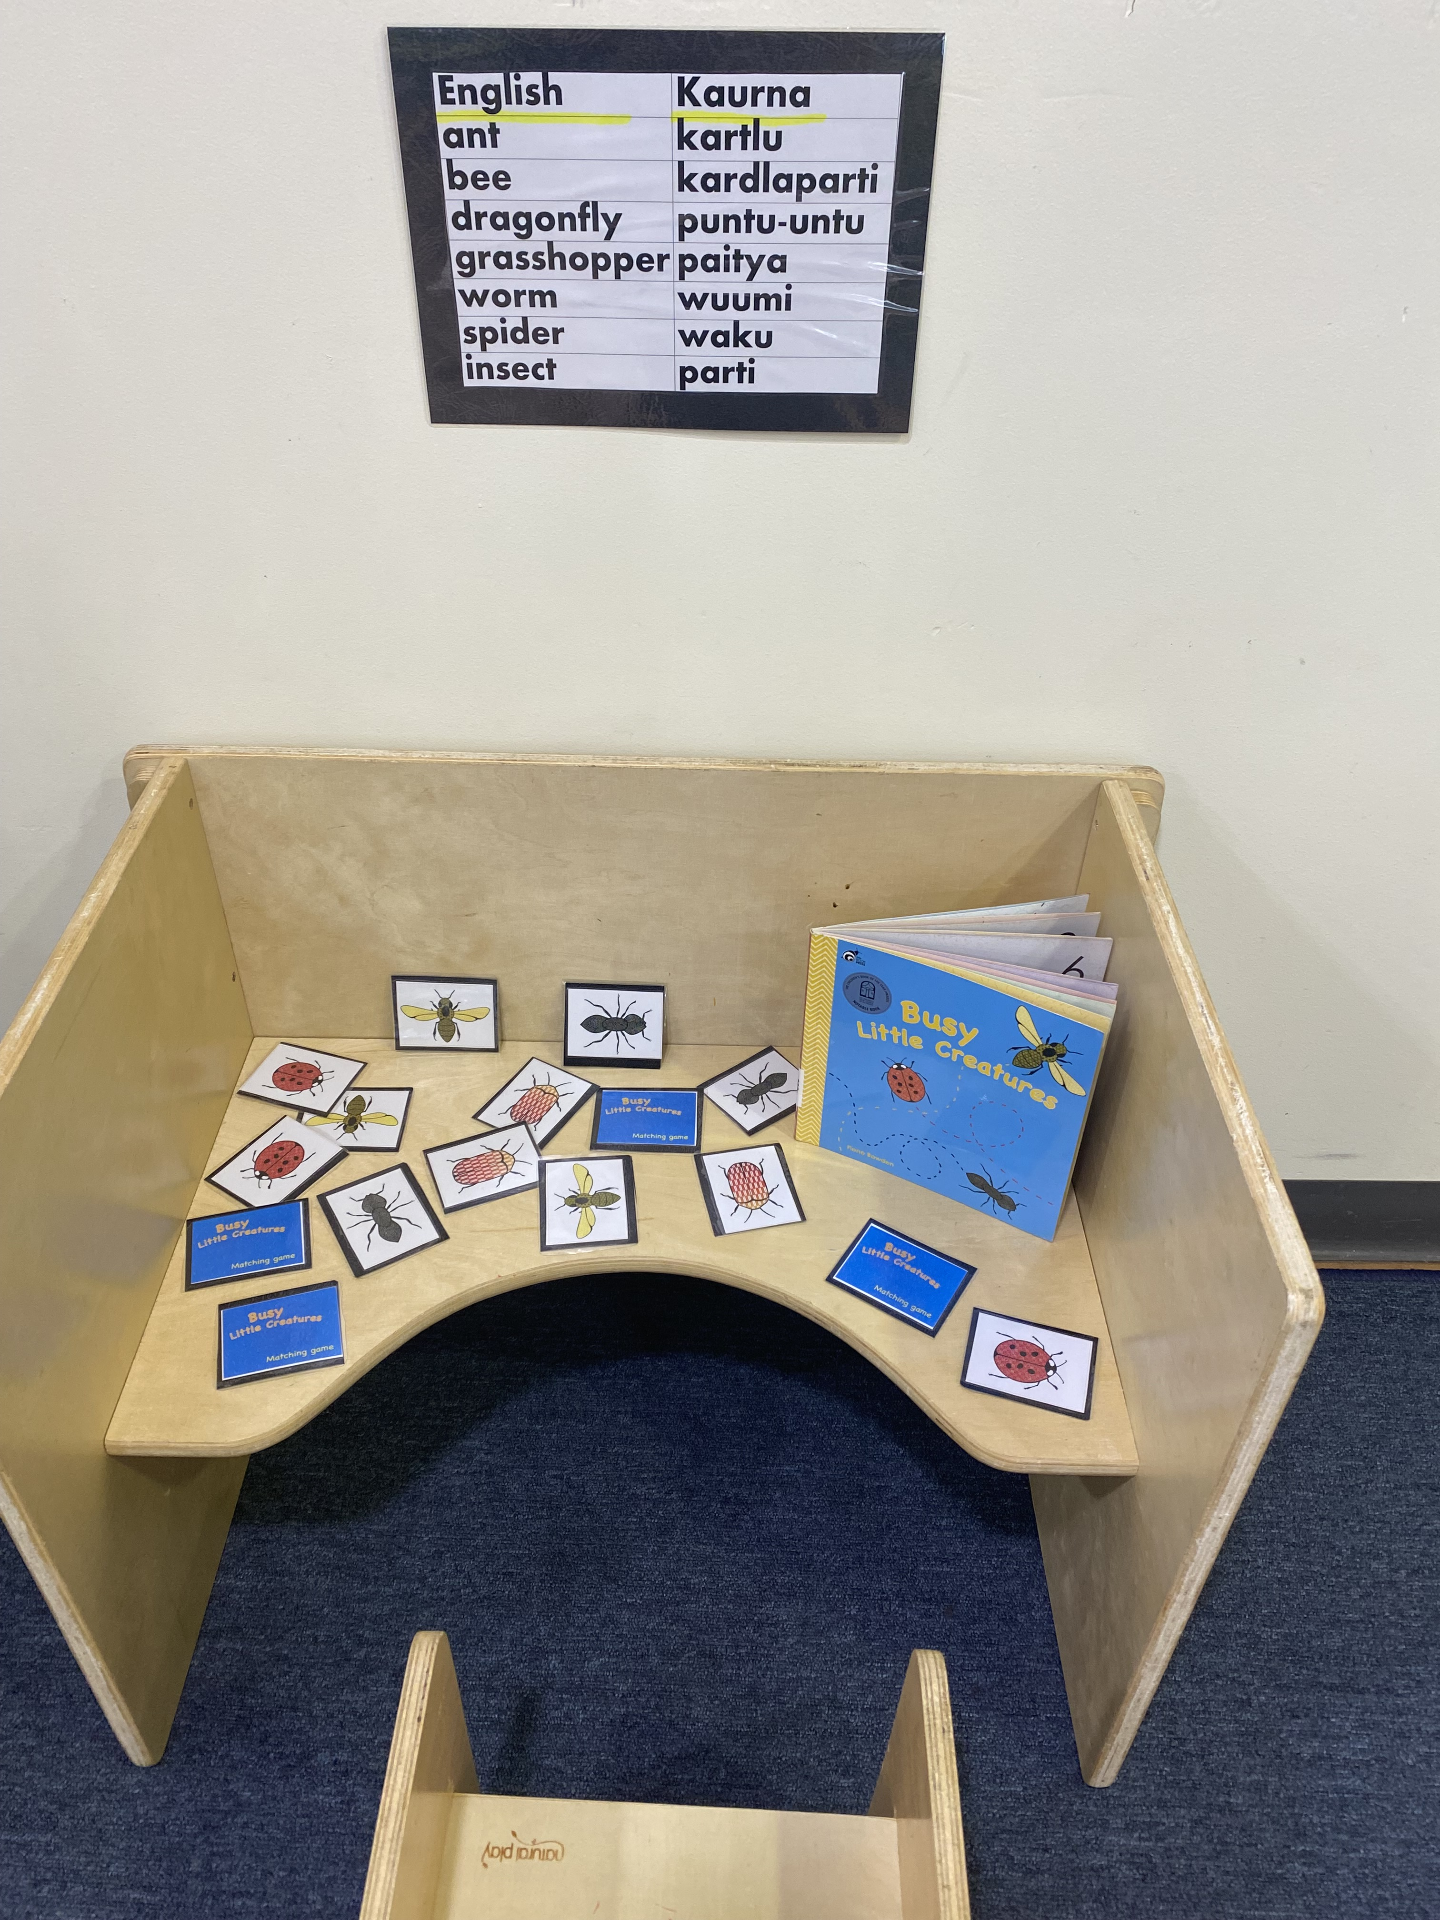 | In Karra kuu, a paper on the board have been displayed near the IPad for parents to write ’Hello and Welcome’ in their home language. Incorporating Aboriginal words into daily language is a wonderful way to honour and celebrate Indigenous culture. Nina Marni (Welcome) Kuu (Room) Using these words in greetings and everyday conversations can help create a more inclusive and culturally aware environment. For enhancing the partnership with families in Term 1, monthly newsletter was sent to parents to inform what has been doing in the room and before Harmony week, a welcome email to parents to let them feel free to wear orange or cultural traditional clothing to celebrate Harmony week.  The photo is the display wall of the culture tree and ‘Welcome’ paper in Karra Kuu.  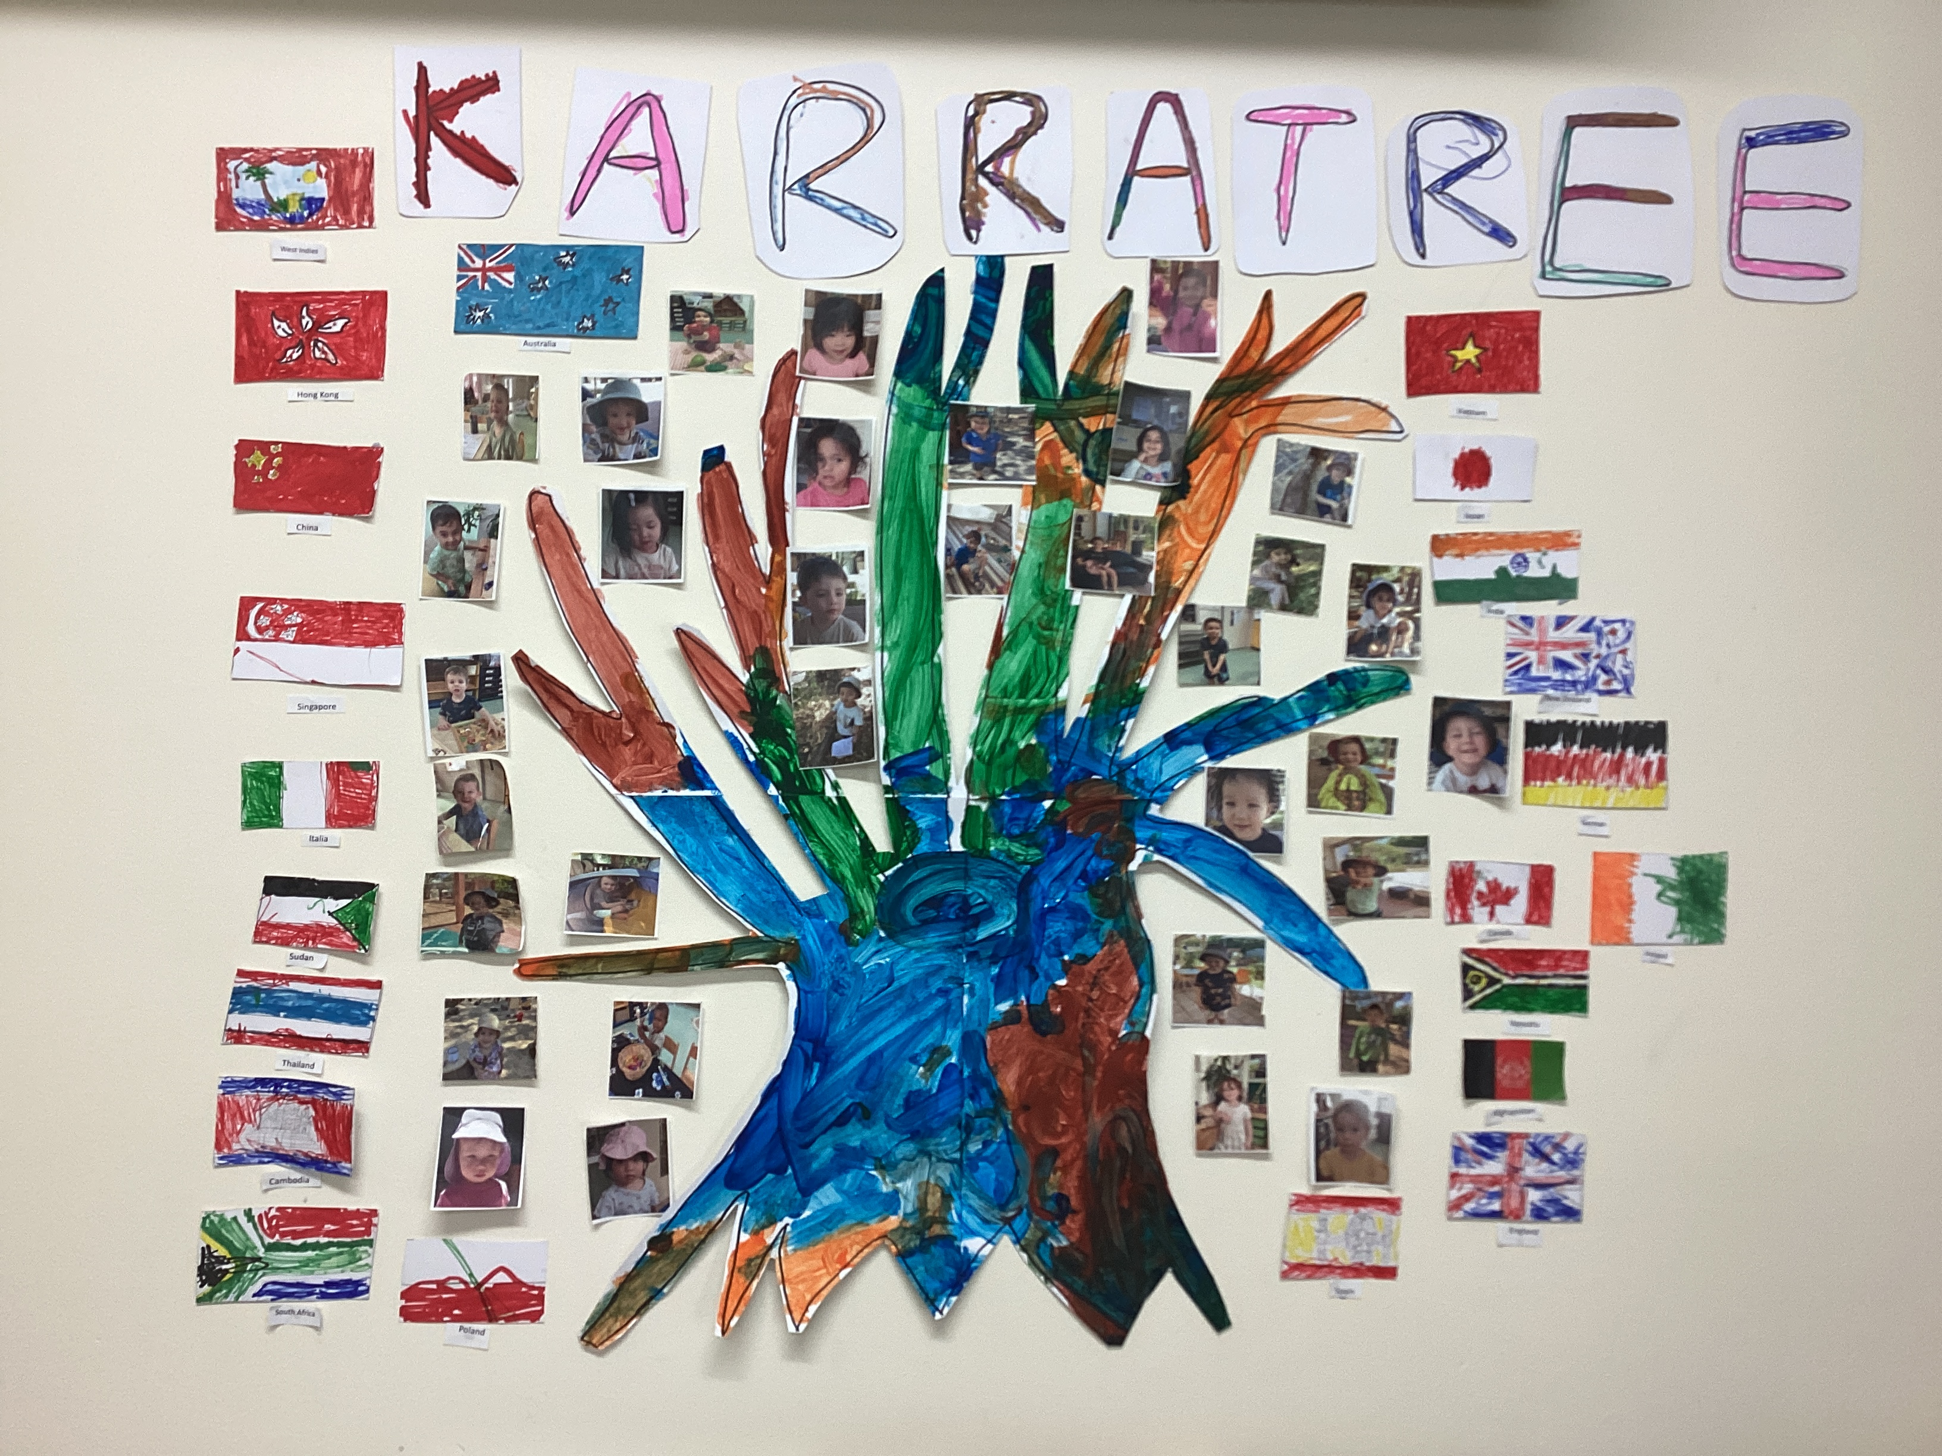  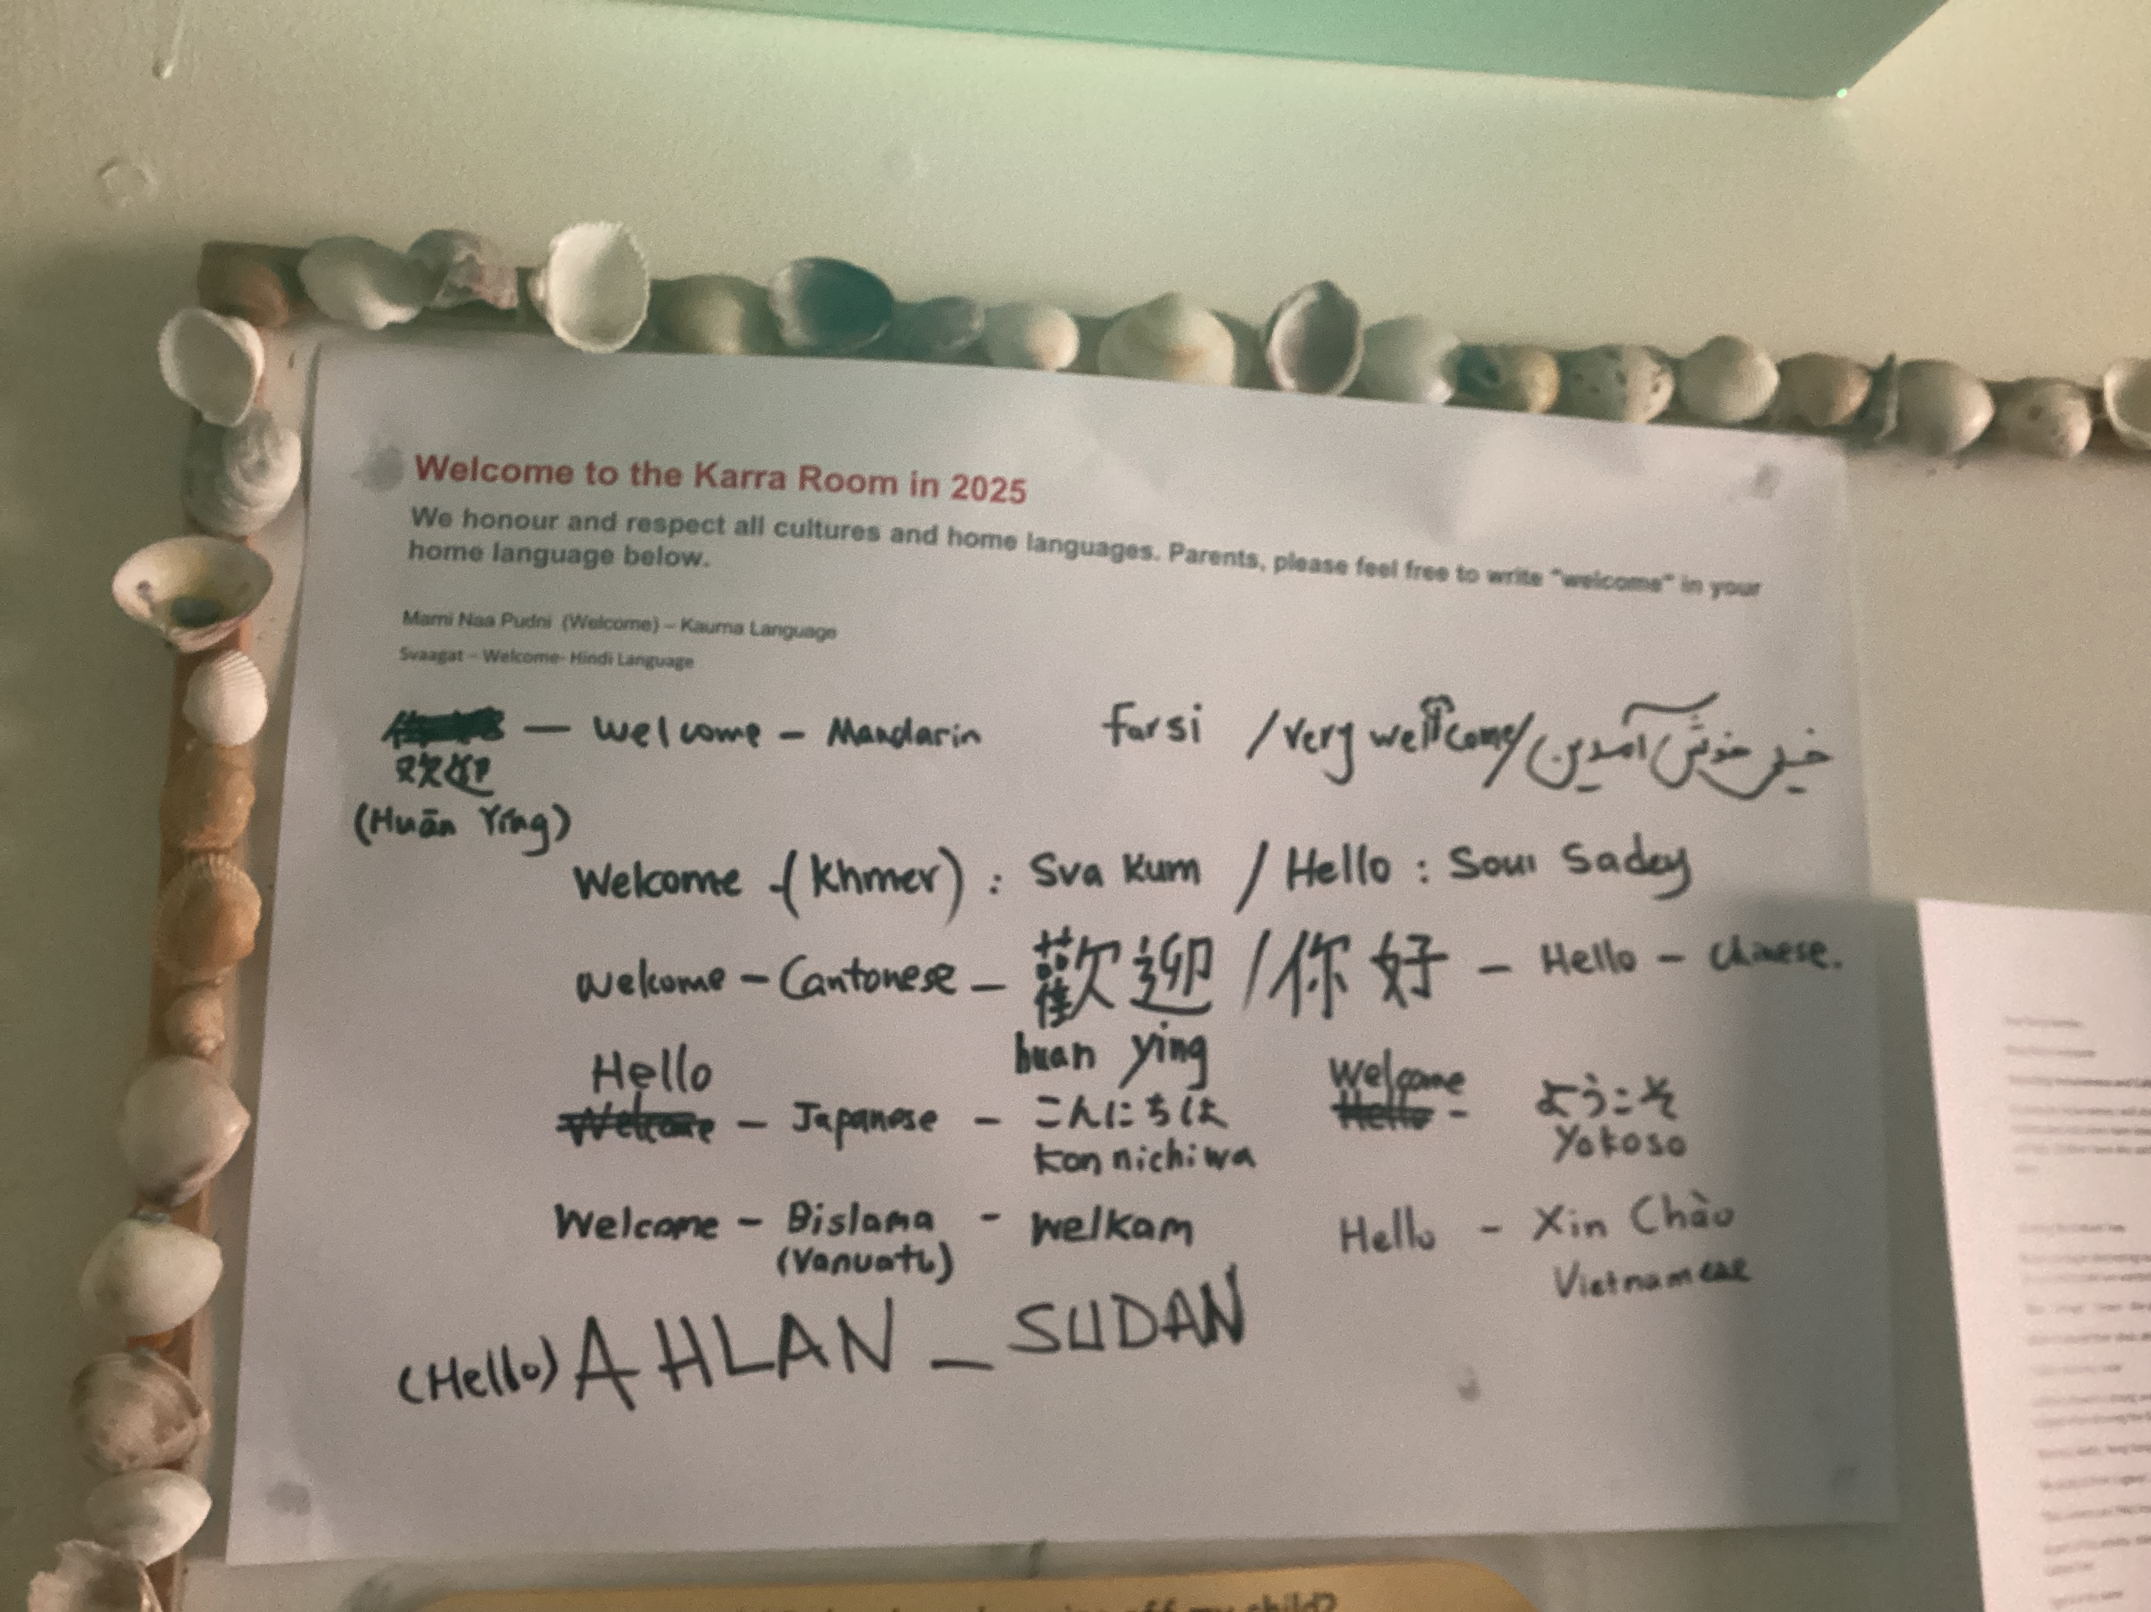  Term 2  Last term, children were curious about animals when talking about 'Alexander is outing' and a child asked 'Can we learn some animals in Kaurna language?'. In Term 2, a book was called 'Wombat Stew' was chosen to read with children. We talked about different animals and ingredients to put in the stew. Children sang the words in the book and learned some animals in Kaurna language with a guessing music game called 'What's in the bag'.  Children did Acknowledgment of Country as part of the routine every day. We started to introduce another 'Niina Marni' with simple and repetitive lyrics. Children had the agency to choose a musical instrument and we talked about the rules for playing the instruments eg. play it until everyone have an instrument.  To celebrate Reconciliation week, Karra children were warmly invited to have a lemon myrtle tea tasting experience during the week. Children expressed their perspectives about the smell, colors and how it tastes like. We also talked about Indigenous people used lemon myrtle as the medicine for generations. Books about Aboriginal culture have been read with children in the group time.  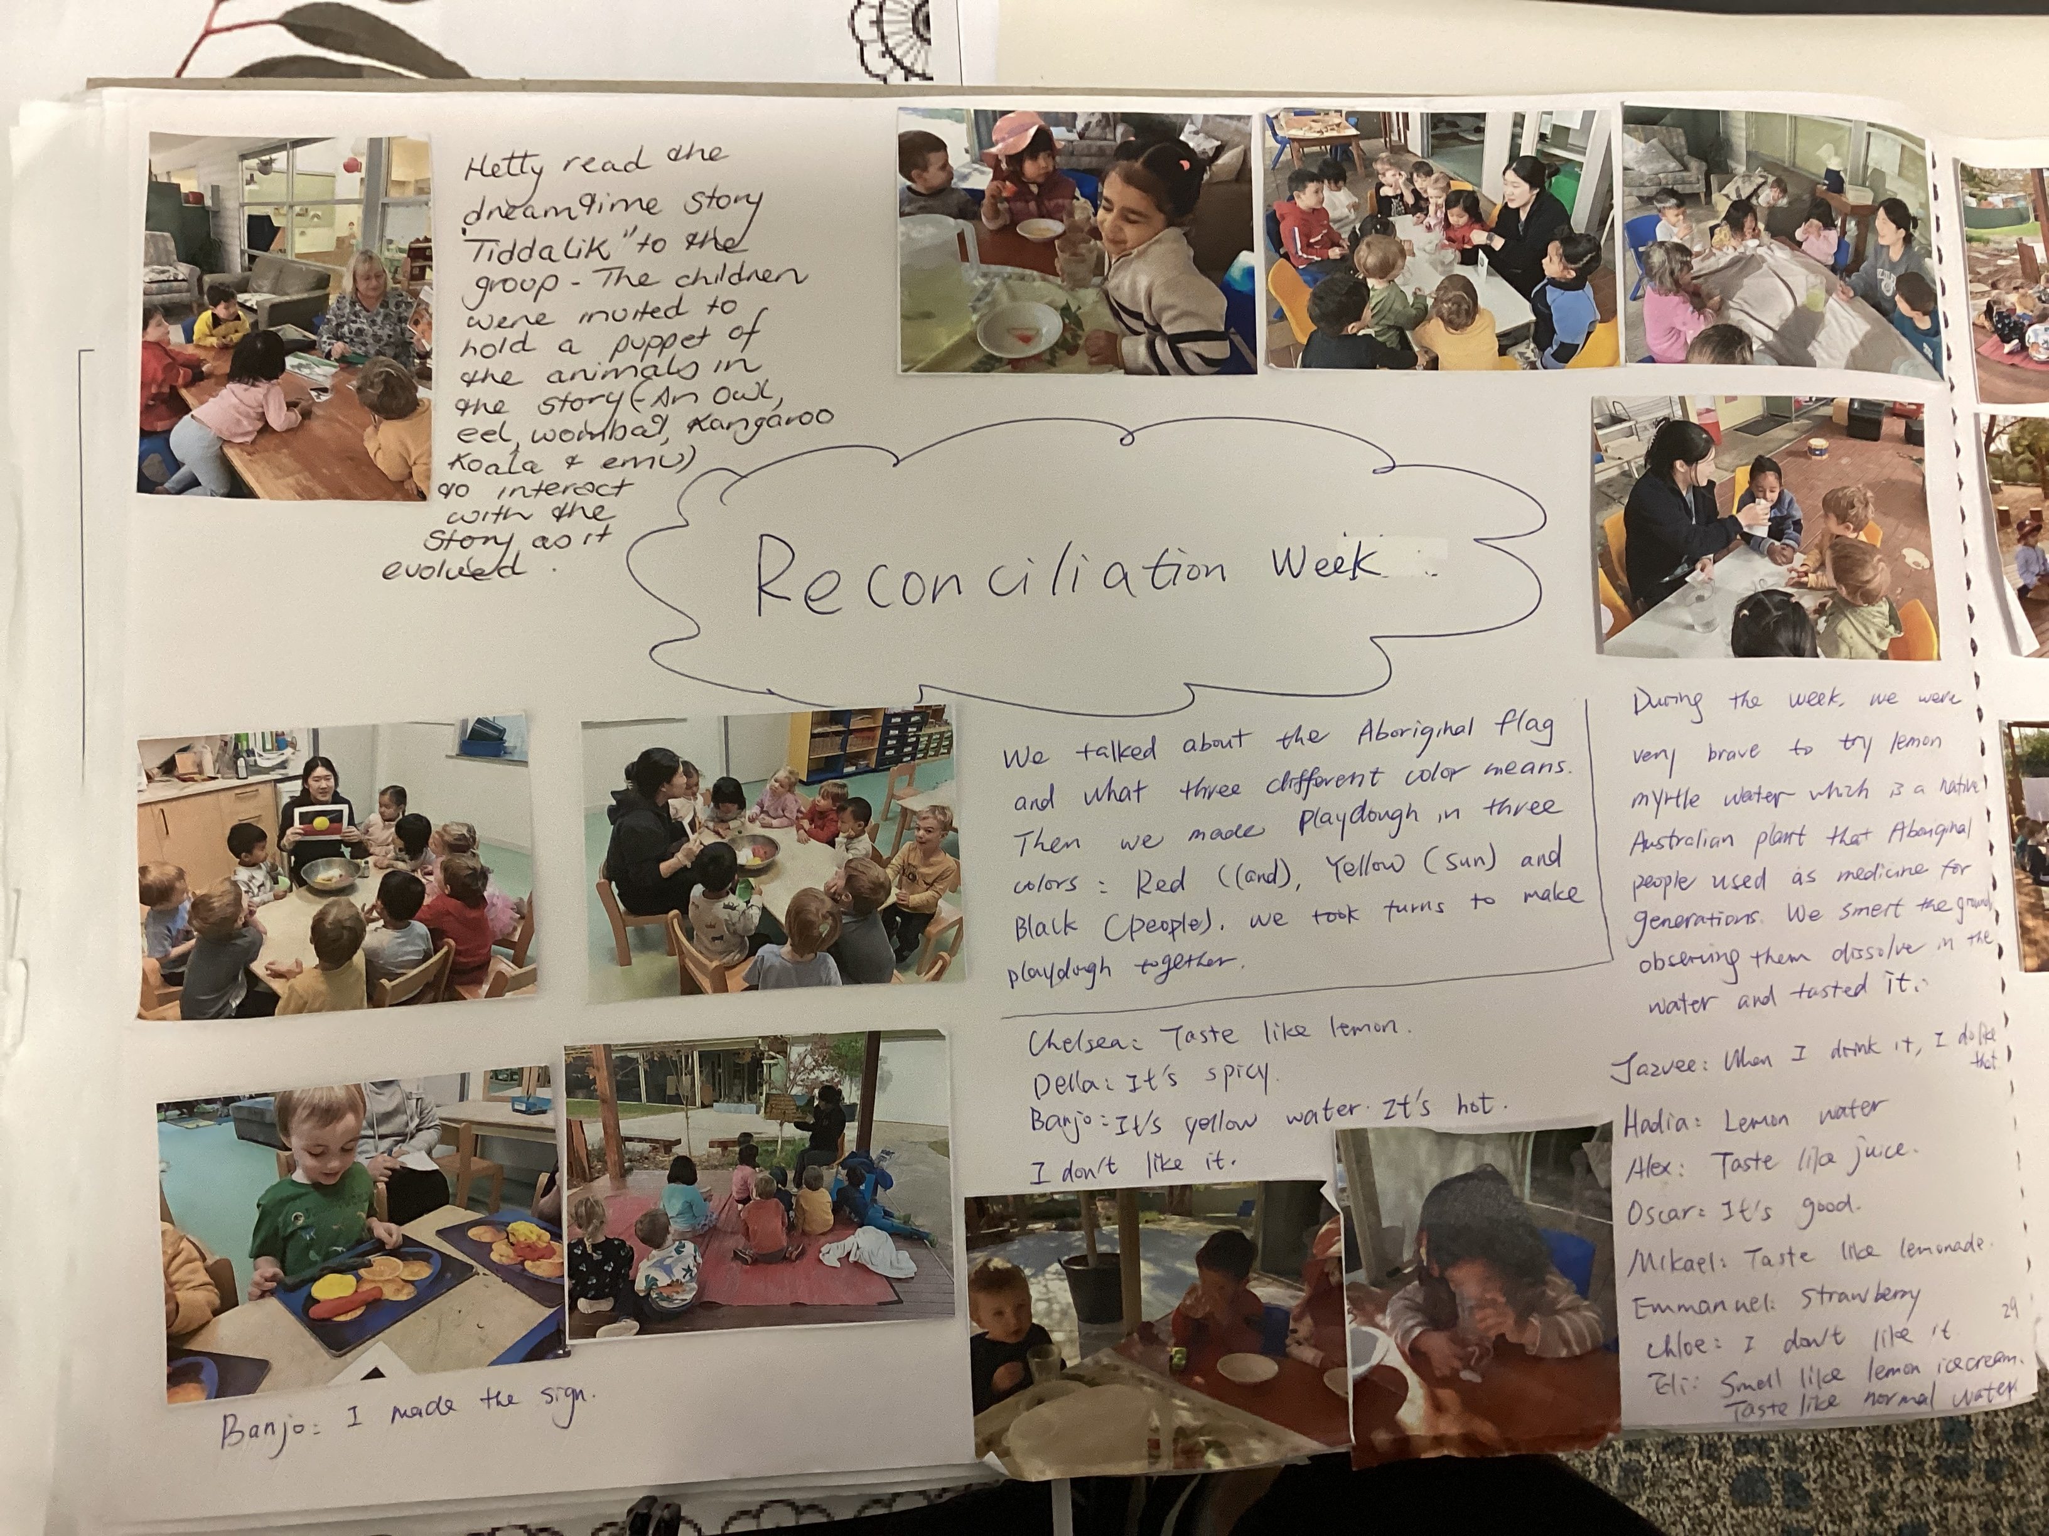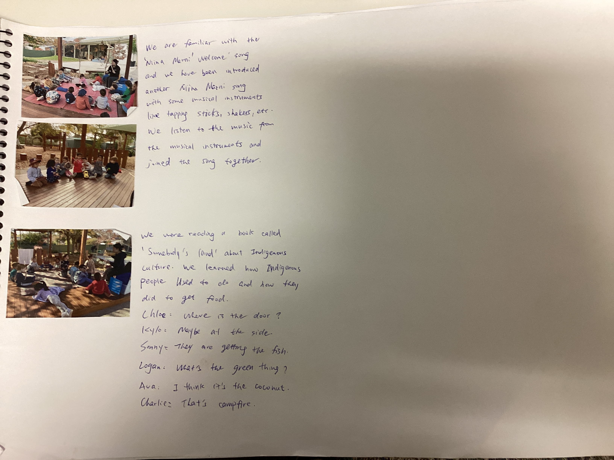  To promote inclusiveness and respect to different cultures, we celebrated Japanese Children’s Day in the room as well. Children had agency to choose the color of the texas and shared their ideas about their drawing on the paper cup. Children were excited to see the streamers flying in the wind.  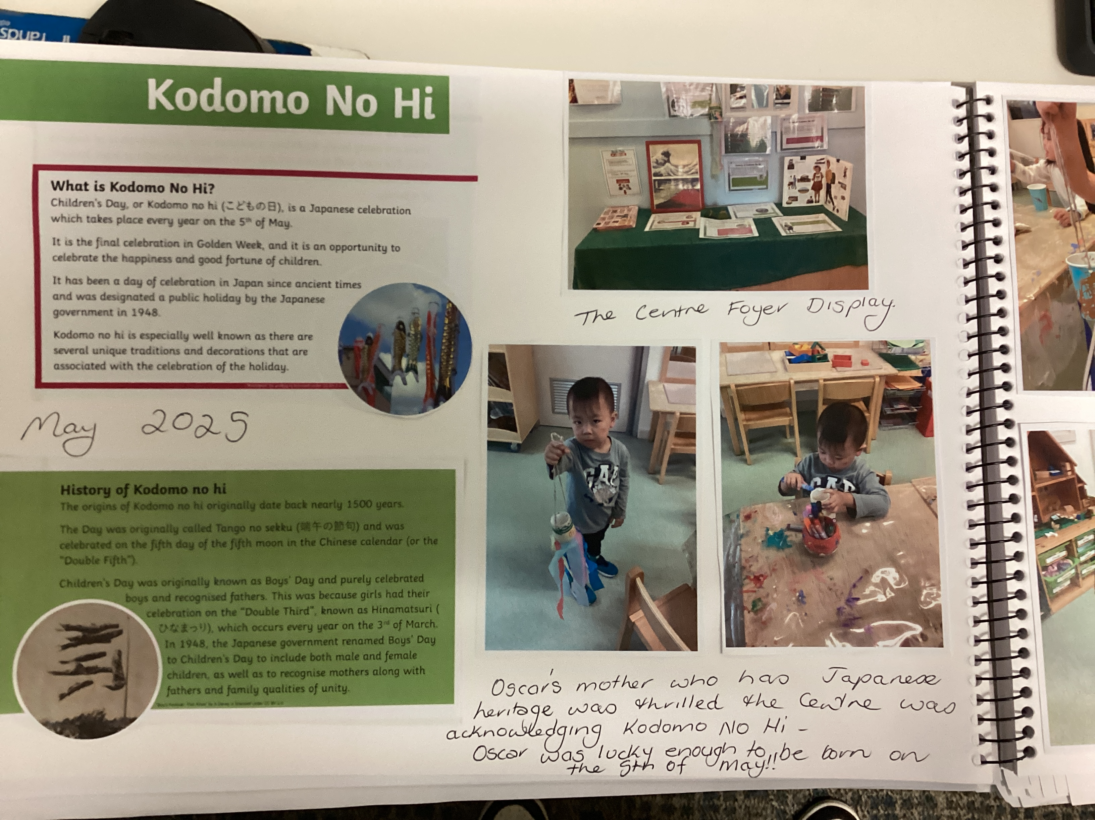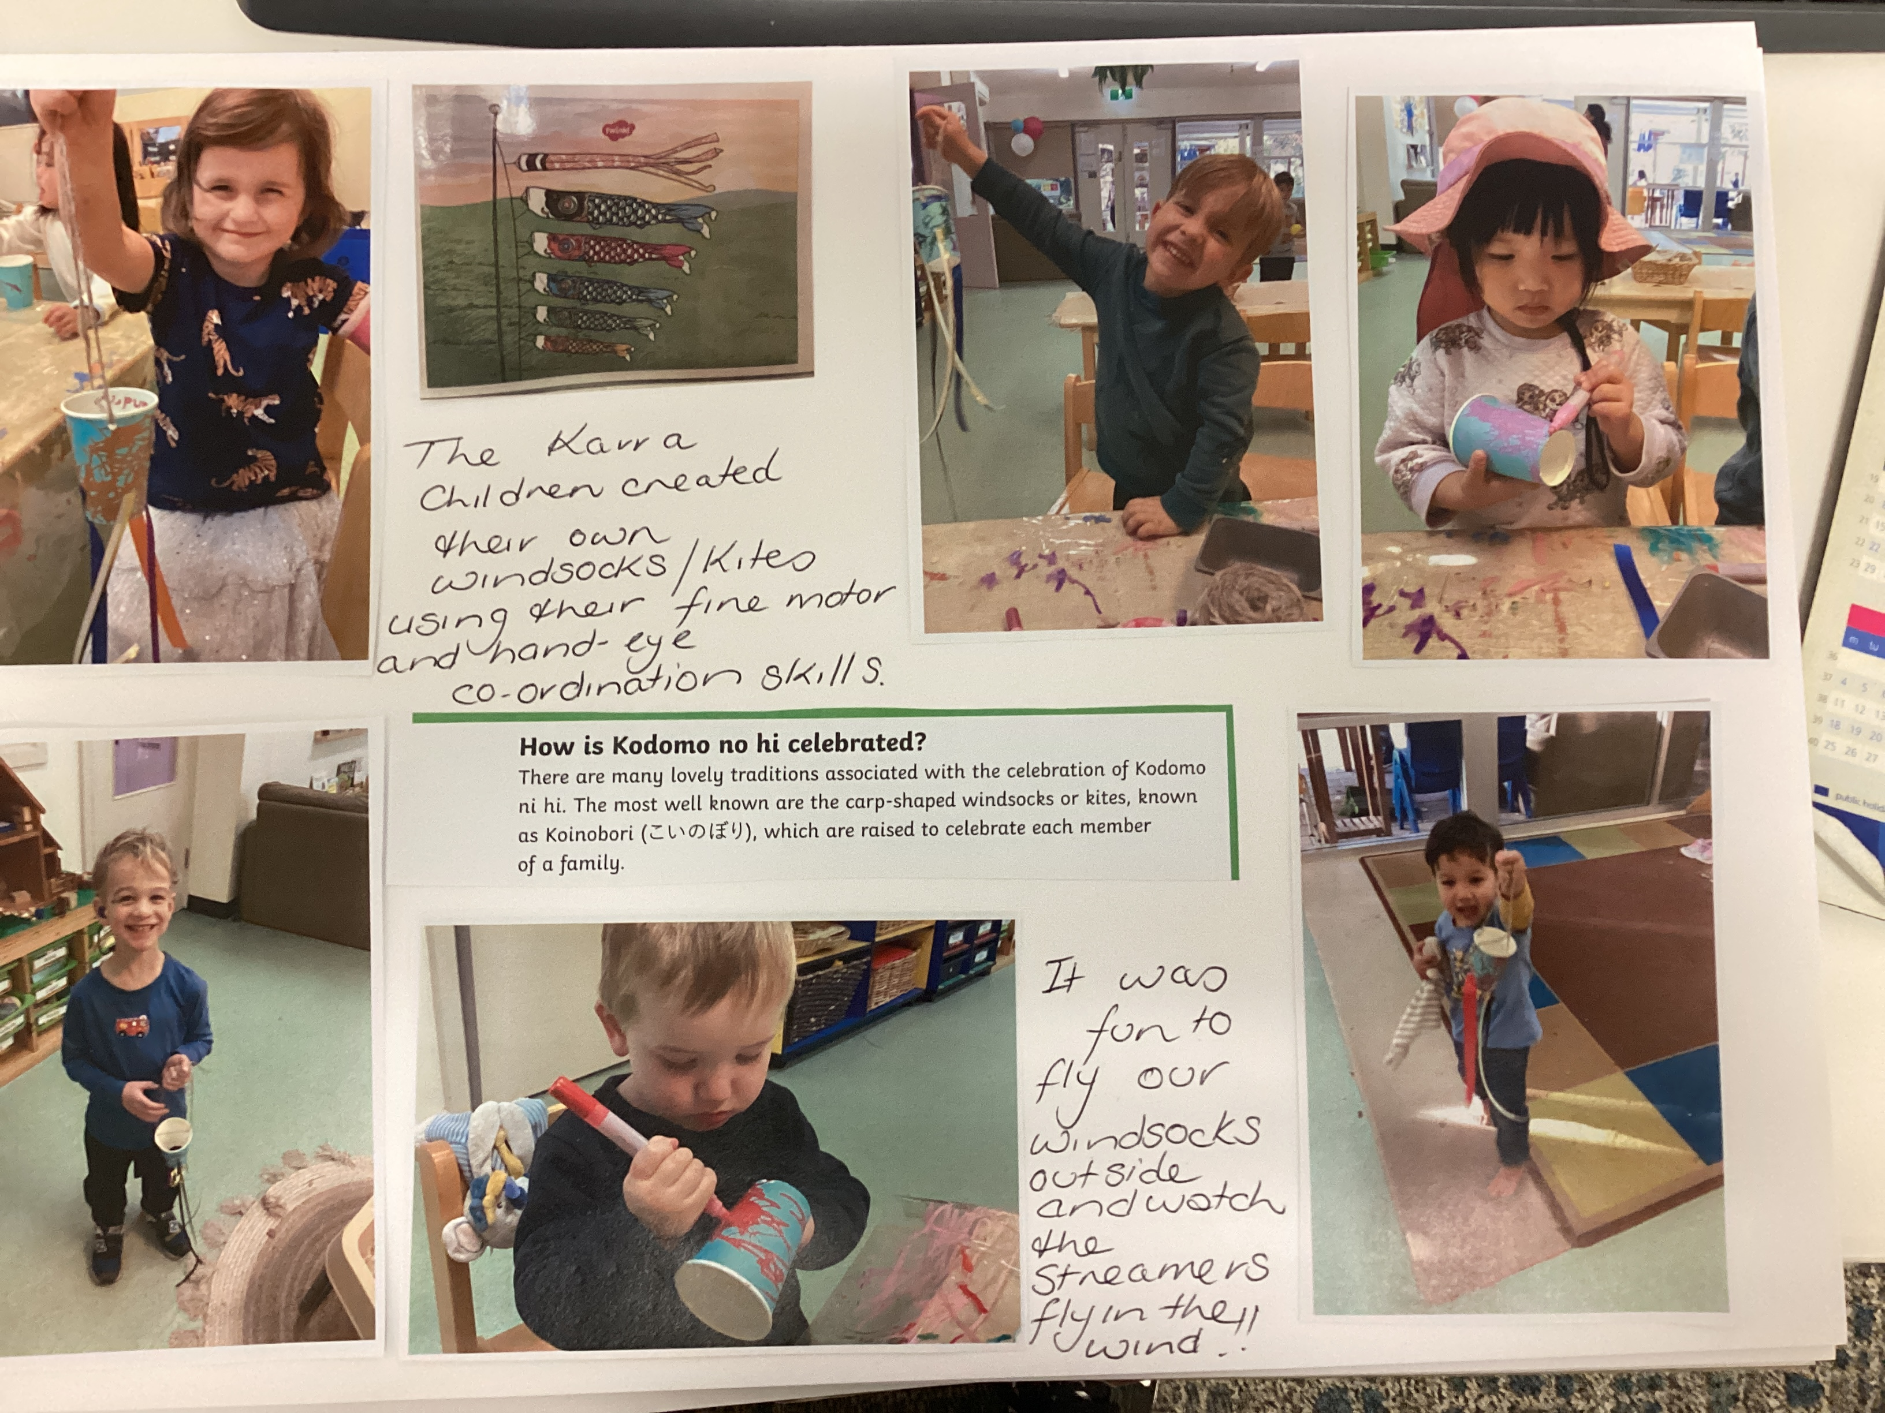  YT staff shows great interest in learning about the children and families 'cultural background. As the first step, we work with families to create a world map that shows where the children and families come from. In Term 1, we created the cultural map with the use of string connecting the country from one end to the image of the child on the other. We also added the countries’ flags and names regarding it, as well as brainstorming an overall heading for the display and involving sharing and having conversations with children and families through the process.  Here is a picture of our cultural map.  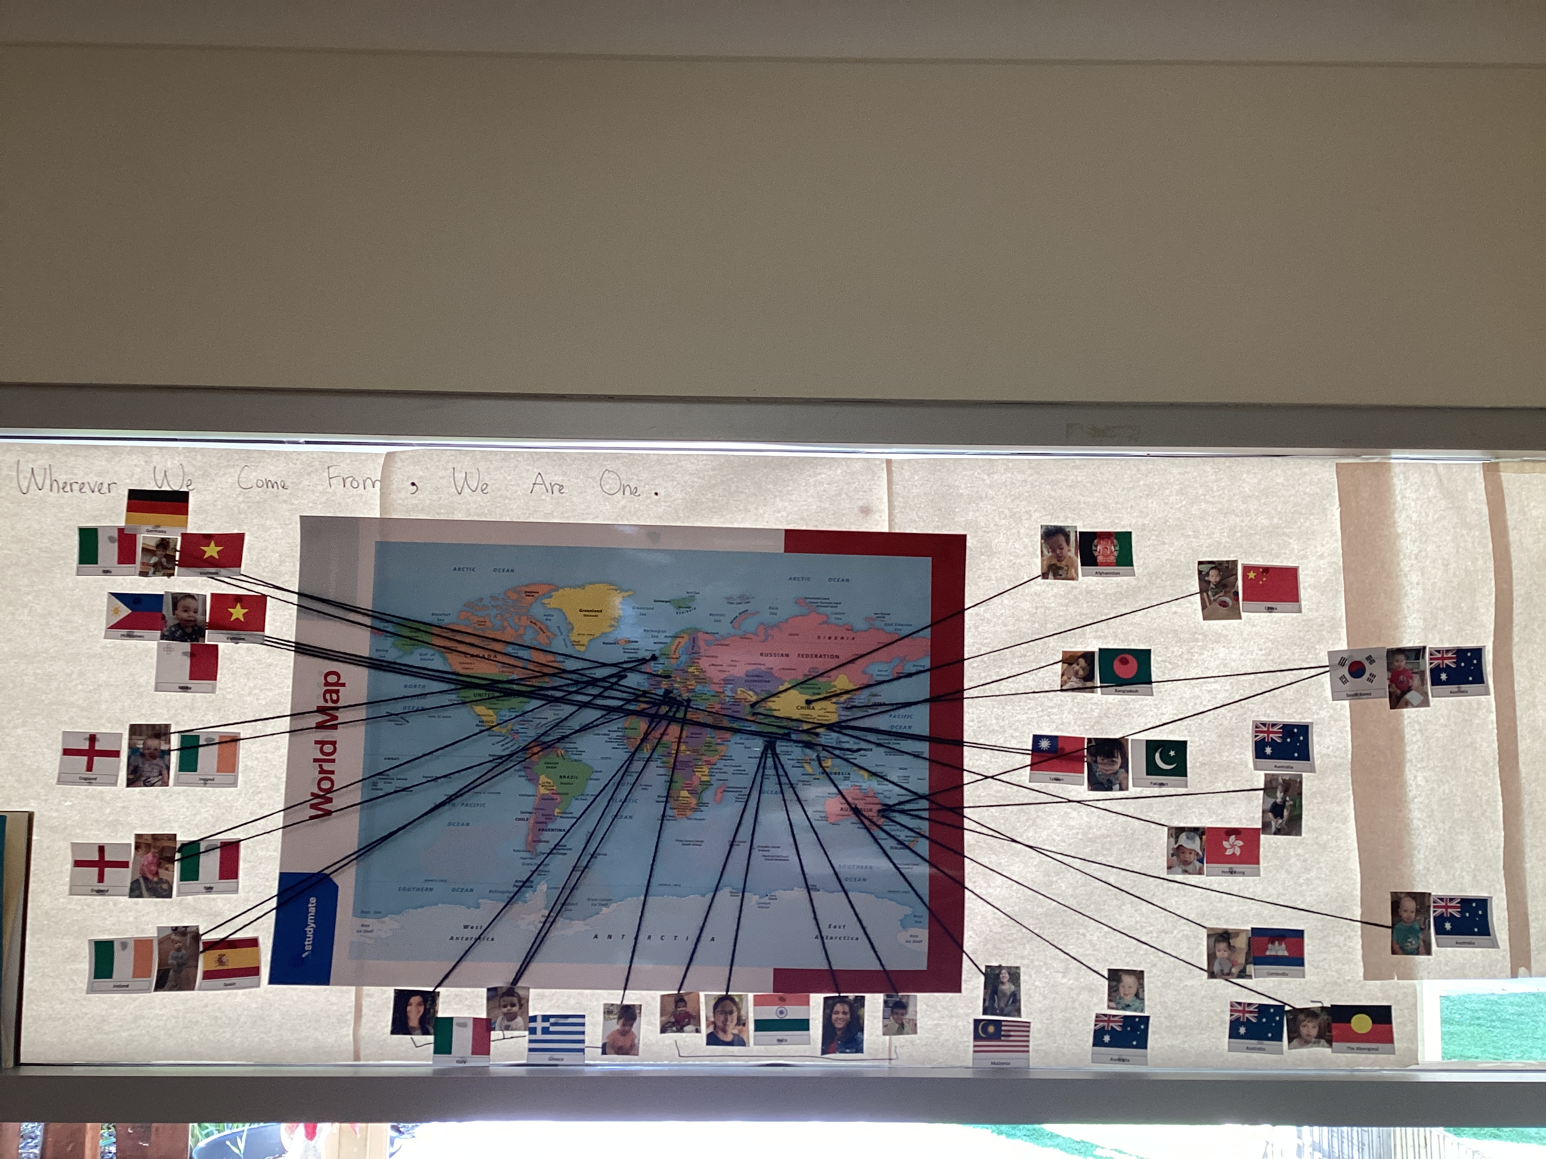  Incorporating more Kaurna words around the room through displaying Kaurna words and phrase around the room.  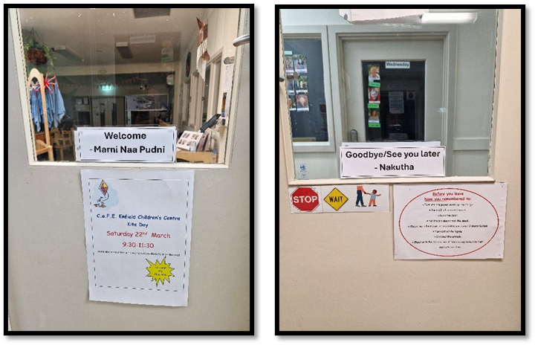  (For example, we added greeting words in both English and Kaurna language at the entrance)  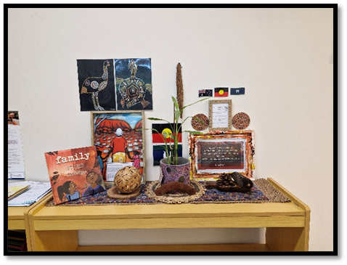  (An example of appreciating and respecting the Aboriginal and Torres Strait Islander culture)  In Term 2, we reflected on the placement of the cultural map being too high up, making it not easily accessible to the children. The children had to be picked up to have a closer look at the cultural map. Thus, we moved the cultural map from paper to a hard board and placed it at child-level. This allows children to see where they and other children come from and find connections if they share the same countries of origin.  To celebrate Reconciliation Week, the children collaborated to paint a white t-shirt using natural materials and paints that hold symbolic meaning to Aboriginal and Torres Strait Islander cultures. This aligns with the National Reconciliation Week theme: ‘Bridging Now to Next’.  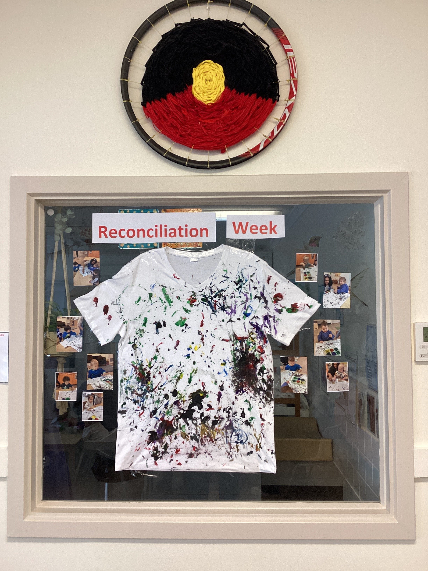  In addition, the children painted on paper with hand outline, illustrating we all have ten fingers but in different colour to celebrate diversity.  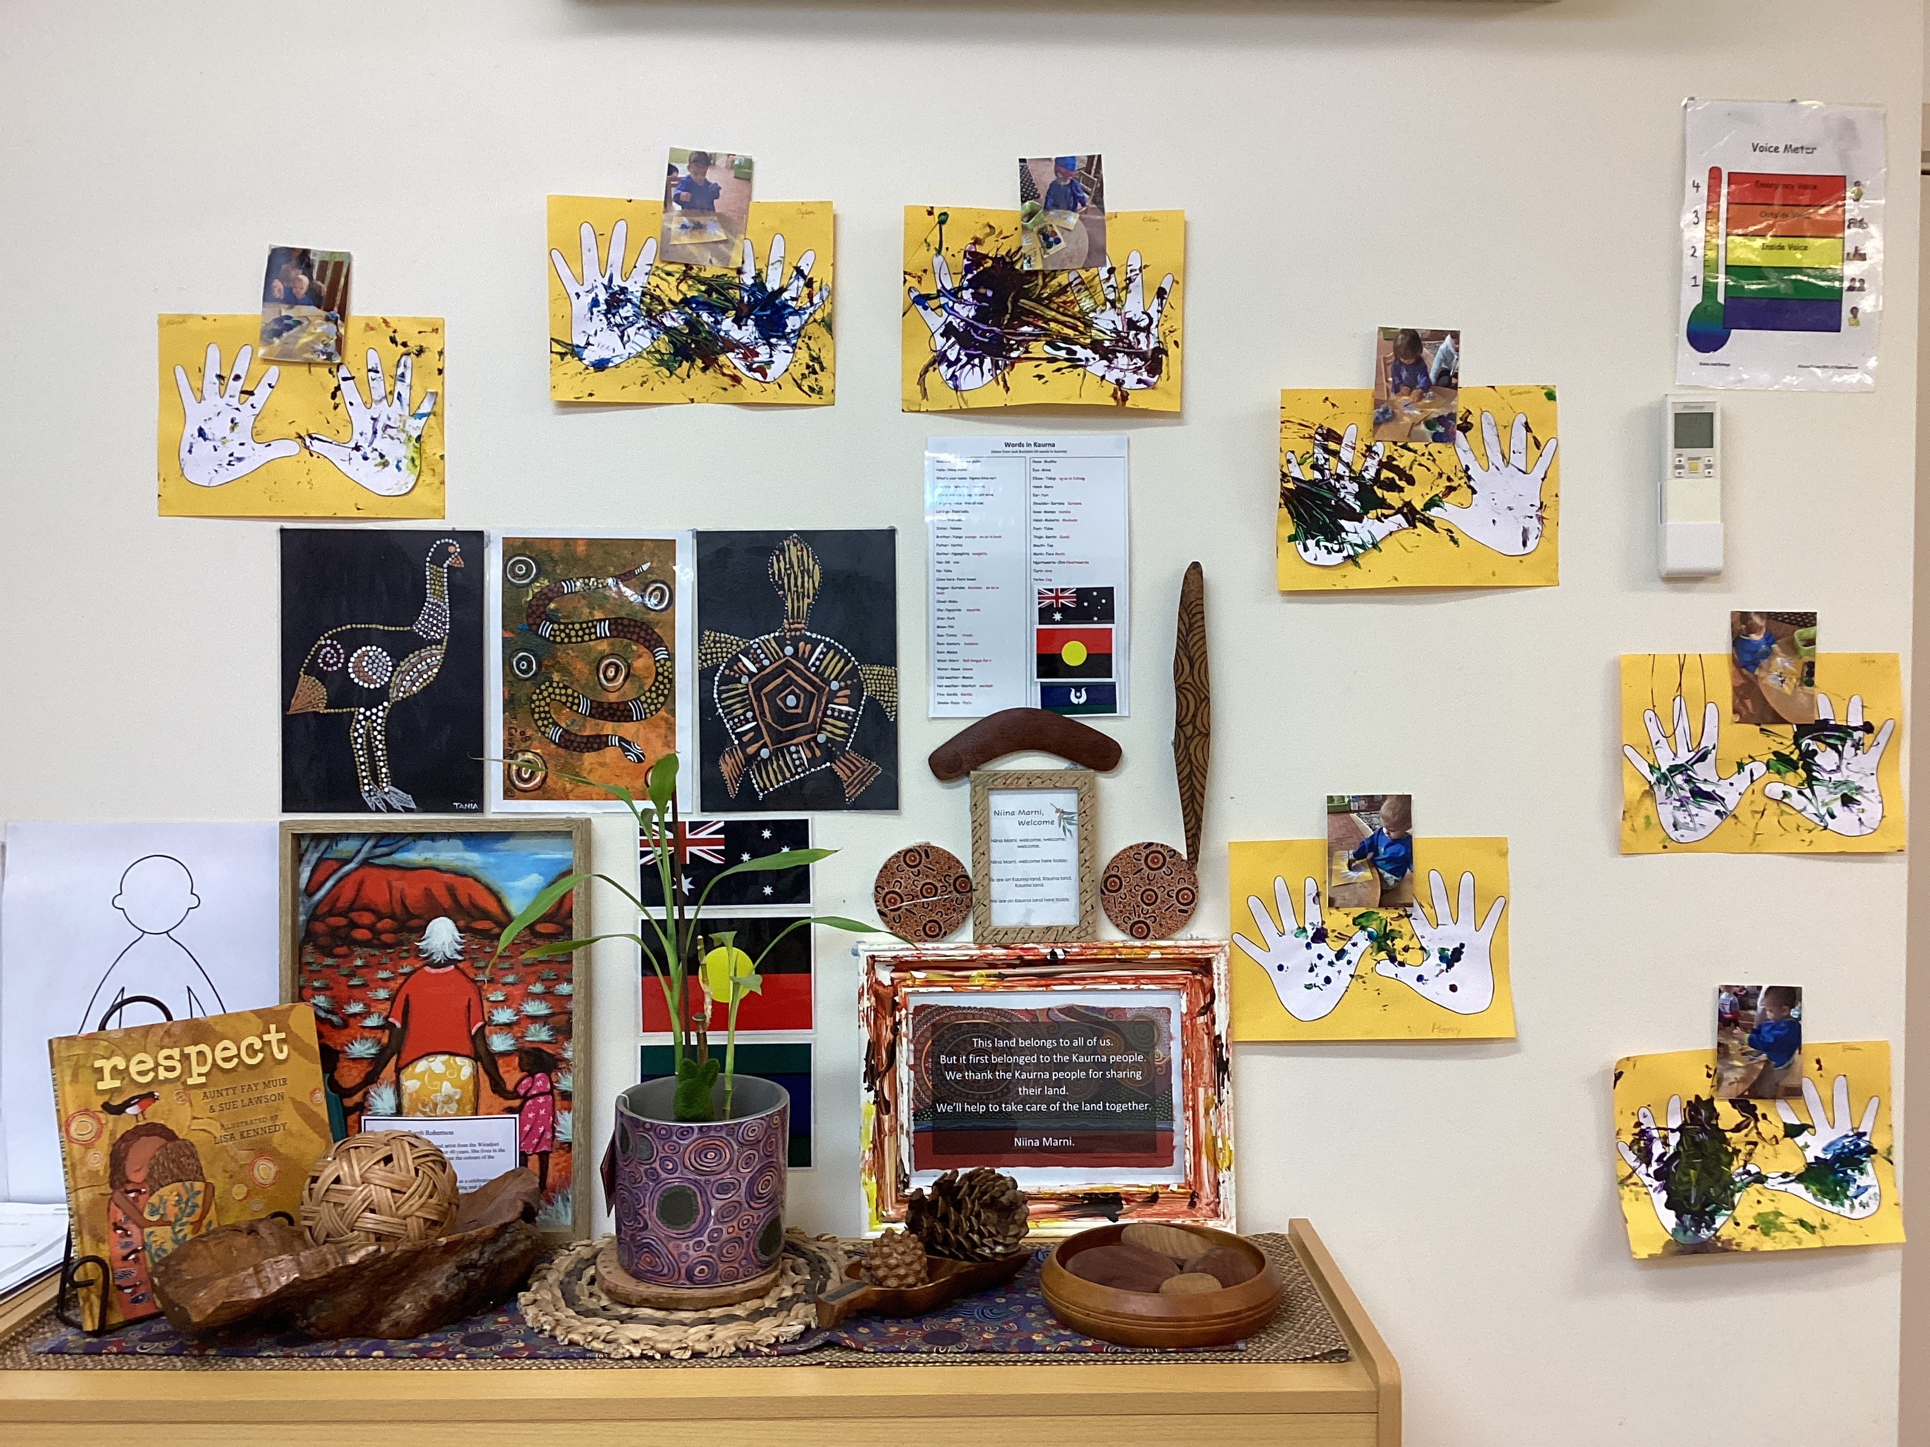  To celebrate National NAIDOC week, the children explored First Nations Symbols through an archaeologist-themed pretend play. They engaged in role-playing as archaeologists, using paintbrushes, cups, and spoons to practice uncovering the symbols.  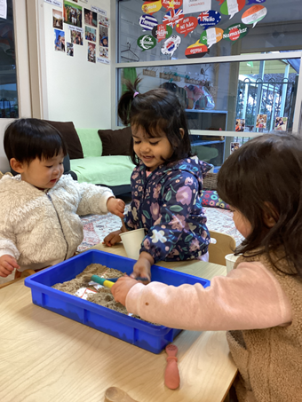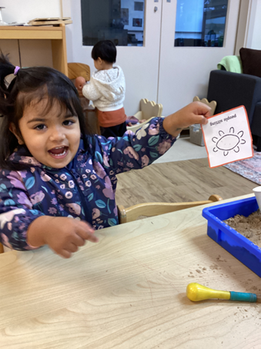  In term 3, we invited the children to look at the cultural map with their peers and magnifying glasses. We created cards with children’s photo and the flags of the countries they are from. These allows children to engage in learning relationships with a wide diversity of people, to develop a sense of belonging to the group, to learn about different countries and flags, and to share what they notice through verbal and non-verbal communication.  Moreover, we celebrated the Indigenous Literacy Dat to learn about First Nations stories, cultures and language. We introduced the ‘Warna-Manda Baby Earth Walk’ and ‘What Do You Call A Baby?’ stories to the children. They can learn about Aboriginal cultures and the connection between people, land, sky and spirits through the visual and written text.  Kangkulya Kuu  KK educators reflected on the wording of the Kaurna Acknowledgement that is shared each day during morning group times. Educators discussed how the phrase “we thank the Kaurna people for sharing their land” does not represent true Aboriginal history and decided to remove the sentence from the acknowledgment.  Photo of our updated Kaurna Acknowledgment  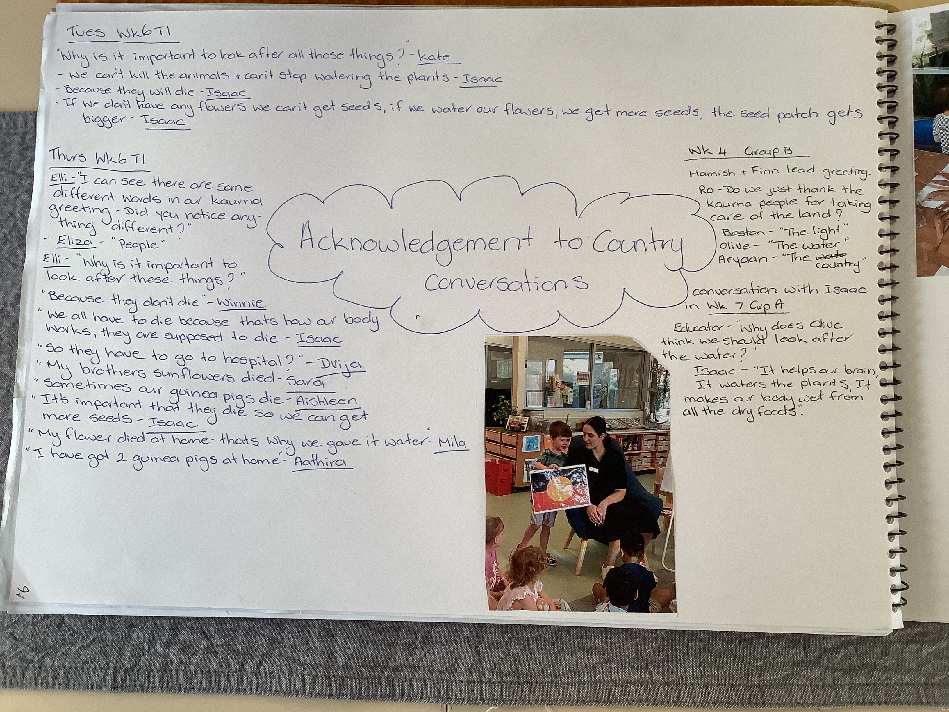  Photo of our floor book story highlighting children’s voices and conversations about ‘Acknowledgment of Country’.  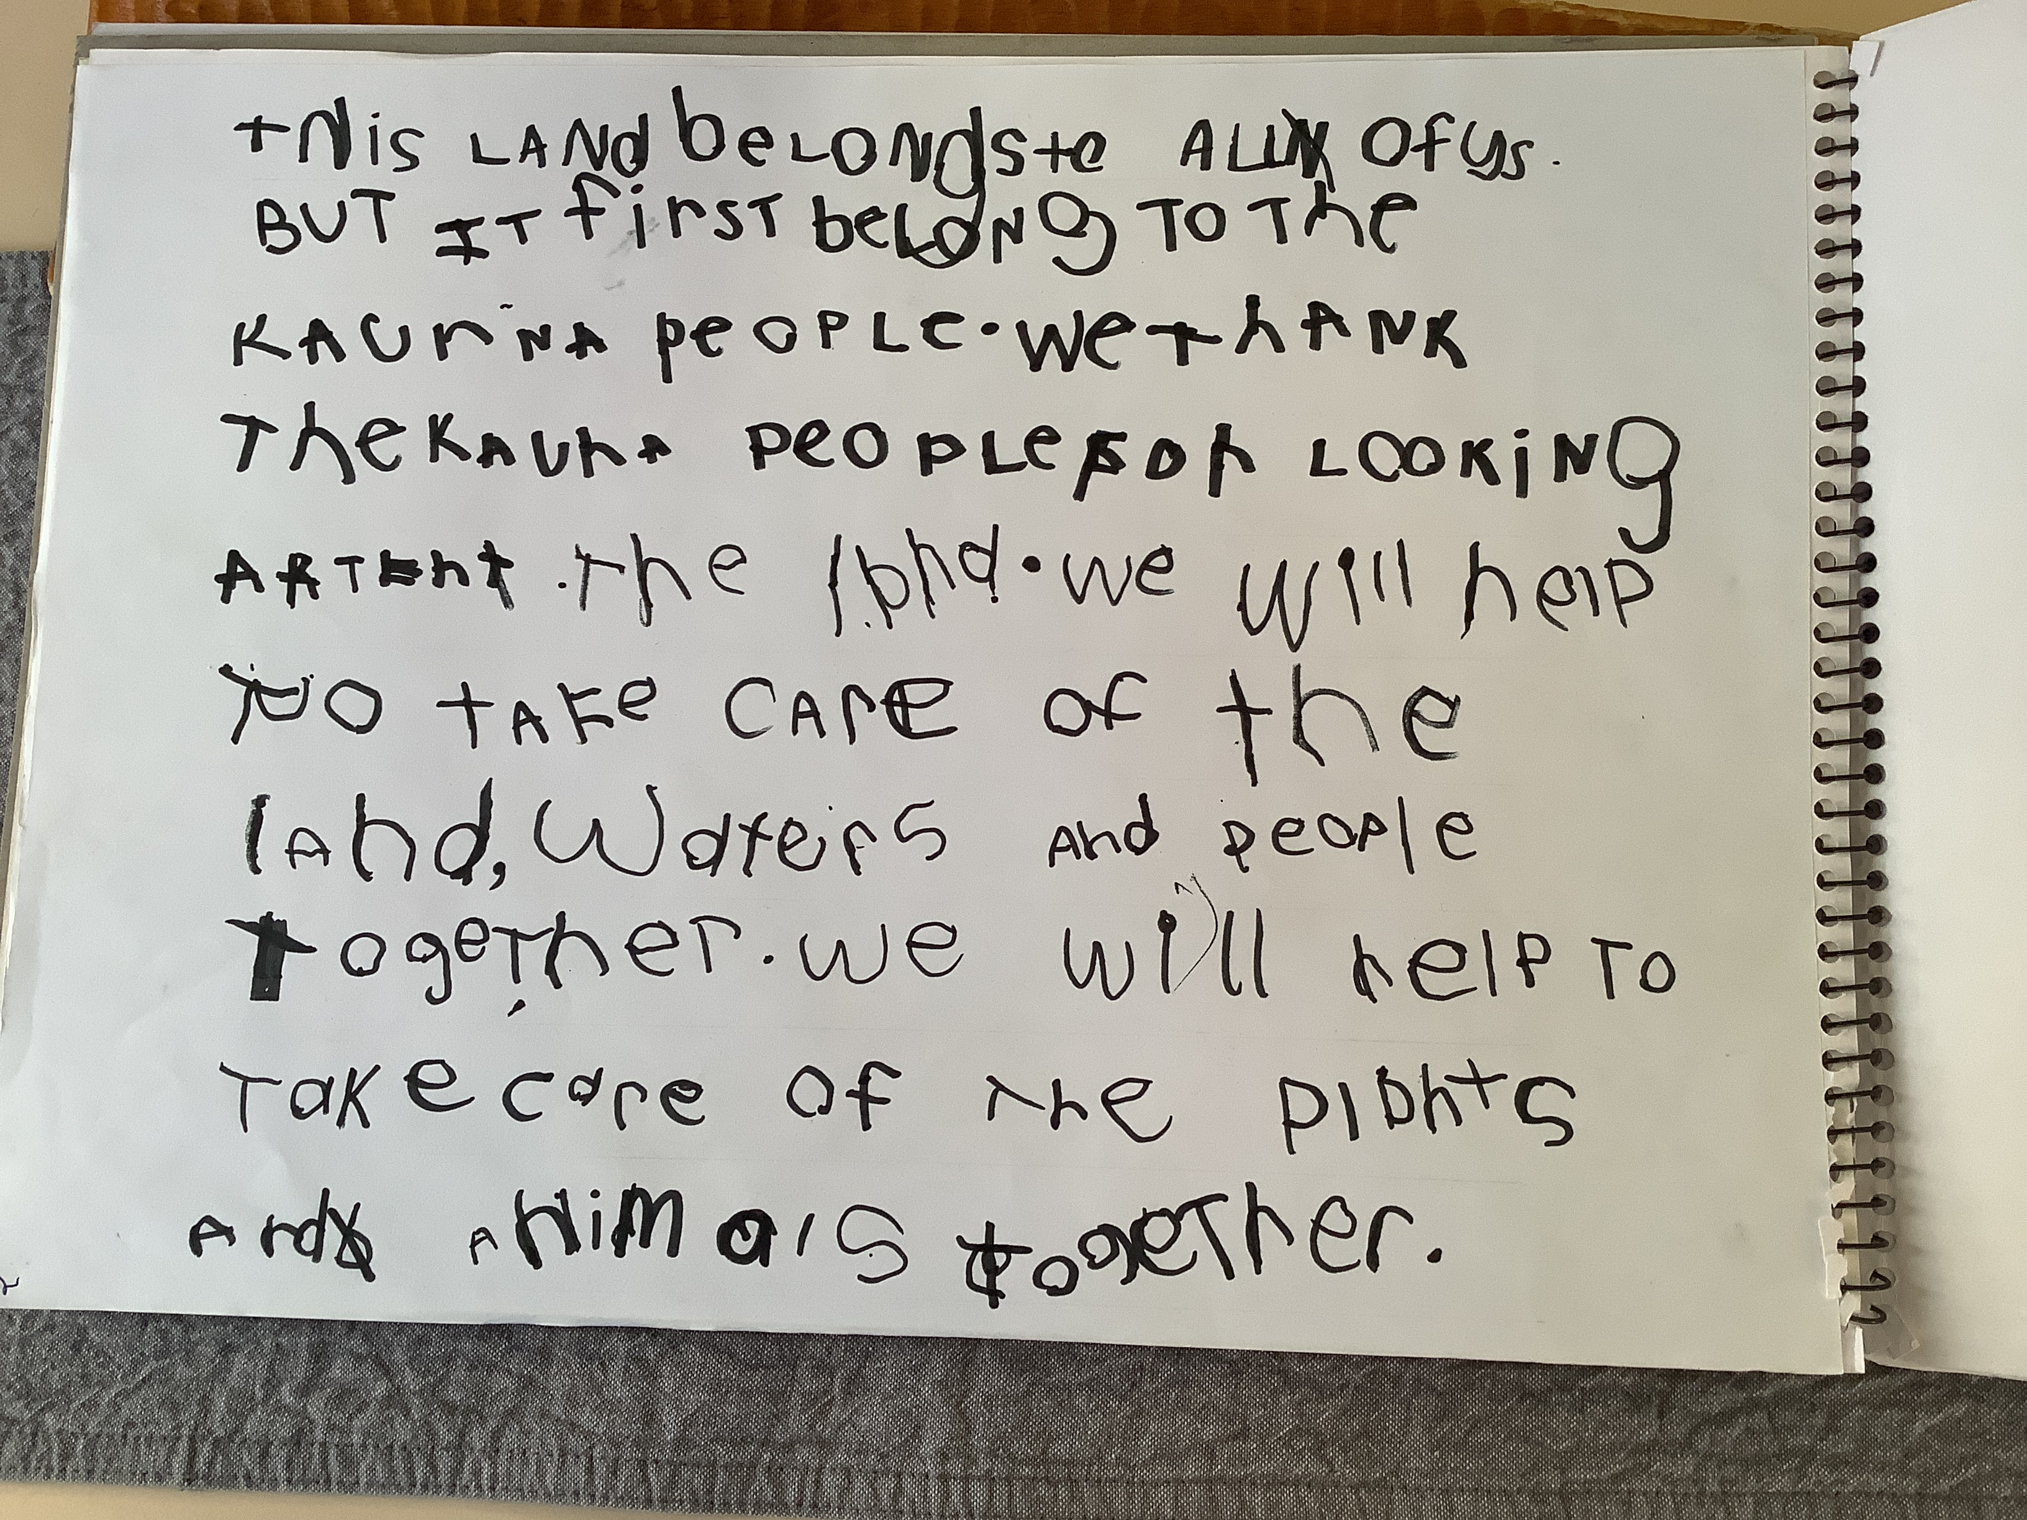  Labels around the Kangkulya room in Kaurna and Key Word sign to promote educators and children to use throughout routines.  Photo of body part visual and visual board  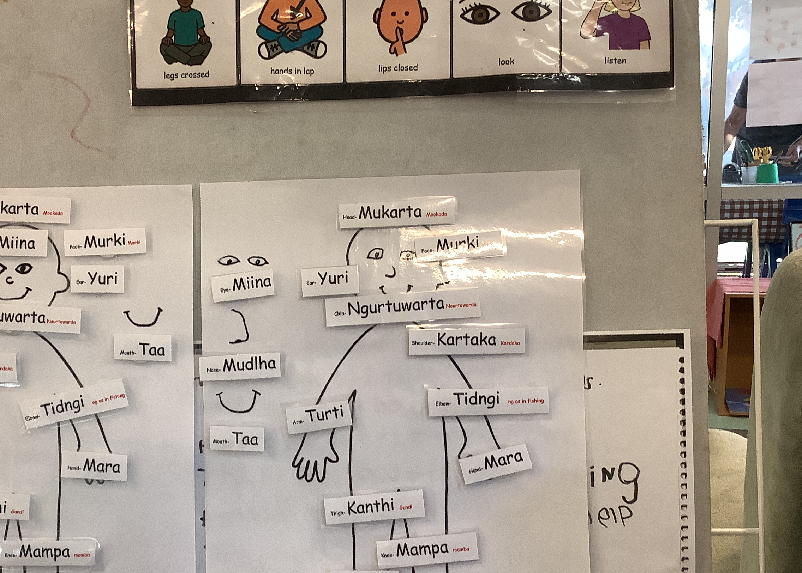  The Kangkulya children and their families were invited to engage in several campfire experiences in June whereby the children and their families engaged in Acknowledgement of Country. Kate supported the children to feel the earth which their feet were touching, listen to the sounds including the birds chirping and smell the smoke of the campfire. The children listened to Kate’s voice as she tweaked the wording of their Acknowledgement to be authentic and connected to pedagogy of place. ‘This Kaurna land, at the Beyond Space belongs to all of us, but it first belonged to the Kaurna people.’ Children sang a selection of songs including, ‘Sing a Rainbow’ naming the colours using Kaurna language and using Auslan for signing the colours. Children used tapping sticks to keep the beat of other songs like Kookaburra sits in the old gum tree and . |  | Parents wrote the word "welcome" in different languages.  Educators had conversations with families to know about their cultural backgrounds and whether they speak another language at home. Educator printed out different flags to talk with children about where their parents as well as their friends come from and then they decorated the flags using textures for contributing to a Karra Cultural Tree in the room together.  Term 2 Many families have contributed to celebrating Harmony week by wearing special clothes. Books about diversity have been read with children during the week to talk about different cultures and people with different skin and hair colors to promote inclusiveness and respect to different cultures. Children actively participated in the guessing game and brainstormed and shared their perspectives what they thought hiding in the bag and then learned animals in Kaurna language afterwards. In that way, children showed their interests and respect in learning Kaurna cultures.  Children engaged in playing music when learning Kaurna culture and they had agency to choose what they wanted to use. They followed the instructions and some children started to sing the song together when playing with the music.  Some parents commented it is visually pleasing to see the children's cultural background. One parent said she is surprised to find out other child has an Italian background like her.  YT staff learn about the children and families who we didn’t realise that’s the background of where they were from. This opens up more conversation with the families.  Term 2  Children gathered around to observe the cultural map with their friends. One child sang, 'Where is Samuel? Where is Samuel?' and then pointed at Samuel’s photo, continuing to sing, 'Here he is.'  Children can visit the cultural map anytime and learn about their cultural backgrounds and the flags of different nations.  Some families asked their child to point out where they are on the map, and the child successfully pinpointed their own photos next to the flags.  The children explored painting with natural resources and worked collaboratively on a large art project. A parent shared that she had never seen her child so concentrated as when the child was painting on the t-shirt.  For the NAIDOC week activity, the children practised fine and gross motor skills when they held the paintbrush with their fingers and moved around the tray to engage with the activity. In addition, the children used their verbal and non-verbal communication to show the educator their findings, raise questions or share their ideas. They gained knowledge about the different First Nations Symbols and their representations. This activity promotes the understanding of how symbols and pattern systems work.  Term 3  The children would locate and name their own photos on the map. In addition, a child recognised some flags have stars and moons and shared this information with his peers. This encouraged another child to point at the Australian flag and said, “Star.”  Two children who moved up to Karra room, came to visit Yitpi Tarnanthi room after a month. They asked an educator where their photos were and then searched the photos on the cultural map. When a child successfully found her photo, she shouted, “My photo!” The other started naming people on the map, including herself.  When reading ‘Warna-Manda Baby Earth Walk’, a child pretended to put sand on his head and said ‘star’ while looking at the night sky illustration. Some children would read the ‘What Do You Call A Baby?’ story at their own pace or share it with their friends. These stories encourage children to understand how symbols and pattern systems work, and build connections to the Aboriginal cultures, land, sky and spirits.  Impact for children: To inform the children of the change, educators read the story ‘Somebody’s Land’ by Adam Goodes. This supported conversations about Aboriginal history and understanding who the traditional owners of the land are. Children showed empathy as they shared “the white people were unfair” (Isaac). “The Aboriginal people were here first but the white people said it was nobodies land” (Hamish).  Impact for children: Children worked alongside an educator to create a visual of a whole body and labelled the body parts in Kaurna.  When applying sunscreen, children are referring to body parts in Kaurna, for example “I rubbed my sunscreen on my muddla” (nose) – Mehar.  Children who began preschool in Term 3, 2024 learnt the song “Colours of the Rainbow” in Kaurna and Key Word Sign. A small group of children have taken on their own initiative to want to teach their peers how to sing the song and actions.  Families have emailed educators asking for the song to listen to at home (Mila’s mum).  An Aboriginal family in the preschool room have shared a few picture books they have been reading at home (Charlie). Educators have been reading them during group times. | Introducing more Aboriginal language into the classroom and incorporating it into daily routines. Utilising a screen in the room to enhance language learning and vocabulary development. Incorporating the "Head, Shoulders, Knees, and Toes" song in the Kaurna language, and using a chart to reinforce learning, especially when applying sunscreen or discussing body parts.  Term2  Had conversations with families about tea tasting experience and Sonny‘s mum said she uses lemon myrtle very often to cook meals at home.  We also celebrated Japanese Children’s day in the room as well as at the hallway. Had conversation with Oscar’s mum and she said Oscar was born on Children’s Day.  Send monthly newsletter to families to inform what has happened in the room and update floorbooks regularly so that children and families can have a look and have conversations during drop-off and pick-up time.  Once completed, take a photo and laminate for children to explore and take a closer look  Discussions and conversations with children around diversity and culture and exposure to the world and countries  Support and encourage children to touch and feel the strings and photos having conversations and using Marte Meo practises of naming, linking, confirming, leading  Reading books around culture and diversity ie: “Whoever you are” and "Ceremony".  Continue labelling and adding Kaurna words alongside the English word  Add and display further phrases that correspond to our daily routines eg: eat, food, drink, nappy, sleep  Incorporating Kaurna words through play opportunities, adding words to songs – visual aids ie: animal names, song displayed on the wall?  Term 2  Encourage children to explore mark-making in sand or other mediums to enhance their creativity and sensory experiences.  Greet children in their home language to make them feel welcome and acknowledged.  Invite families to share cultural events they celebrate and incorporate these celebrations into the room activities.  Send floorbook stories to families via email (currently available for families to view in floor book located under kindy veranda).
Educators are able to support all children to regulate and therefore implement their 100 languages to engage in thinking and communicate their learning. | On 7th March, whole site P.D day educators were introduced to Nicolle Stephanos, DfE Inclusive Educator who presented a power point based on the O.T Alert Program. Nicolle went through the 8 sensory senses and then shared how the educator is to be the detective in order to determine what zone a child is experiencing and then provided the team with strategies in order to support the child to regulate and get back into the ideal zone in order for them to engage and socially participate appropriately in the learning.  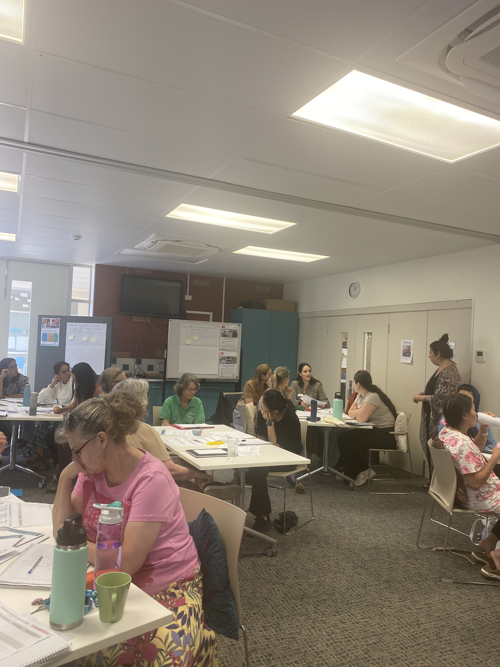  Strategy to support regulation.  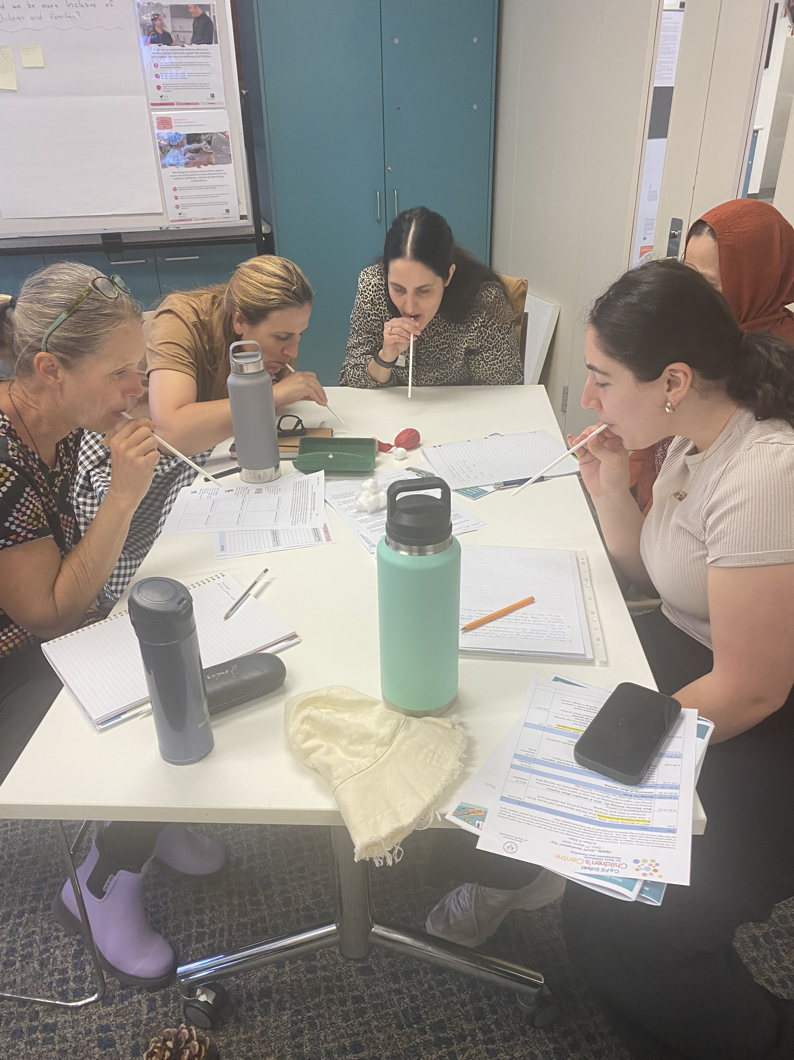  Kangkulya Kuu: (17/02/25)  With new children starting Kindy this year and continuing children coming back from school holidays, children’s wellbeing has been on a varied spectrum (in particular separation from families has been challenging).  With this in mind, introducing the story ‘The Invisible String’ by Patrice Karst not only supported with our Literacy Program, but allowed children to connect with one another on a familiar concept and express their thoughts and ideas. This process of shared-sustained thinking supported children to regulate themselves by, making realisations (understanding that they will see their family after kindy, they can think about them, talk to peers about them etc), sharing stories of themselves and their families, drawing representations, displaying their work in our environment to share with everyone, build safe/secure spaces and much more.  Photos of children’s family representations being displayed within our environment.  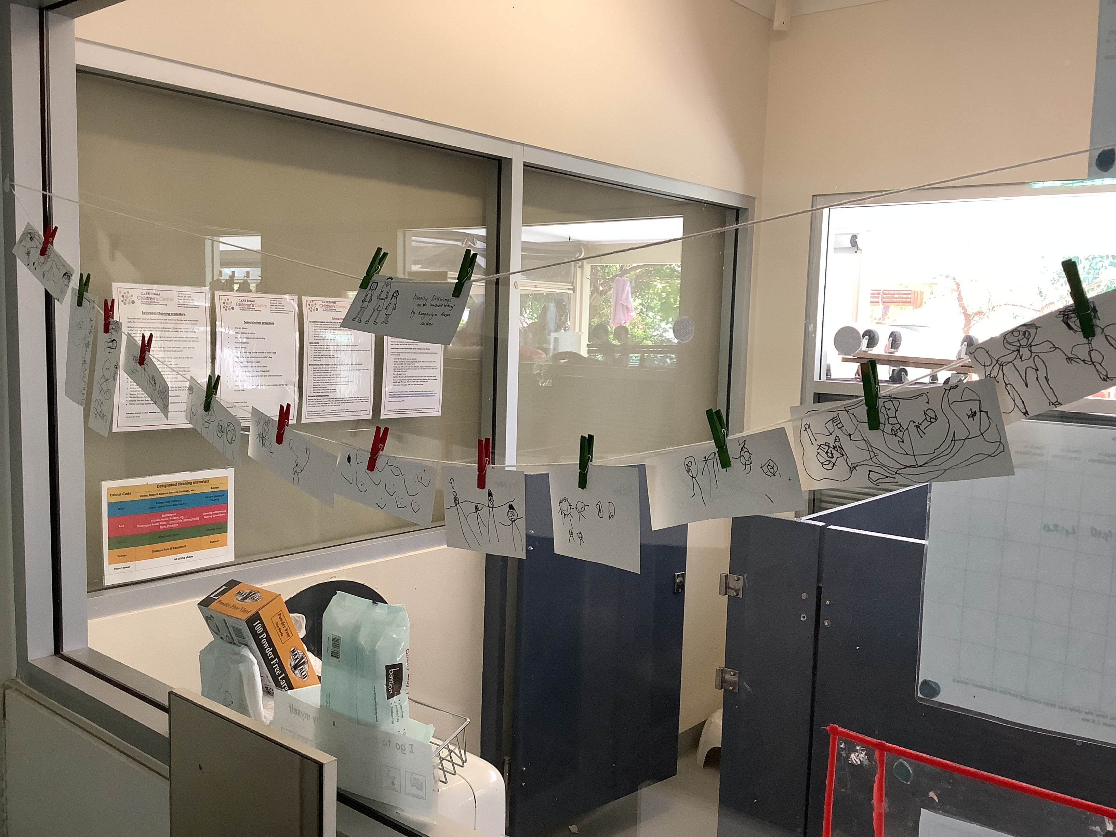  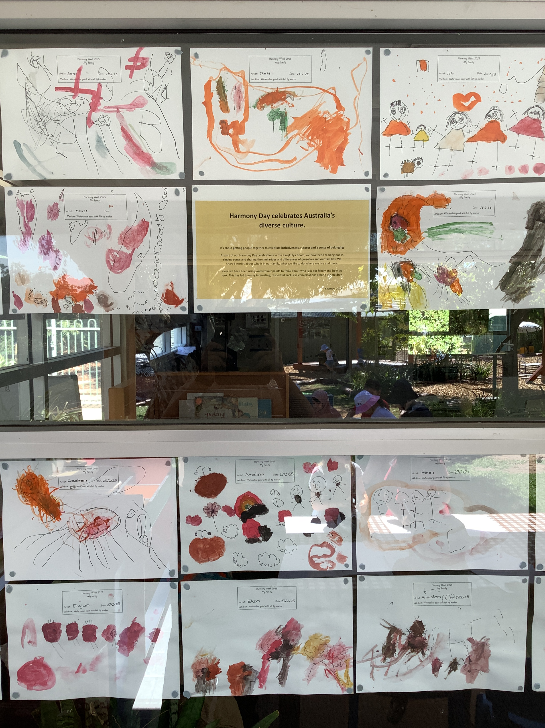  Kangkulya Kuu 28/7/25  Term 2 Small Groups  Children engaged in Small Group learning, reading ‘The Very Hungry Caterpillar’. This was selected as it coincided with ‘Eat A Rainbow’ program that was also on offer in the preschool room.  This term we decided instead of creating a ‘small group plan’ we follow the lead and ideas of the children.  Isaac expressed himself by wondering which fruit or vegetable the caterpillar liked the most.  Whilst reading the story during a large group one morning, Isaac wondered “I wonder which fruit the caterpillar liked best?” The educator wondered with Isaac “Ohh that is a great wondering, I wonder how we could find that out?”  Another child shared “We can have a vote, just like when we vote for books we want to read”. |  | Educators providing deep pressure massage on limbs. With permission from parents provide chew tools. Children in Kangkulya room are engaging in woodwork experiences, using real tools.  Educators are intentionally setting up obstacles outdoors to engage children in big body part movement. All these strategies are to support children’s regulation, ultimately supporting them to be in the right zone for engaging in the learning.  Educators are acknowledging the impact families have on children’s early learning development and by having conversations, listening to children’s stories, using our Kangkulya family book to identify, reflect, calm children.  We are noticing and naming their actions, reinforcing expectations, using the Zones of Regulation to measure and support them with regulating themselves.  Impact for children and families:  Children feeling confident to share their ideas, give things a go and look into the world of others. | Continue to work with Jo O’Callaghan, sites OT to build capacity around strategies that support children’s regulation. Investigate what other resources/Props do we have or need to purchase to assist those children that are struggling to regulate. Eg purchase new peanut ball.  Collaborate with families (connect home learning/culture to preschool learning/environment), through our Music Strategy Plan (refer to below section).  Sharing these songs from home and embedding them to our preschool practice, will support with being inclusive, working with families, building a safe and secure community.  Next Steps:
Music Education Strategy 2019 to 2029 ‘Music exists in every culture and is a fundamental form of human expression. It is a vehicle to connect and celebrate the diversity within our site, recognising and embracing children and young people of all cultures, experiences and abilities.  Music Strategy (Whole-site PD)  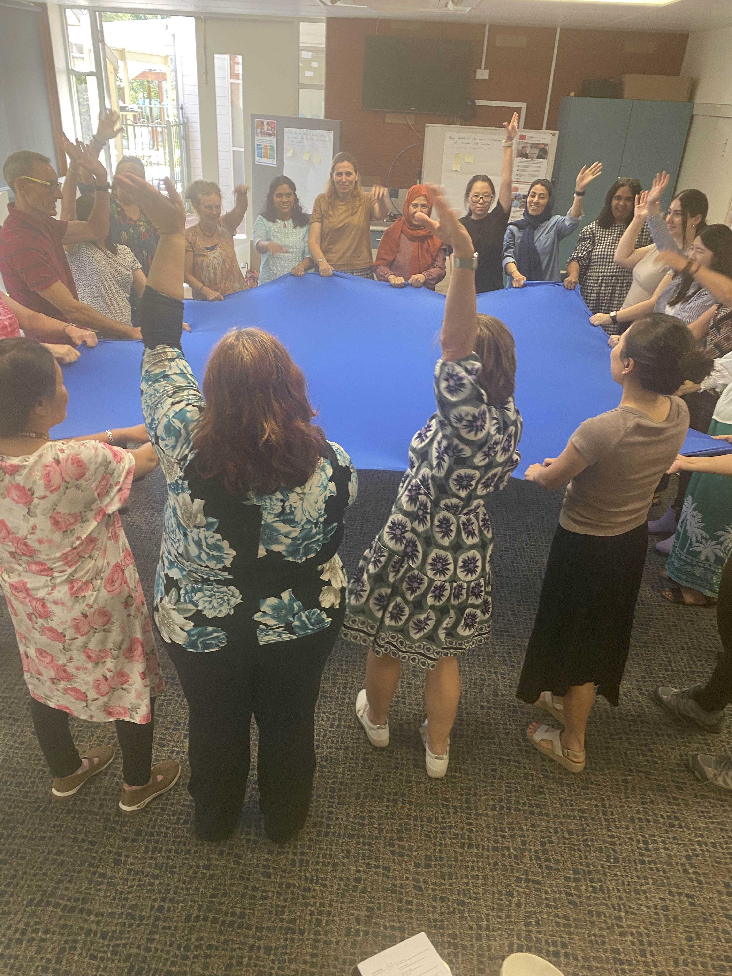  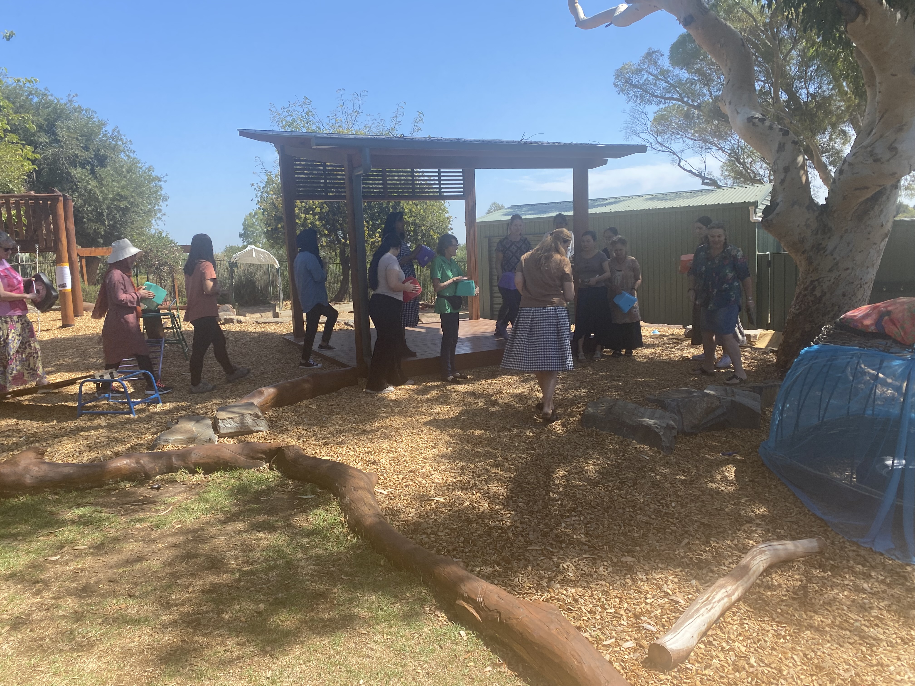 | Following a professional development day 7th March focused on music strategies, staff are incorporating more music into daily activities to enhance literacy, numeracy and regulation.  After the music workshop, YT staff have picked 3 main songs from the PD day that we as educators enjoyed singing and learning that we are practising and sharing with our children and families.  We have sent of an email and information to our families around what we have been implementing with music and where families can share their own musical experiences from home.  YT staff have been having conversations and collaborating with Tricia and Jo, around different musical ideas and musical needs for the room and outside provocations which is part of the Music Project that is in the process.  Term 2  YT staff set up an indoor and outdoor music area so the children can engage with the musical instruments at their own pace and regulate themselves. In addition, we worked with Tricia and Jo to make a basket of musical instruments, including rain shakers, maracas, xylophones and drums. Children can explore the instruments through tapping, banging and shaking them to create music.  We have feedback from families about the songs the children enjoy at home and the musical instruments they are interested in. For example, Louis likes guitar and goes to sleep with the "The Ants Go Marching" song. Thus, we have been singing the songs from family feedback with the children.  Jo teaches educators the actions that go with the songs “Row, Row, Row Your Boat” and we set up an area under the veranda with soft mat so children can do the actions with educators or their friends safely. Later, we invited the children to lay on the mat to dance to “Sleeping Bunnies” and putting children on our lap for the “Bouncy, Bouncy, Boo” action song.  Term 3  In the last few weeks, YT staff noticed a growing interest in farm animals and the nursery rhyme, ‘Old MacDonald Had A Farm’. Thus, we set up a story table based on the song with animal figurines, felt pieces, pretend barn and natural resources. It provides children opportunities to create scenes from the song, make up their own story and explore the relationship between the animals, as well as between the animals and their environment and the people.  After reflecting our music area, we decided to move our indoor music area next to the loft. This way, the children can see themselves and their friends in the mirror when they are playing with the musical instruments.  As a part of our music journey, we introduce ‘Come On Everyone’ and ‘Walking Walking’ songs to the children. These songs encourage children to slow down their bodies, listen to instructions and transition from one place to the other.  Ro and Elli went to Twilight Music Strategy in Action PD on 3rd March. (BANBI)  Elli and Yilu attend Music Strategy PD on 24th March. …….the dots….  Kangkulya Kuu:  Music Strategy professional development inspired us to learn new songs and rhymes to sing with children during group times and throughout the day.  Educators sent an email to families requesting cultural songs that are sung at home and requested families to send videos of children engaging in music and movement within their home. Anh collaborated with others to create a Power Point Presentation on the Music Inquiry and we celebrated this learning by sharing it with families at the MYI Celebration on the 28th June. Set up the interactive smart board on the veranda for parents to gather around and watch at their leisure. Children were proud of their contribution and encouraged their families to watch them on the big screen. |  | The children have been copying our action when we sing "Charlie Over The Ocean”and "Feet, Feet, Feet”songs.  One parent asks the educator how to sing the songs.  Term 2  The children like to play with the shakers, conga drums and xylophones in creative ways. For example, one child would use the rainshaker as a walking stick or torch when he walks around the room. Another example is a child would be tapping the xylophone with a spatula and another child got interested and joined in the play.  Children from YT, Karra and Yitpi visited the outdoor music area occasionally and played music together.  The new and existing families share the songs their child enjoy.  This acts as a conversation starter between families and educators.  The children showed interest in doing the “Row, Row, Row Your Boat” actions with educators and dancing to “Sleeping Bunnies” with their peers. Through music, they develop their gross motor skills and strengthen their relationships with educators and peers.  Term 3  The children were interested in the ‘Old MacDonald Had A Farm’ story table. They would sing the song, make different animal sounds and engage with the animal figurines. They use verbal and non-verbal communication to express and share their ideas with educators and friends.  After moving the music area next to the loft, some children would move the drum in front of the mirror and look at their own reflections as they were tapping on the drum. They would giggle and sing “La,la,la”. This showed that they gain confidence in their singing and drumming skills.  When educators sing ‘Come On Everyone’, the children know that it is transition time and would follow the educator’s guide. Children like to hold hands with their friends when listening to ‘Walking Walking’. They would slow down their bodies and walk in the room when they were running around.  Singing the "Nina Marni" song during group time to acknowledge the Country. Also using simple songs like "Hello to You and Hello to You" to intorduce ‘Hello’ in different languages. For older children, a song called ‘Copy cat’ has been introduced and children started to have initiatives to do different actions when singing the song.  A song called ‘Birdie, Birdie, where is your nest’ has also been sung in the group time to enhance children’s turn-taking skills. Children waited for their turn to hold bird and then choose a friend to pass it on.  Educators are noticing children are singing more throughout the day, particularly whilst engaging in regulating experience such as drawing or playdough (Mehar, Sherrie, Billie and Isla).  Children with special rights are now joining in singing simple repetitive songs at group times and following along with actions (Rebecca).  After introducing a syllable -clapping song to the children, (Isaac) then shared his own idea to create his own ‘game’.  Families are sharing cultural songs and videos of their child/ren participating in musicianship at home or within the  community. | Continue working with Tricia and Jo to develop our indoor and outdoor music project.  Term 2  Encourage families to bring books or songs in their home language to share it with the class.  Add songs in Kaurna language to our song list and introduce them to families and new staff.  Continue working with Tricia and Jo to develop our outdoor music project.  Create a shared file/movie with all the songs (videos and recordings) from families, for preschool to access during group time, relaxation etc and to share with families.  Continue to sing songs with children in the group time and during play. When children are familiar with some songs, musical instruments can be introduced to play with children through guidance.
What did we learn?
What progress have we made?

Term 1 Preschool Evaluation:
Small Groups:
- This term during small group we noticed the need for children to feel safe and secure within their environment. For some children this is their first time at Kindy and for others it’s their first time back after the long school break. With that in mind, children’s wellbeing has varied and wanting to support them to regulate themselves and be active participants in their learning was our team’s goal.
- "The Invisible String" by Patrice Karst is a powerful story that can significantly supports children's self-regulation and wellbeing. The book introduces the concept of an invisible string that connects people to those they love, regardless of distance. This idea can be particularly comforting for children and helping them manage emotions.
- Our learning allowed children to connect with one another on a familiar concept and express their thoughts and ideas. This process of shared-sustained thinking supported children with making realisations (understanding that they will see their family after kindy, they can think about them, talk to peers about them etc), sharing stories of themselves and their families, drawing representations, displaying their work in our environment to share with everyone, build safe/secure spaces and much more.
Data Collection:
- Collected handwriting and wellbeing data.
- Recorded data using excel spreadsheet, level ranking and colour codes.
- Educators decided to recollect data for new children who began preschool at the beginning of 2025, as well as selected children who began preschool in 2024, who still showed low wellbeing (refer to data sheet).
Wellbeing Data:
- Group A: 6 children scored (Low), 15 scored (Medium), 0 scored (High). Children who scored low showcased common factors (e.g., complex home life, speech and language barriers).
- Group B: 1 child scored (Low), 11 children scored (Medium), 4 children scored (High).
- Educators reviewed and analysed children who scored low and put intervention strategies in place (refer to Wellbeing Data Analysis Sheet 2025).
- Data will be re-collected in Term 3 to compare progress.
Handwriting Data:
- Group A: Most children were unable to recognise their name, most children showed low memory, 11 children use Tripod Grip, 6 children are developing their pencil grip (Incomplete Tripod Grip), 2 children are continuing to explore their pencil grip (Palmer Grip).
- Group B: Majority can recognise their name but not write from memory, 7 children use Tripod Grip, 7 children are developing their pencil grip (Incomplete Tripod Grip), 2 children are continuing to explore their pencil grip (Palmer Grip).

Enablers: What factors have been critical for success?
Term 1 Kindy Evaluation:
- Having two consistent educators collect data, review and analyse it through a visual spreadsheet.
- Parent-Teacher Meetings to establish goals and intervention strategies.
- Marte Meo practices (notice and naming actions).

Inhibitors: What factors have impeded progress? How will we work through this?
Term 1 Kindy Evaluation:
- Inconsistent staffing
- Not having a preschool support timetable for educators to work on intervention strategies with particular children.
- Not having team meetings to discuss progress of children, goals, challenges, ideas.

What will we embed?
Term 1 Kindy Evaluation:
- Established regular team meetings.
- Create timetable for preschool support, in order to support children throughout the day, not only in small group learning time (share the load with all ECW’s).

Term 2 Preschool Evaluation:
Actions Taken:
Small Groups: “The Very Hungry Caterpillar” as book based focus within Small Groups. Shifting from planning small groups to following the children’s interest and ‘what the children are most interested in’.
Educators gathered to reflect on children’s interests, provocations, evaluate and extend opportunities for children to extend their sense of agency.

Evidence Collected:
- Ped Doc pieces
-Samples of children’s work displayed in the room for families to view
-Photographs and Children’s voices
-Emails from families?
What Progress have we made?
Children confidently expressing their sense of agency by expressing their ideas and interests e.g Isaac sharing with the group “I wonder which food the caterpillar liked the most”. Educators allowed children time to wonder how they could find out. Isaac shared “how about we do a vote to see which one it liked the most”. Educators noticed the children were confident in sharing their own ideas (although sometimes shouting over the top of one another excitedly and we wondered how we could support this).
Educators noticed a need to foster children’s theory of mind. Playing listening games such as ‘Sound Detectives’ to hone in on supporting children to understand that others have beliefs and ideas that can be different to theirs. Also supporting inclusion and social awareness.
Enablers:
- Consistent Small Groups of children and educator
- Use of ‘Marte Meo’ by educators to see to notice and name children’s intentions, provide a sense of achievement and confidence to express their ideas, and take on ideas of others.
- Educators being flexible and open to extending children’s 100 languages.
Inhibitors: What factors have impeded further progress?
Staffing and complexity of children’s needs, educators often missed opportunities to engage in small group learning. Grouping of children, re-arranging children to learn from others with dominant ideas and confidence. Educators missed opportunities to hone in on other children’s ideas and voices e.g Humma

Where to next:
Further develop educator practise to use Marte Meo to develop children’s confidence and ways to express their 100 languages.

Notes

Endorsements

Endorsed by Director
Name
Rowena McAvaney

Date
Signature:

Endorsed by Education Director
Name
Paul Newman

Date
Click or tap to enter a date.

Signature:

